#### 9.7.12 Band Gap Renormalization

The band structure theory has been developed so far for small carrier densities. If the carrier density is large the interaction of free carriers has to be considered. The first step was exciton formation. However, at high temperatures (ionization) and at large carrier density (screening) the exciton is not stable. Exchange and correlation energy leads to a decrease of the optical absorption edge that is called *band gap renormalization* (BGR).

An effect due to significant carrier density is to be expected when the density is of the order of the exciton volume, i.e.

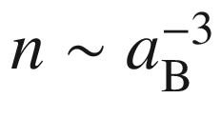

. For

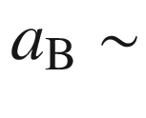

15 nm (GaAs) this means

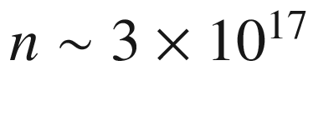

cm

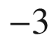

. The dimensionless radius

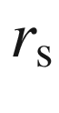

is defined via

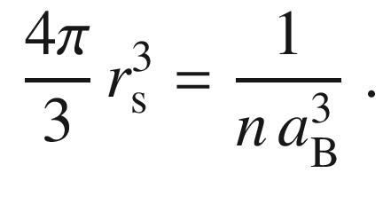

(9.63)

The sum of exchange and correlation energies

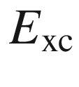

is found to be mostly independent of material parameters [886] (Fig. [9.29](#u116076_4_En_9_Chapter-Fig29)a) and follows the form

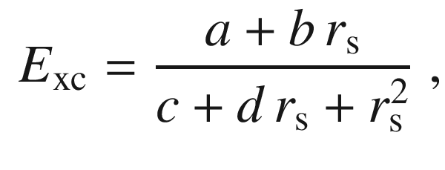

(9.64)

with

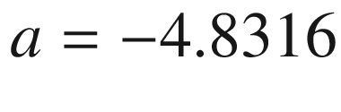

,

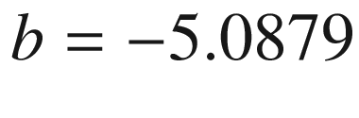

,

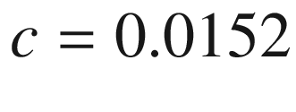

and

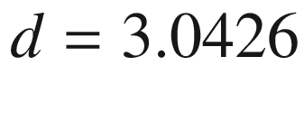

. Thus the density dependence of the band gap at small carrier density is

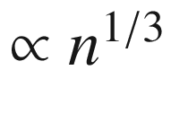

. Experimental data for a number of II–VI semiconductors roughly follow such a dependence (Fig. [9.29](#u116076_4_En_9_Chapter-Fig29)b).

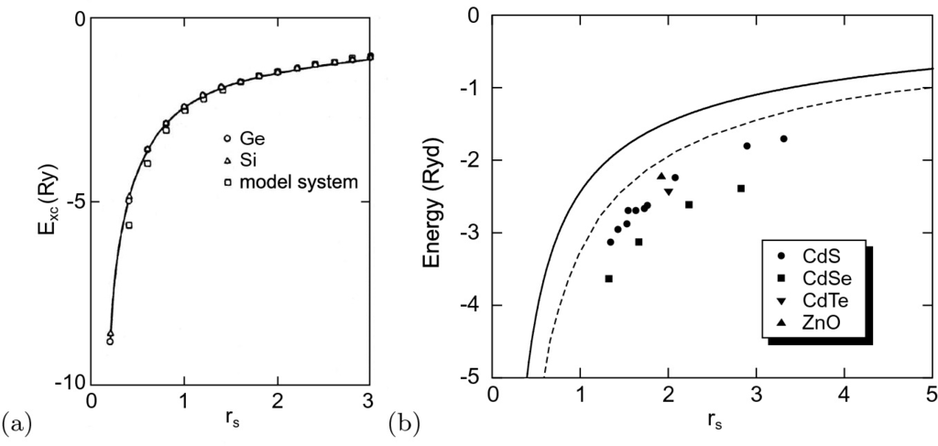

Fig. 9.29

**a** Theoretical exchange and correlation energies in units of the exciton Rydberg energy as a function of the dimensionless variable

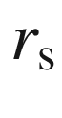

for Ge, Si and a model system (with one isotropic conduction and valence band each). The *solid line* is a fit according to ([9.64](#u116076_4_En_9_Chapter-Equ66)). Adapted from [886]. **b** Band gap renormalization in terms of the excitonic Rydberg for various II–VI semiconductors. *Solid line* is the relation according to ([9.64](#u116076_4_En_9_Chapter-Equ66)), *dashed line* is the dependence predicted in [887] for

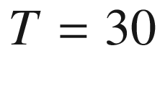

 K. Data are compiled in [888]

In Fig. [9.30](#u116076_4_En_9_Chapter-Fig30), a theoretical calculation of the absorption spectrum of bulk GaAs for various carrier densities (n=p) [889] is shown. With increasing density, the excitonic resonance broadens and vanishes. The shape approaches the electron–hole plasma shape. The absorption edge shifts to smaller energies. At high carrier density, the absorption becomes negative in a spectral range before absorption sets in. In this spectral region, the material exhibits gain and an incoming light wave is amplified (cmp. Sect. [10.​2.​6](#u116076_4_En_10_Chapter)).

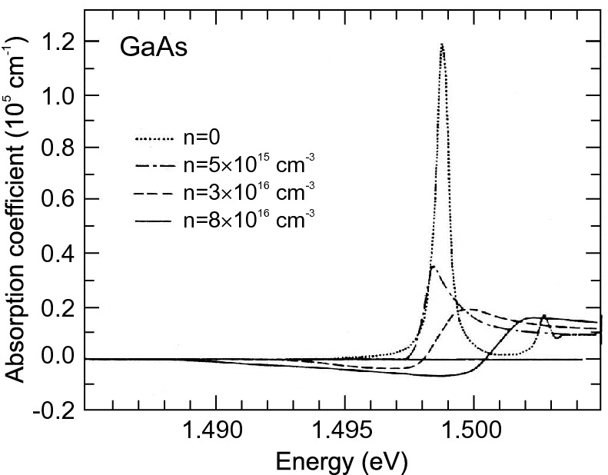

Fig. 9.30

Absorption of GaAs (low temperature,

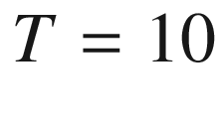

 K) as a function of the electron–hole density *n* (theory).

Adapted from [889]

#### 9.7.13 Electron–Hole Droplets

At low temperature and high density, electron–hole pairs in Ge and Si can undergo a phase transition into a liquid state. This electron–hole liquid (EHL) was suggested in [890] and is a Fermi liquid exhibiting the high conductivity of a metal and the surface and density of a liquid. The condensation is due to exchange interaction and correlation. The formation is fostered by the band structure of Ge [891] and the long lifetime of carriers in the indirect band structure. In unstressed Ge typically a cloud of electron–hole droplets with diameter in the

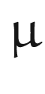

m range exists. The phase diagram is shown in Fig. [9.31](#u116076_4_En_9_Chapter-Fig31)a. In suitably stressed Ge electron–hole droplets with several hundred

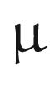

m diameter form around the point of maximum shear strain in inhomogeneously strained crystals, as shown in Fig. [9.31](#u116076_4_En_9_Chapter-Fig31)b. The pair density in such a liquid is of the order of

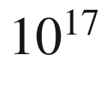

 cm

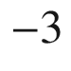

.

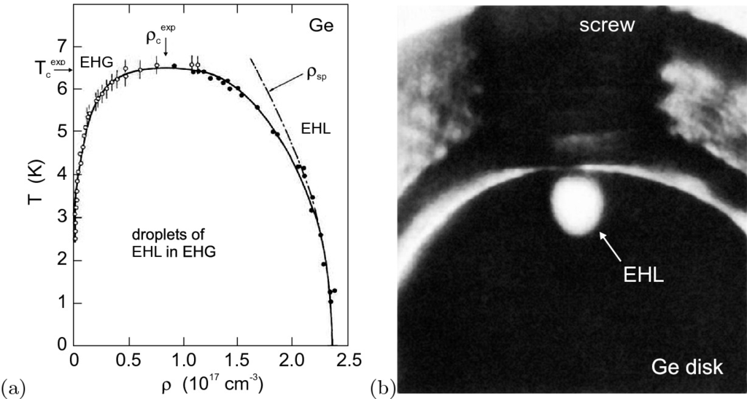

Fig. 9.31

**a** Temperature–density phase diagram of electrons and holes in Ge. The regions of electron–hole gas (EHG) and liquid (EHL) and the droplet phase are labeled. *Solid line* is theoretical calculation, *symbols* are experimental data from [892]. The *dash-dotted line* denoted

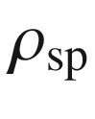

is the experimentally obtained temperature dependence of the liquid density due to single-particle excitations.

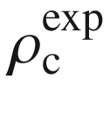

and

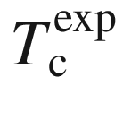

denote the experimental critical density and temperature, respectively. Adapted from [893]. **b** Photographic image of radiative recombination (at 1.75

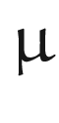

m wavelength) from a 300-

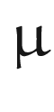

m diameter droplet of electron–hole liquid (EHL) in a stressed (001) Ge disk (diameter 4 mm, thickness 1.8 mm) at

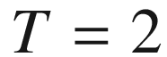

 K. The stress is applied from the top by a nylon screw along a

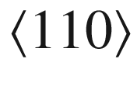

direction. Adapted from [894], reprinted with permission, ©1977 APS

We note that the metallic EHL state hinders observation of the Bose–Einstein condensation (BEC) of (bosonic) excitons. The light-exciton mass offers a high condensation temperature in the 1 K range (compared to the mK range for atoms). Recent experiments with spatially indirect excitons in coupled quantum wells lead towards BEC [895, 896]. A sufficiently long lifetime ensures cooling of the excitons close to the lattice temperature. Another potential candidate for BEC are long-living excitons (ms-range) in Cu



O [897]. The condensation of polaritons (cf. Sect. [9.7.8](The_Physics_of_Semiconductors00004.docx#u116076_4_En_9_Chapter-Sec15)) in microcavities to well-defined regions of



-space has been discussed in [898] and compared to bosonic condensation in bulk.

#### 9.7.14 Two-Photon Absorption

So far, only absorption processes that involve one photon have been considered. The attenuation of the intensity *I* of a light beam (of frequency

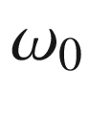

) along the *z* direction can be written as

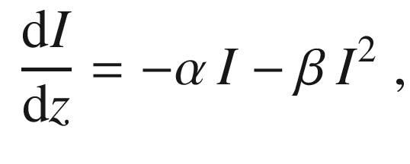

(9.65)

where

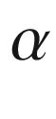

is due to the (linear) absorption coefficient (and possibly scattering) and

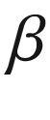

is the two-photon absorption coefficient. A two-photon process can occur in two steps, e.g. via a midgap level, which is not considered any further here. Here, we consider two-photon absorption (TPA) via the population of a state at

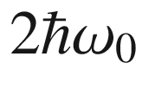

higher energy than the initial state with a nonlinear optical process. The TPA coefficient is related to the nonlinear third-order electric dipole susceptibility tensor [899]

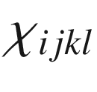

. Within the two-band approximation theory predicts [900]

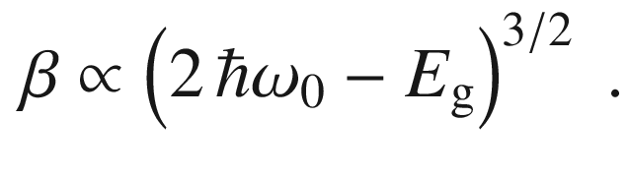

(9.66)

The exponent 3/2 is indeed found experimentally, as shown in Fig. [9.32](#u116076_4_En_9_Chapter-Fig32) for GaAs. The strength of absorption depends on the relative orientation of the light polarization with respect to the main crystallographic directions, e.g. TPA for polarization along

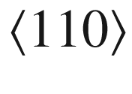

is about 20% larger than for the

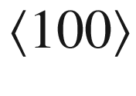

orientation.

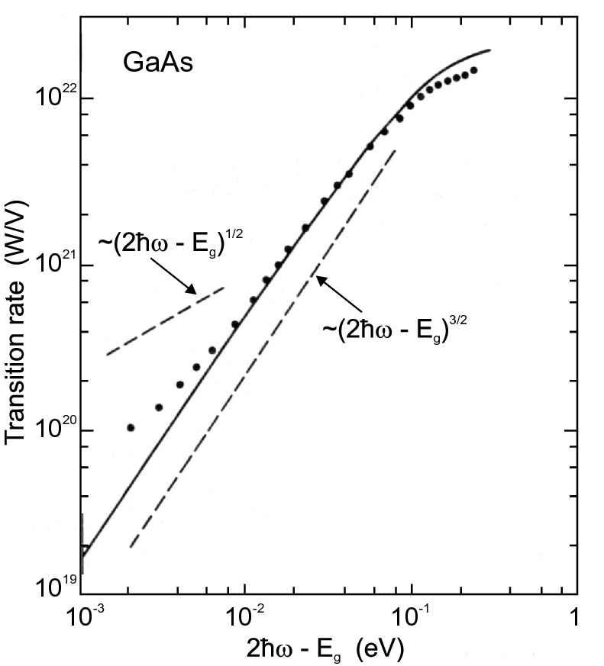

Fig. 9.32

Experimental two-photon absorption spectrum of GaAs (

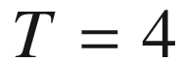

 K) (*dots*) plotted as a function of the difference of the double-photon energy

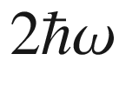

from the GaAs band edge

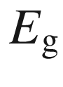

. The *solid line* is a theoretical calculation, the *dashed lines* represent slopes with exponent 1/2 and 3/2, respectively.

Adapted from [901]

### 9.8 Impurity Absorption

#### 9.8.1 Shallow Levels

For charge carriers bound to shallow impurities long range Coulomb forces are most important and they exhibit a hydrogen-like term scheme

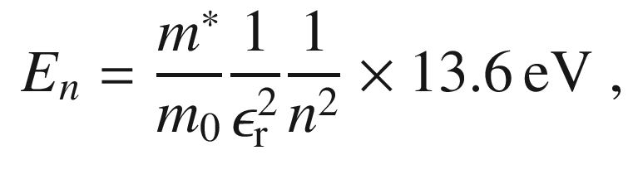

(9.67)

with the ionization limit

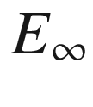

being the conduction (valence) band edge for donors (acceptors), respectively. They can be excited by light to the nearest band edge. Such absorption is typically in the FIR region and can be used for photodetectors in this wavelength regime. The optical absorption cross section of impurity absorption can be related to the carrier capture cross section [588, 589].

The actual transition energies can deviate from ([9.67](#u116076_4_En_9_Chapter-Equ69)) due to deviation of the potential close to the impurity from the pure Coulomb potential. Such an effect is known as the chemical shift or central cell correction  (cf. Sect. [7.​5.​5](The_Physics_of_Semiconductors00003.docx#u116076_4_En_7_Chapter)) and is characteristic of the particular impurity. In GaAs such shifts are small (



100

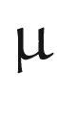

eV) [902].

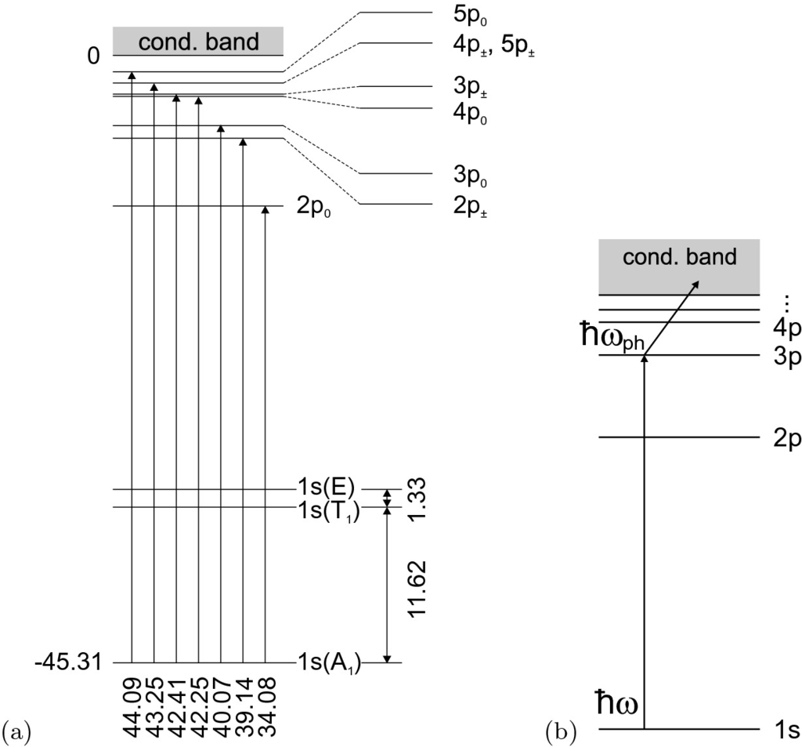

Fig. 9.33

**a** Term scheme of phosphorus donor in silicon, all energies in meV. After [903]. **b** Schematic sequence for photothermal ionization, here absorption of a photon with

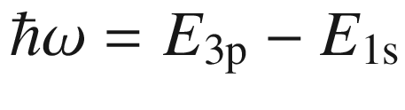

and subsequent absorption of a phonon with energy

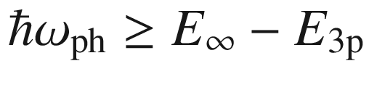

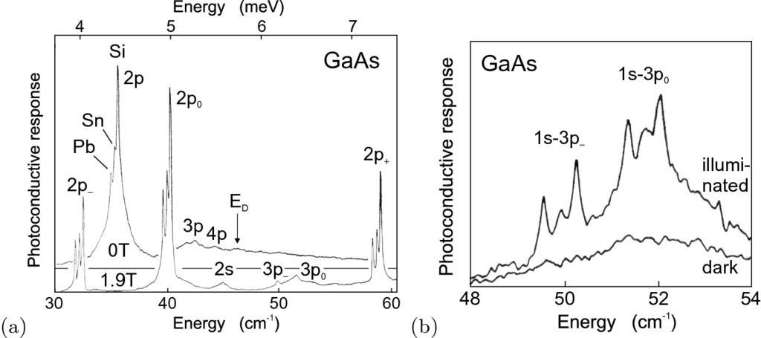

Fig. 9.34

**a** Far-infrared photoconductivity response (Lyman-type s

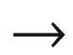

p series) of not intentionally doped GaAs with residual donors Pb, Sn, and Si,

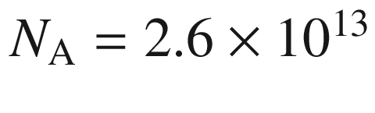

 cm

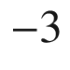

,

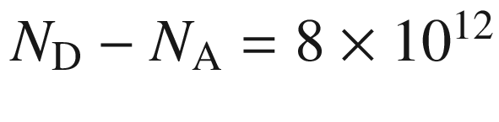

 cm

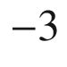

. The *upper* (*lower*) curve is for a magnetic field of 0 (1.9) T. Measurement temperature is 4.2 K. **b** Photoconductive response of a (different) GaAs sample with the same impurities (

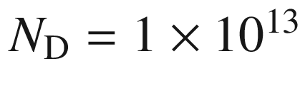

 cm



) with (*upper curve*) and without (*lower curve*) illumination with above-bandgap light (

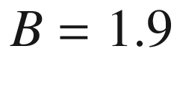

 T,

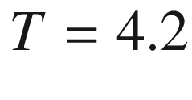

 K).

Adapted from [905]

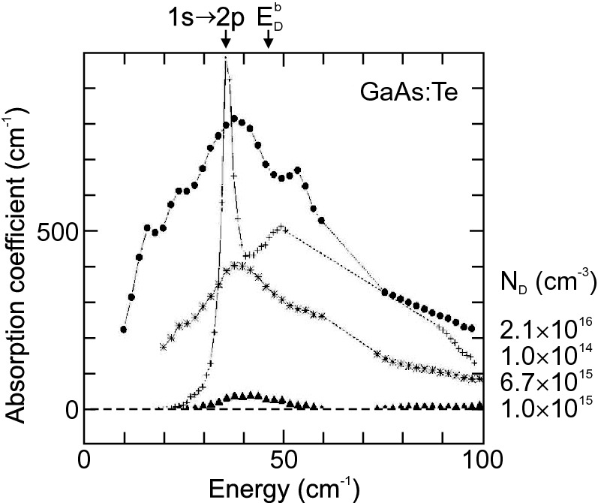

Fig. 9.35

Low-temperature (

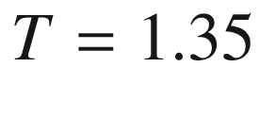

 K) absorption spectra of highly doped n-type GaAs:Te with doping concentrations as labeled (*circles*:

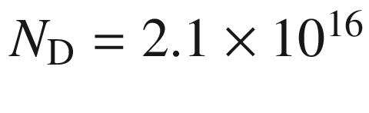

 cm



, *stars*:

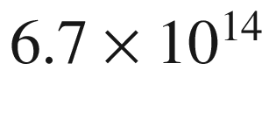

, *triangles*:

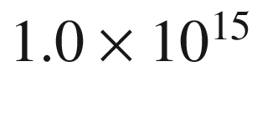

). A sharp photoconductivity spectrum (in arbitrary units) from low-doped GaAs:Te (*crosses*,

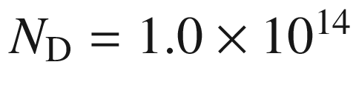

 cm



) is shown for comparison (cf. Fig. [9.34](#u116076_4_En_9_Chapter-Fig34)a). The energy of the 1s

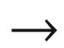

2p transition and the donor binding energy (onset of continuum absorption) are indicated.

Adapted from [906]

The term scheme for P in Si is shown in Fig. [9.33](#u116076_4_En_9_Chapter-Fig33)a. The ground state (1s) is split because of a reduction of the tetrahedral symmetry due to intervalley coupling. The anisotropic mass at the X-valley in Si causes the p states (and states with higher orbital angular momentum) to split into p



and p



states. Such an effect is absent in a direct semiconductor with an isotropic conduction-band minimum such as GaAs (Fig. [9.34](#u116076_4_En_9_Chapter-Fig34)). Optical transitions between the 1s and various p states can be directly observed in absorption, e.g. for Si:P in [904]. These transitions are also observed in photoconductivity because the missing energy to the ionization into the continuum is supplied by a phonon at finite temperature (photothermal ionization) (Fig. [9.33](#u116076_4_En_9_Chapter-Fig33)b) [903]. The splitting of the 2p transition in Fig. [9.34](#u116076_4_En_9_Chapter-Fig34)a is the chemical shift due to different donors incorporated in the GaAs (Si, Sn, and Pb). Peak broadening is mostly due to Stark broadening due to neighboring charged impurities. The application of a magnetic field induces Zeeman-like splittings and increases the sharpness of the peaks. The peak width can be further increased by illuminating the sample with light having a higher energy than the band gap. The additional charge carriers neutralize charged impurities and allow higher resolution (Fig. [9.34](#u116076_4_En_9_Chapter-Fig34)b).

In Fig. [9.35](#u116076_4_En_9_Chapter-Fig35) absorption spectra of highly doped n-type GaAs are shown. For doping concentrations larger than the critical concentration of

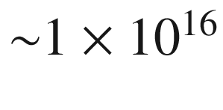

 cm

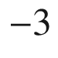

(cf. Table [7.​6](The_Physics_of_Semiconductors00004.docx#u116076_4_En_7_Chapter-Tab6)) significant broadening is observed due to the formation of an impurity band.

#### 9.8.2 Deep Levels

The absorption of deep levels is typically in the infrared. In Fig. [9.36](#u116076_4_En_9_Chapter-Fig36)a the possible optical absorption processes involving the Fe levels in InP (cf. Sect. [7.​7.​8](The_Physics_of_Semiconductors00003.docx#u116076_4_En_7_Chapter)) during the charge transfer

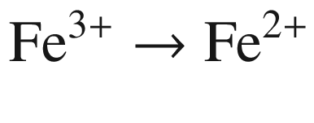

are shown. These transitions and their fine structure (Fig. [9.36](#u116076_4_En_9_Chapter-Fig36)b) have been observed in calorimetric absorption spectroscopy (CAS) experiments [682].

In Fig. [9.37](#u116076_4_En_9_Chapter-Fig37) photoproductivity of Si:Mg is shown. The sharp peaks are due to transitions of interstitial, singly ionized Mg, Mg

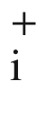

[907]. Mg in Si is a double donor [653] (see Sect. [7.​7.​2](The_Physics_of_Semiconductors00003.docx#u116076_4_En_7_Chapter)). Above the ionization limit of about 256 meV, the peaks are replicated, shifted by the LO phonon energy of 59.1 meV. However, now they rather appear as dips. This behavior is typical for a discrete state interacting with a continuum, also called Fano resonance[908, 909] with its characteristic lineshape, going *below* the continuum level.

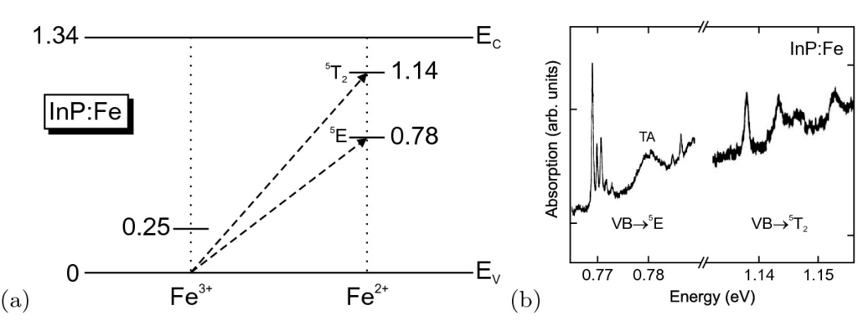

Fig. 9.36

**a** Schematic band diagram of InP with levels of Fe impurities in the

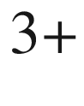

and

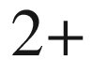

charge states at low temperature. All energies are given in eV. The *arrows* denote the optical transition of a valence-band electron to the Fe center, Fe

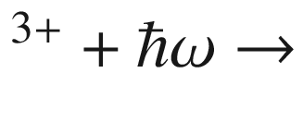

Fe

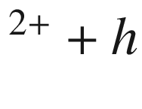

. **b** Calorimetric absorption spectra (at

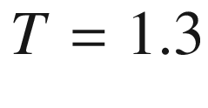

 K) of InP:Fe, [Fe]=

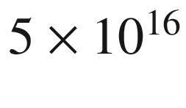

 cm

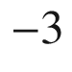

. Part **b**

Adapted from [682]

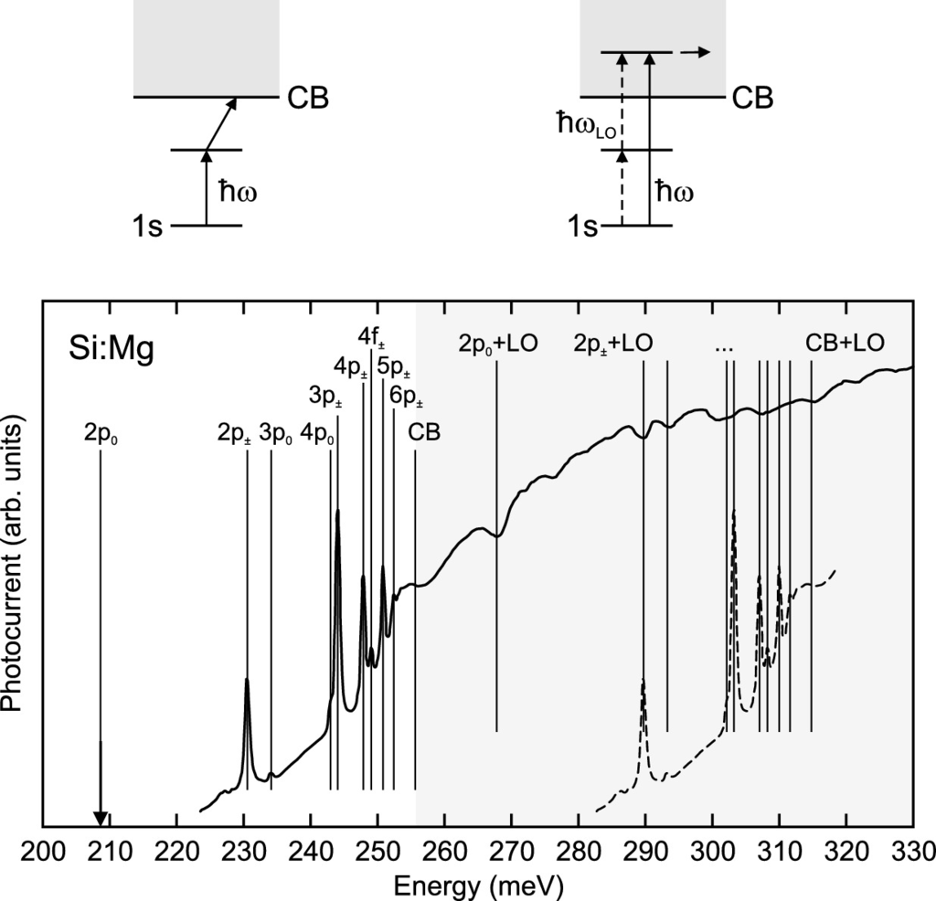

Fig. 9.37

Photocurrent spectrum of Si:Mg. Transitions are due to Mg



from its 1s state to excited states as labeled and indicated by *vertical lines*. CB denotes the conduction band edge (ionization limit). Above the CB edge (*shaded area*) phonon-assisted absorption occurs (Fano resonances). For comparison the absorption spectrum below CB is shown shifted by the phonon energy (*dashed line*). Above the plot, the transition mechanisms (photothermal ionization and Fano resonance) are schematically shown. Adapted from [907]

The absorption spectra due to various deep acceptors in GaAs are compared in Fig. [9.38](#u116076_4_En_9_Chapter-Fig38). The density of states in the band increases with *k* (proportional to

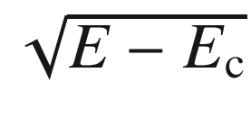

). The carrier on the impurity is strongly localized and described with a wave packet centered around

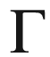

, its *k*-components decreasing with increasing *k*. Thus the maximum absorption will be at an intermediate *k*-value and an associated energy larger than the ionization energy

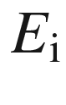

(lowest transition to continuum at for

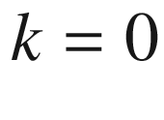

). The lineshapes in Fig. [9.38](#u116076_4_En_9_Chapter-Fig38) fit to a model with a

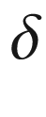

-potential (zero range model, neglecting long range Coulomb terms) [910] with maximum absorption close to

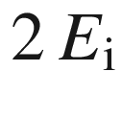

,

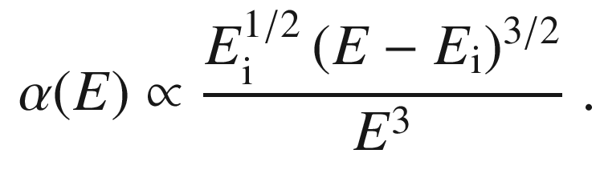

(9.68)

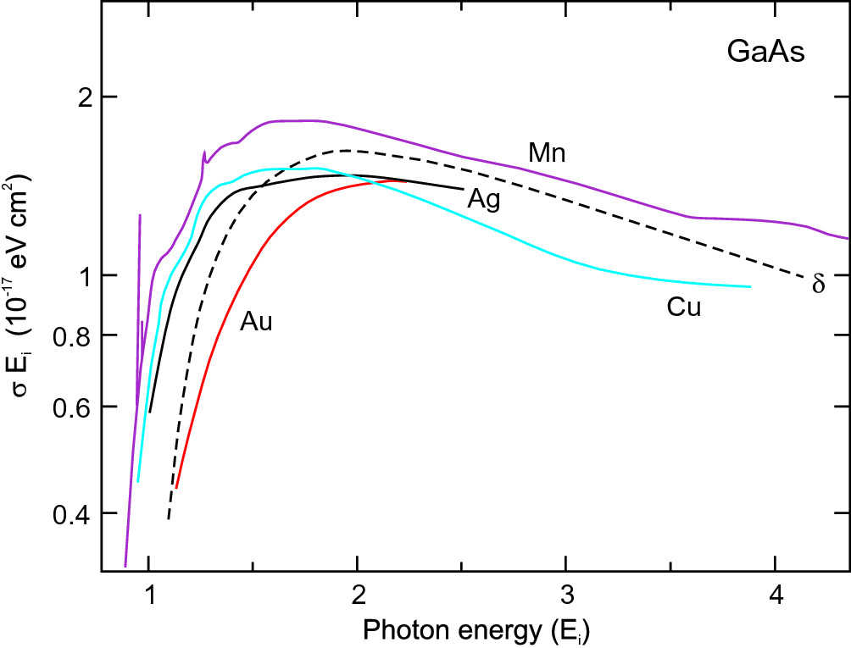

Fig. 9.38

Absorption spectra (

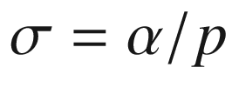

) due to various deep impurities in GaAs as labeled. The *dashed line* is a theoretical lineshape assuming a hole bound to a

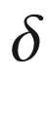

-potential. The energy axis is scaled by the ionization energy. The kink for Mn at

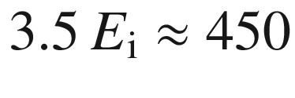

 meV is due to the onset of absorption into the split-off valence band.

Adapted from [314]

### 9.9 Absorption in the Presence of Free Charge Carriers

In the presence of charge carriers, various absorption processes can occur. First, the dissipative motion of carriers leads to infrared absorption, termed the free carrier absorption (Sect. [9.9.1](#u116076_4_En_9_Chapter-Sec26)). Filling of a band with carriers leads to a shift of the band-band absorption edge, the Burstein-Moss shift (Sect. [9.9.2](#u116076_4_En_9_Chapter-Sec27)). Besides the free-carrier absorption, free carriers present in the semiconductor can lead to further absorption processes with transition energies below the band gap. These processes are due to transitions within the band structure and can be

inter-valence band transitions of holes (Sect. [9.9.3](#u116076_4_En_9_Chapter-Sec28)),

phonon-assisted inter-valley transitions of electrons (Sect. [9.9.4](#u116076_4_En_9_Chapter-Sec29)),

phonon-assisted intra-band transitions of electrons (Sect. [9.9.5](#u116076_4_En_9_Chapter-Sec30)).

#### 9.9.1 Absorption Coefficient, Plasma Frequency

The absorption due to free carriers in the infrared spectral range (away from phonon resonances) can be described with the Drude model [911].

A time-dependent electric field accelerates the charge carriers within a band. The excess energy is subsequently transferred to the lattice via scattering with phonons. A review of the effect of free carriers on optical properties can be found in [912]. In the relaxation-time approximation energy is relaxed with a time constant



. Thus energy is absorbed from the electromagnetic wave and dissipated. Effectively, this process represents an intra-band excitation.

The complex conductivity ([8.​37](The_Physics_of_Semiconductors00004.docx#u116076_4_En_8_Chapter)) is given by

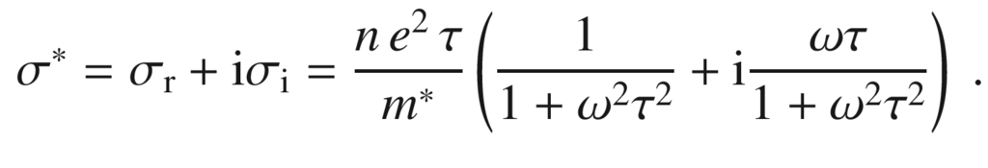

(9.69)

We note that a static magnetic field introduces birefringence as discussed in more detail in Sect. [15.​2.​2](The_Physics_of_Semiconductors00006.docx#u116076_4_En_15_Chapter). The wave equation for the electric field is

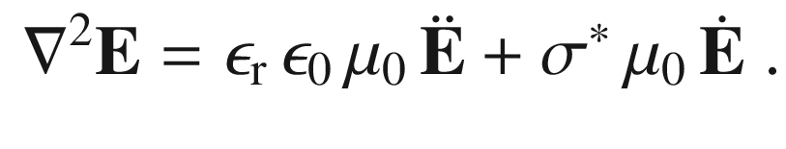

(9.70)

For a plane wave

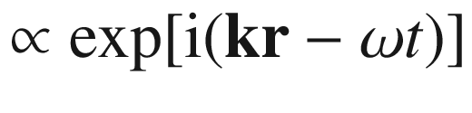

the wavevector obeys

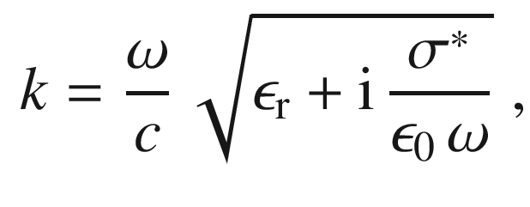

(9.71)

where

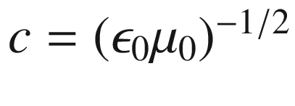

is the velocity of light in vacuum,

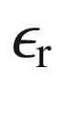

is the background dielectric constant (for large

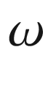

).

The part



 of the dielectric function due to free carriers is

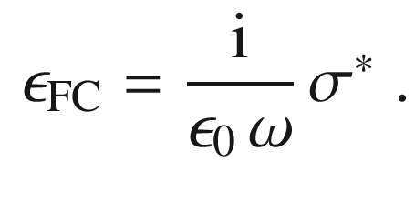

(9.72)

The complex index of refraction is

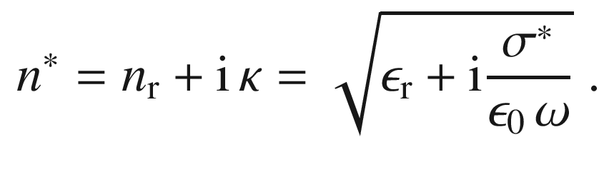

(9.73)

Taking the square of this equation yields

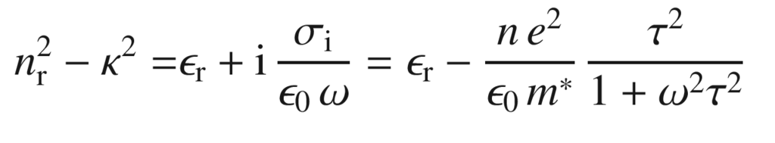

(9.74a)

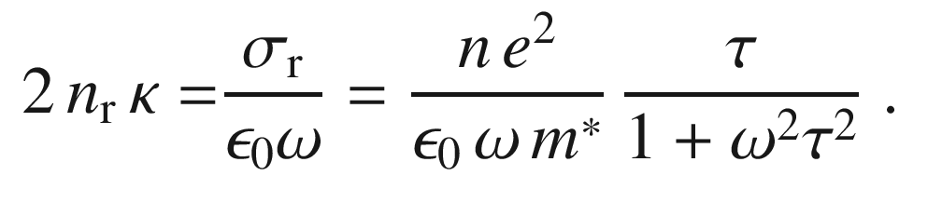

(9.74b)

The absorption coefficient is related to

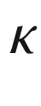

by ([9.9](The_Physics_of_Semiconductors00004.docx#u116076_4_En_9_Chapter-Equ9)). For the case of higher frequencies, i.e.

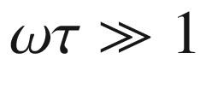

, the absorption is

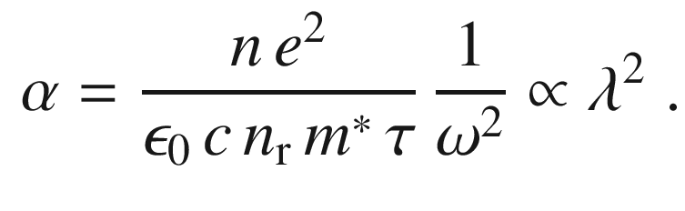

(9.75)

The absorption decreases with increasing frequency like

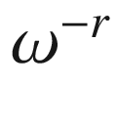

. The classical Drude treatment as followed here results in an exponent of

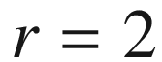

. This is the case for neutral impurity scattering and also for small frequencies

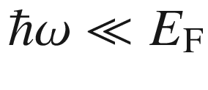

. A more detailed discussion of the energy dependence of free-carrier absorption can be found in [913]. Other exponents have been derived for scattering by acoustical phonons (

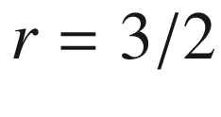

), LO phonons (

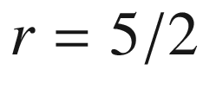

) and ionized impurities (

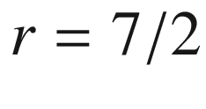

). More detailed quantum mechanical treatments of free-carrier absorption in the presence of impurities and phonons can be found in [914–916].

For semiconductors free-carrier absorption is particularly important in the mid- and far-infrared regions when carriers are present due to doping or thermal excitation. In Fig. [9.39](#u116076_4_En_9_Chapter-Fig39)a absorption spectra of n-type Ge for various doping concentrations are shown. The absorption coefficient in the transparency regime varies proportionally to

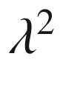

as predicted in ([9.75](#u116076_4_En_9_Chapter-Equ78)). In Fig. [9.39](#u116076_4_En_9_Chapter-Fig39)a, the absorption can be seen to rise for photon energy above 0.7 eV due to absorption in the band structure. Electrons are excited from the valence band across the fundamental band gap into the conduction band (cmp. Sect. [9.7.3](The_Physics_of_Semiconductors00004.docx#u116076_4_En_9_Chapter-Sec10)), which is an indirect transition in Ge.

In Fig. [9.39](#u116076_4_En_9_Chapter-Fig39)b the absorption coefficient due to free carrier absorption at fixed wavelength is shown as a function of dopant concentration.[11](#u116076_4_En_9_Chapter-Fn11) The slope is slightly overlinear, indicating a weak dependence

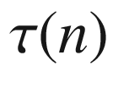

. A sub-linear relation has been found for heavily p-doped GaAs [917].

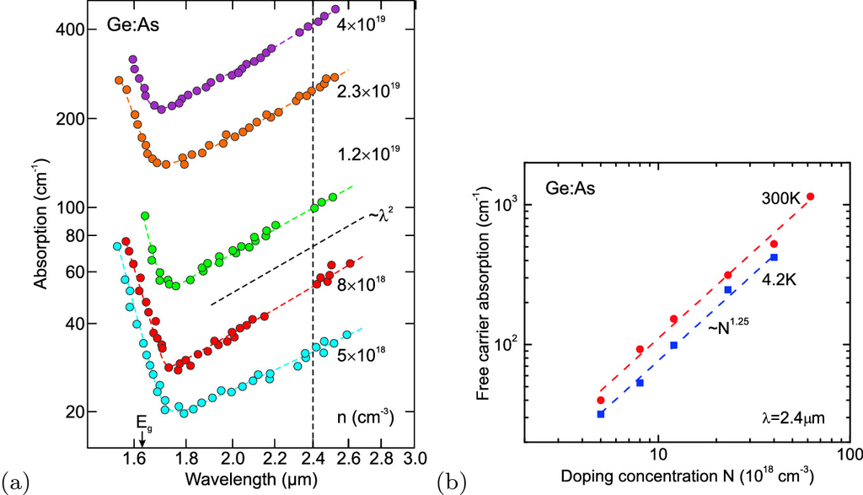

Fig. 9.39

**a** Optical absorption spectra (at

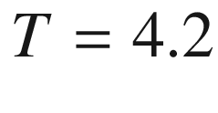

 K) of n-type Ge for various As dopant concentrations as labeled. The *arrow* denotes the band edge of undoped Ge, the *vertical dashed line* the energy for which the free-carrier absorption is measured in part **b**. The inclined *dashed line* visualizes the slope

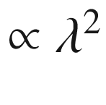

. *Curved dashed lines* are guides to the eye. Adapted from [851]. **b** Free-carrier absorption at

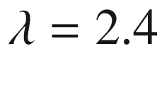



m as determined from part **a** of the figure (*blue* *squares*) as a function of As dopant concentration. Additionally data at 300 K (*red* *circles*) from the same samples are included [851]. The *dashed lines* visualizes the slope

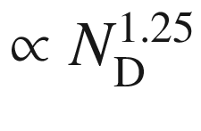

The index of refraction is given by (also for

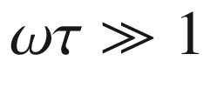

)

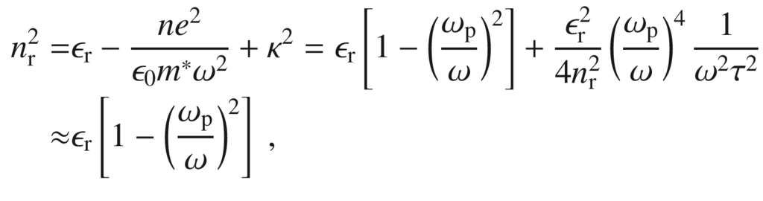

(9.76)

where

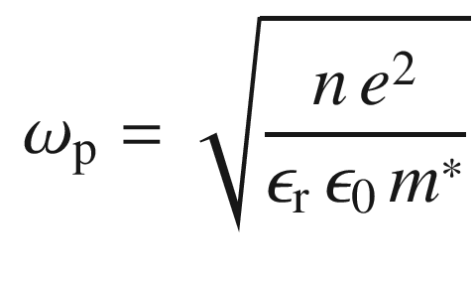

(9.77)

is the plasma frequency. The approximation is valid for small absorption and when

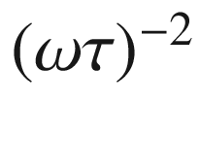

can be neglected. A graphical representation is given in Fig. [9.40](#u116076_4_En_9_Chapter-Fig40)a. For coupling to electromagnetic waves (still

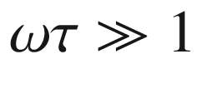

)

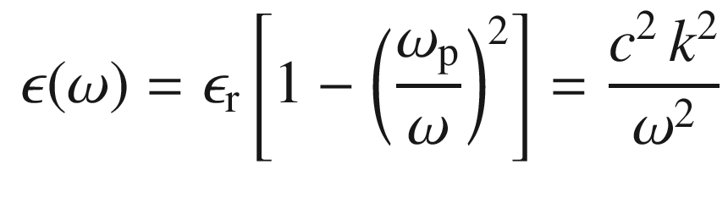

(9.78)

must be fulfilled. It follows that the dispersion relation in the presence of free carriers (Fig. [9.40](#u116076_4_En_9_Chapter-Fig40)b) is

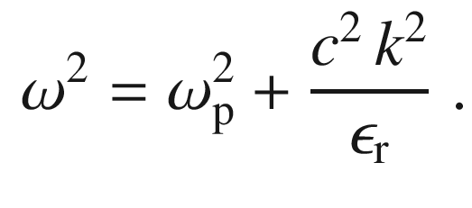

(9.79)

For

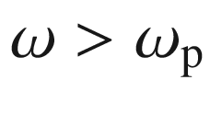

,

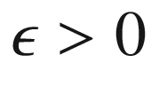

, thus waves can propagate. For

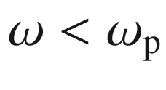

, however, the dielectric constant is negative, i.e.

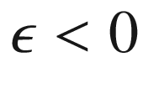

. For such frequencies waves are exponentially damped and cannot propagate or penetrate a layer. This effect can be used in a plasmon waveguide or in metamaterials (cf. Sect. [19.​1.​10](The_Physics_of_Semiconductors00007.docx#u116076_4_En_19_Chapter)). The expected dependence of the plasmon wavelength on the carrier density

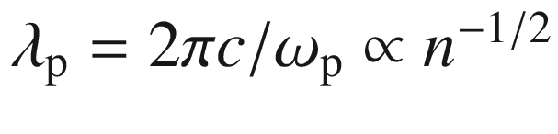

is depicted in Fig. [9.41](#u116076_4_En_9_Chapter-Fig41) for GaAs. For semiconductors the plasmon frequency is in the mid-or far-infrared spectral region.[12](#u116076_4_En_9_Chapter-Fn12)

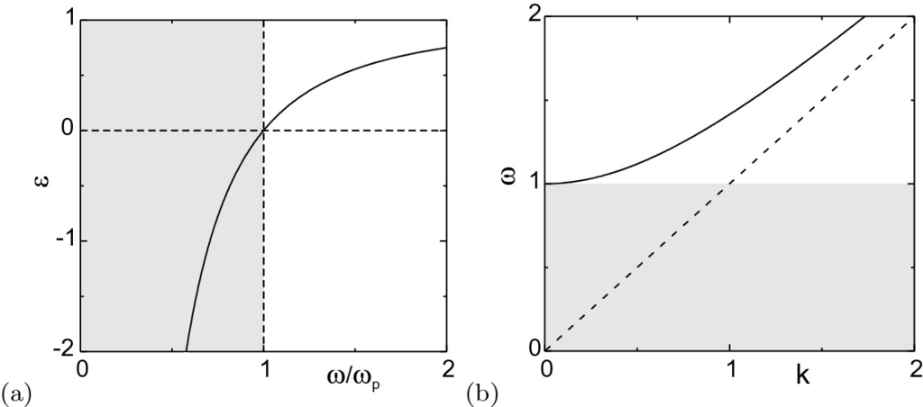

Fig. 9.40

**a** Dielectric constant for plasmon oscillations. *Shaded area* represents region of attenuation (negative

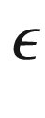

). **b** Dispersion relation (*k* in units of

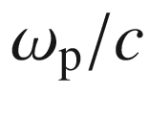

,

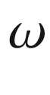

in units of

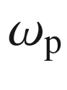

) in the presence of free carriers ([9.79](#u116076_4_En_9_Chapter-Equ82), for

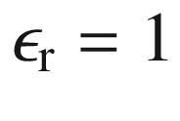

). *Shaded area* represents forbidden frequency range for propagating solutions. *Dashed line* is photon dispersion

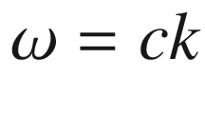

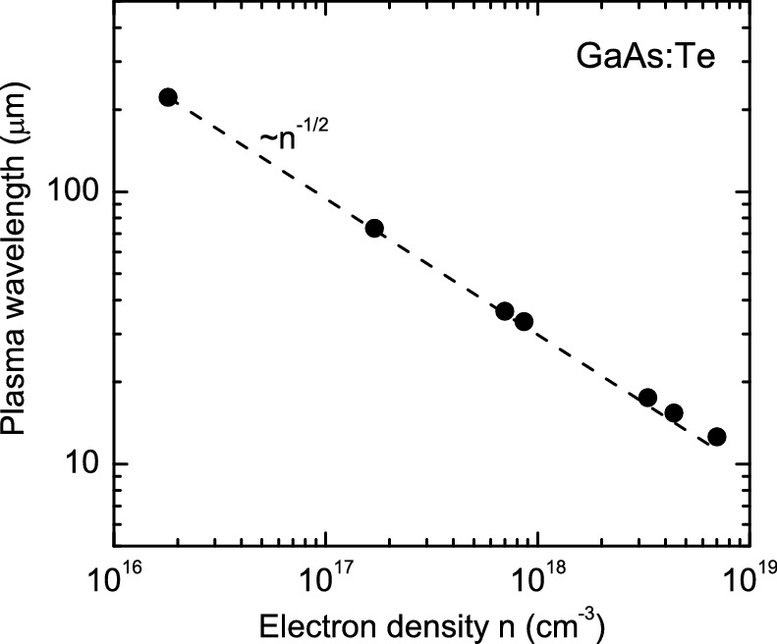

Fig. 9.41

Plasma wavelength

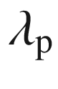

for n-type GaAs with various electron concentrations due to different doping levels. *Filled circles*: experimental values, *dashed line*:

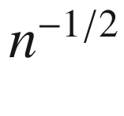

dependence; the deviation is due to nonparabolicity of the electron mass (cf. Fig. [9.53](#u116076_4_En_9_Chapter-Fig53)b). Data from [918]

#### 9.9.2 Burstein–Moss Shift

In the discussion so far it has been assumed that all target states in the conduction band are empty. In the presence of free carriers the absorption is modified by the

change of the distribution function

many-body effects (band gap renormalization).

The latter is discussed in the next section. For a degenerate electron distribution all states close to the conduction-band edge are populated. Thus a transition from the valence band cannot take place into such states. This shift of the absorption edge to higher energies is called the Burstein–Moss shift [919, 920]. Originally, the Burstein–Moss shift was evoked to explain the absorption shift in InSb with varying carrier concentration (Fig. [9.42](#u116076_4_En_9_Chapter-Fig42)).

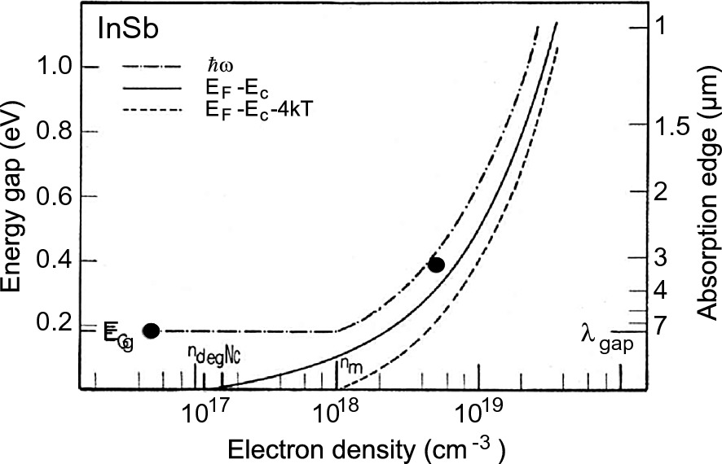

Fig. 9.42

Burstein–Moss effect at InSb (

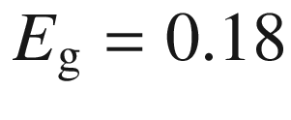

 eV) at room temperature. Theoretical dependence and data points for intrinsic InSb and

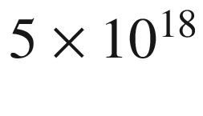

 cm



n-type. Data from [919]

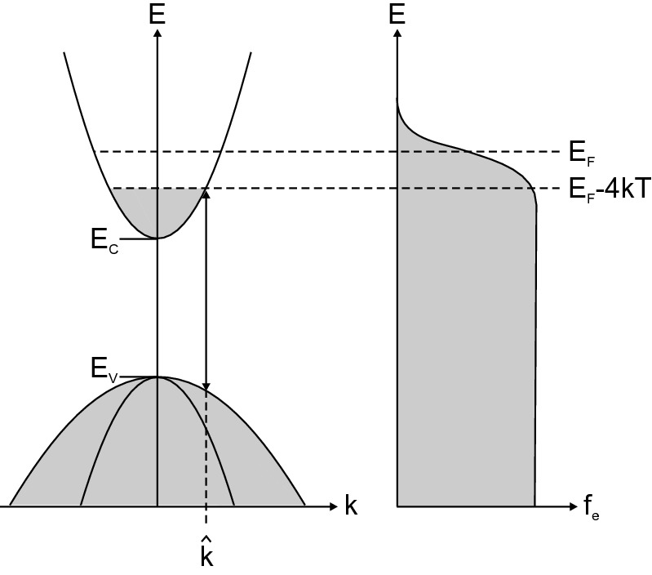

Fig. 9.43

Principle of Burstein–Moss shift. *Left panel*: Schematic band structure with completely filled electron states shown in *grey*. The *k*-vector for the lowest photon energy optical absorption process is indicated as

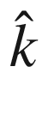

. *Right panel*: Electron distribution function for a degenerate electron gas with Fermi level in the conduction band



-conserving optical transitions between parabolic hole and electron bands have the dependence

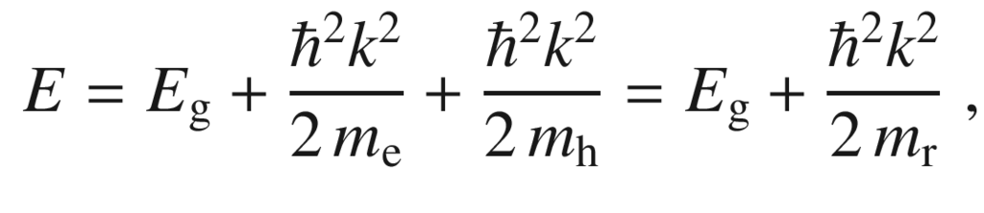

(9.80)

where

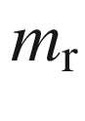

is the reduced mass of electron and hole. About 4*kT* below the Fermi level all levels in the conduction band are populated (Fig. [9.43](#u116076_4_En_9_Chapter-Fig43)). Thus the *k* value at which the absorption starts is given as

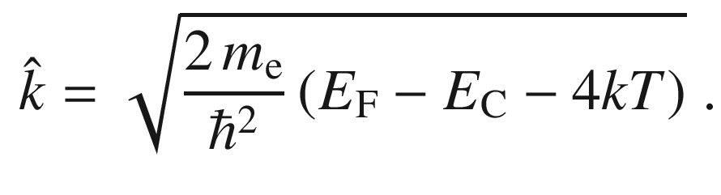

(9.81)

Besides the energy shift in the conduction band, the corresponding energy shift in the valence band

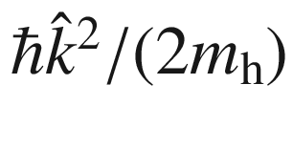

must be considered. Thus, the Burstein–Moss shift of the absorption edge is

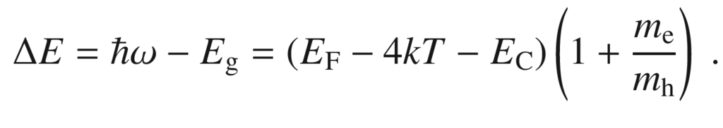

(9.82)

The relation between *n* and the Fermi level is given by ([7.​6](The_Physics_of_Semiconductors00003.docx#u116076_4_En_7_Chapter)). If

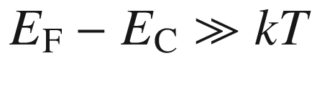

the Fermi integral can be approximated by

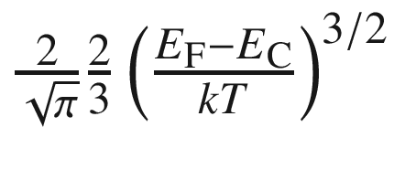

. Using ([7.​8](The_Physics_of_Semiconductors00003.docx#u116076_4_En_7_Chapter)) for

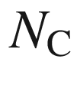

, the Burstein–Moss shift can be written for this case as

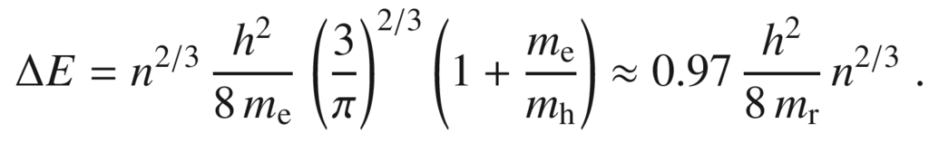

(9.83)

The

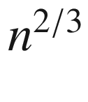

dependence of the energy shift is found, e.g., for CdO[13](#u116076_4_En_9_Chapter-Fn13) with different carrier concentrations (due to different deposition temperature, no intentional doping) [921] and depicted in Fig. [9.44](#u116076_4_En_9_Chapter-Fig44)a. Similar behavior is found for ITO (indium-tin-oxide) thin films, deposited at different sputtering conditions, leading to different carrier concentrations ([9.44](#u116076_4_En_9_Chapter-Fig44)b).

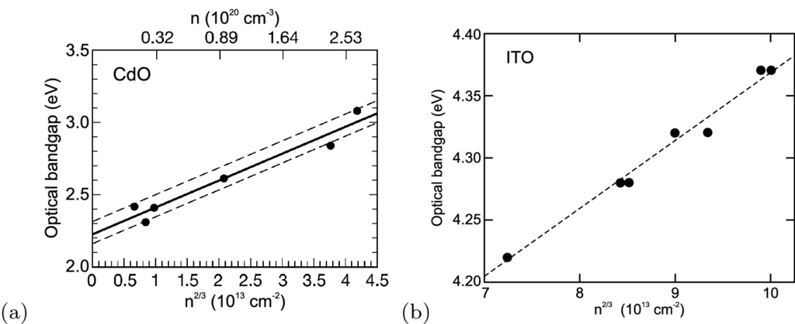

Fig. 9.44

**a** Burstein–Moss effect in CdO. The linear fit is for

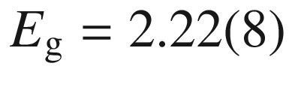

 eV and

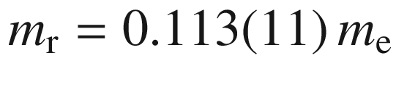

. The *dashed lines* indicate the confidence interval of

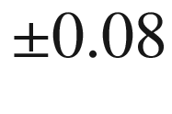

 eV. Adapted from [921]. **b** Burstein–Moss effect in ITO (indium-tin-oxide) versus the ’optical’ carrier density determined from the position of the plasma edge. The *dashed line* is guide to the eye.

Data from [922]

#### 9.9.3 Inter-Valenceband Transitions

Transitions within the valence band can occur between three bands, i.e. lh

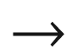

hh, so

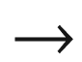

hh, and so

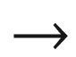

lh, as schematically depicted in Fig. [9.45](#u116076_4_En_9_Chapter-Fig45). Theoretical treatments have been given in [923, 924]. For GaAs, such intravalence-band absorption occurs at photon energies close to

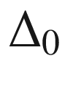

as shown in Fig. [9.46](#u116076_4_En_9_Chapter-Fig46)a for p-type GaAs:Zn [925]. For p-type GaSb, the absorption coefficient below the fundamental band gap is found almost entirely due to inter-valence band transitions, as shown in Fig. [9.46](#u116076_4_En_9_Chapter-Fig46)b for a hole concentration of

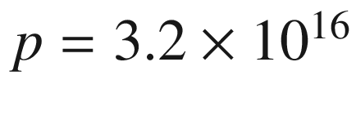

 cm



 [926].

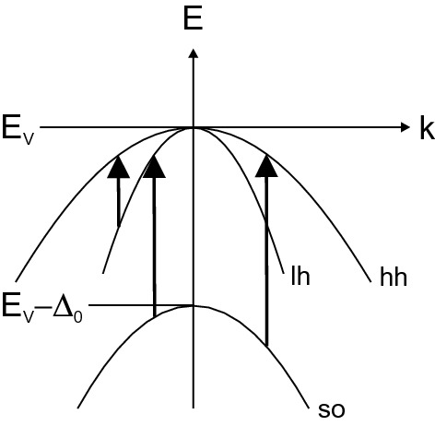

Fig. 9.45

Schematic optical transitions within the valence band

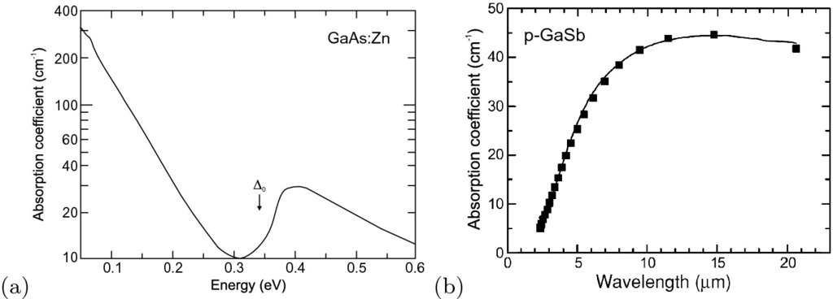

Fig. 9.46

**a** Optical absorption spectrum of GaAs:Zn with

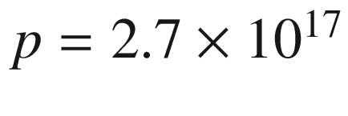

 cm

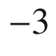

at

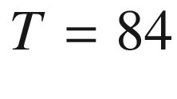

 K. The absorption above the split-off energy

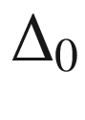

is due to the hh/lh

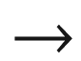

s-o process. Adapted from [925]. **a** Optical absorption coefficient of GaSb with

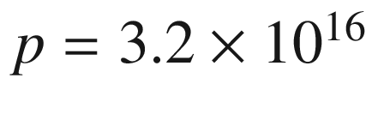

 cm



. Experimental data (*solid line*) and calculation of inter-valence band contribution (*squares*). The free carrier contribution is less than 5 cm

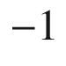

in the considered spectral range.

Adapted from [926]

#### 9.9.4 Inter-Valley Transitions

Electrons at the conduction band minimum can undergo optical transitions to the same band at a different point of the Brillouin zone. Such intervalley transition, as sketched in Fig. [9.47](#u116076_4_En_9_Chapter-Fig47)a, is phonon-assisted to fulfill momentum conservation and occurs around the energy difference

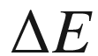

between the two valleys (cmp. Table [8.​4](The_Physics_of_Semiconductors00004.docx#u116076_4_En_8_Chapter-Tab4)).

For InP with an electron concentration of

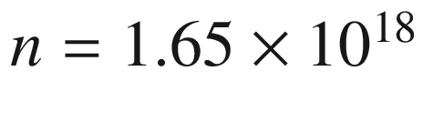

 cm

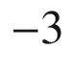

, below the fundamental band edge at 1.4 eV, an additional contribution starting around 0.8–0.9 eV is found besides the free carrier absorption (Fig. [9.47](#u116076_4_En_9_Chapter-Fig47)b) [927]. Taking into account the filling of the bottom of the conduction band, an energy separation for the two valleys of

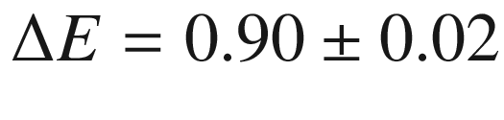

 eV was found for various values of the electron concentrations. This energy corresponds to the energy difference of conduction band minima at

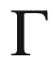

and X in InP. The lineshape of this absorption processes can be modeled and fits well the difference of measured absorption and extrapolated free-carrier absorption spectra. Transitions to the lower minimum at L (

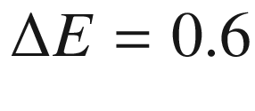

 eV) are not observed, possibly masked by the free-carrier absorption.

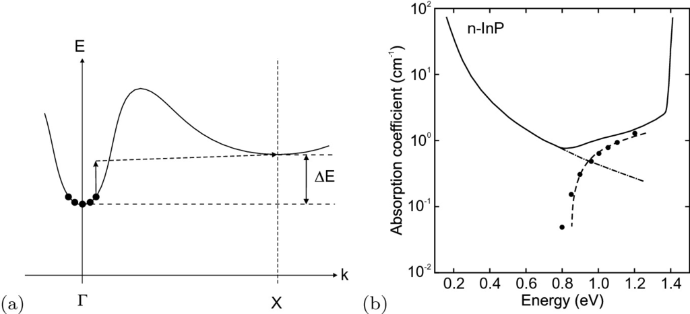

Fig. 9.47

**a** Schematic of inter-valley conduction band transitions involving a photon (*solid line arrow*) and a phonon (*dashed line arrow*). **b** Optical absorption coefficient of InP with

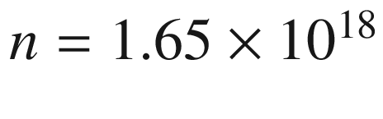

 cm

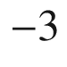

. Experimental data (*solid line*) and calculation of inter-valley band contribution (*dashed line*). The extrapolated free carrier contribution is shown as *dash-dotted line* and the difference of experimental absorption and extrapolated free carrier contribution as *circles*.

Adapted from [927]

#### 9.9.5 Intra-Band Transitions

Phonon-assisted transitions within the lowest conduction band (not to a different valley), as indicated schematically in Fig. [9.48](#u116076_4_En_9_Chapter-Fig48)a for the SnO



band structure [928], can cause absorption at photon energies below the fundamental absorption edge. Actually in SnO



, the optical transition across the fundamental band gap is only weakly dipole-allowed and leads to small absorption coefficient below 100 cm

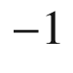

directly above the fundamental band gap of about 3.6 eV. The strong dipole-allowed transition with absorption coefficient around

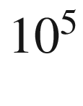

 cm

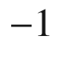

begins at about 4.3 eV and stems from electrons in a lower valence band [929]. The free-carrier absorption due to transitions within the lowest conduction band are calculated to dominate below 2.8 eV (Fig. [9.48](#u116076_4_En_9_Chapter-Fig48)b) and thus can also impact transparency in the visible spectral range. The calculated slope is close to

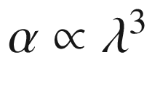

(cmp. ([9.75](#u116076_4_En_9_Chapter-Equ78))), expected from the linear dispersion of the conduction band away from the



-point [928]. A similar effect with the contribution of inter-band and intra-band transitions leading to absorption within the band gap transparency regime has been calculated for Ga



O



as shown in Fig. [9.49](#u116076_4_En_9_Chapter-Fig49) for various doping levels [930].

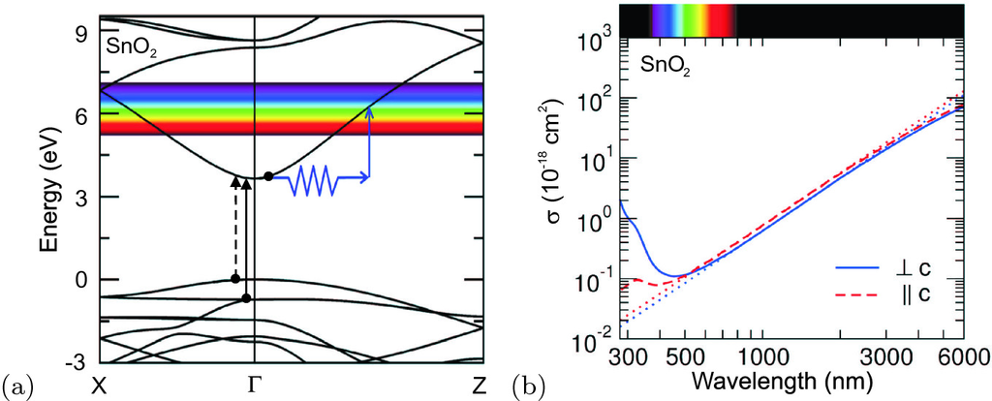

Fig. 9.48

**a** Band structure of SnO



and indirect intra-band absorption process; the transition from the topmost valence band (*dashed arrow*) is forbidden. **b** Calculated free-carrier absorption(

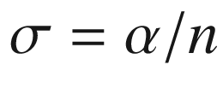

) for SnO



. The *solid* and *dashed lines* are results including phonon-assisted transitions for two light polarizations. The *dotted lines* are fits of the Drude model to the infrared regime.

Adapted from [928]

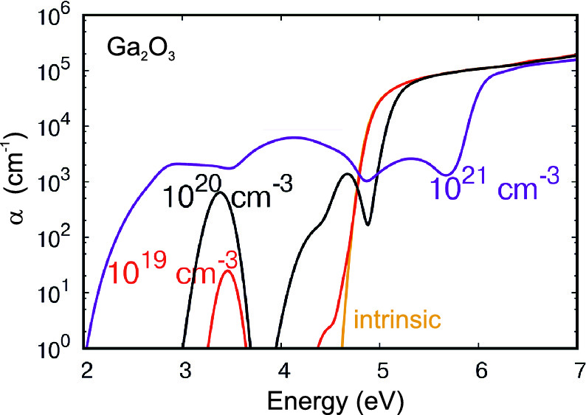

Fig. 9.49

Calculated room temperature absorption coefficient Ga



O



as a function of energy (for light polarized along the *z* direction) for undoped/intrinsic material and three different electron concentrations as labelled.

Adapted from [930]

### 9.10 Lattice Absorption

Due to the lack of a dipole moment of the optical phonons, no first order interaction of optical phonons and (infrared) light exists in the diamond structure for Si and Ge due to crystal structure symmetry [931]. However, higher order processes contribute to lattice absorption in these materials [932, 933]. E.g., two-photon bands are due to a dipole moment that is of second order in the nuclear displacement. Strong absorption effects are present for compound semiconductors. A review can be found in [934].

#### 9.10.1 Dielectric Constant

The (relative) dielectric constant (with damping parameter

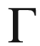

) in the vicinity of the optical phonon energies is given by (cf. ([9.27](The_Physics_of_Semiconductors00004.docx#u116076_4_En_9_Chapter-Equ27)))

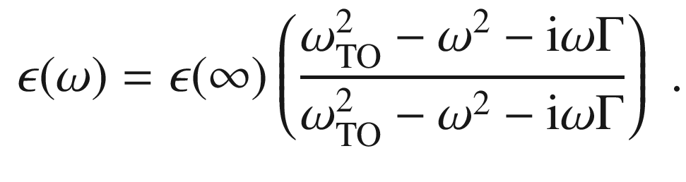

(9.84)

The dispersion relation (without damping) can be rewritten as

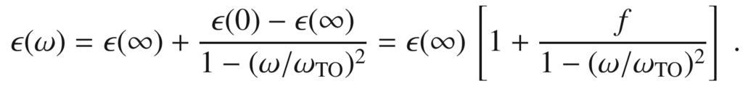

(9.85)

Thus the dimensionless oscillator strength (compare with (D.10)) is

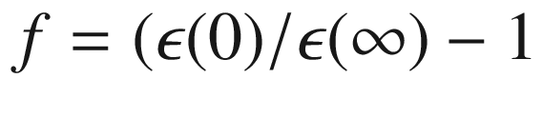

. With the LST relation ([9.26](The_Physics_of_Semiconductors00004.docx#u116076_4_En_9_Chapter-Equ26)) the oscillator strength is

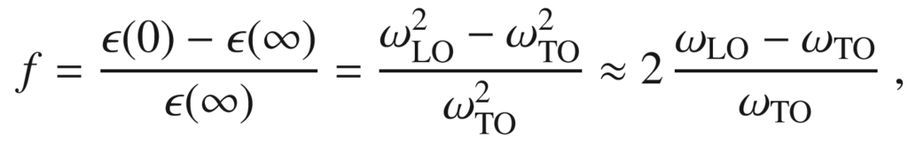

(9.86)

and thus proportional to the splitting

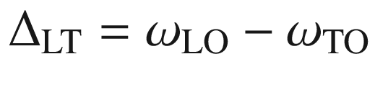

between the longitudinal and transverse optical phonon frequency. The approximation in ([9.86](#u116076_4_En_9_Chapter-Equ89)) is valid for

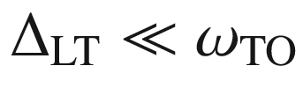

.

The oscillator strength increases with the ionicity, i.e. the electronegativity difference of the atoms in the base (Fig. [9.50](#u116076_4_En_9_Chapter-Fig50)). Additionally, the oscillator strength depends on the reduced mass and the high-frequency polarizability; this can be seen, e.g., for the series of the Zn compounds that all have similar ionicity. For the series of the nitrides, the mass effect is small since the reduced mass is dominated by the light N mass. We refer to Fig. [5.​23](The_Physics_of_Semiconductors00002.docx#u116076_4_En_5_Chapter-Fig23) for the change of phonon oscillator strength in an (Al,Ga)N alloy.

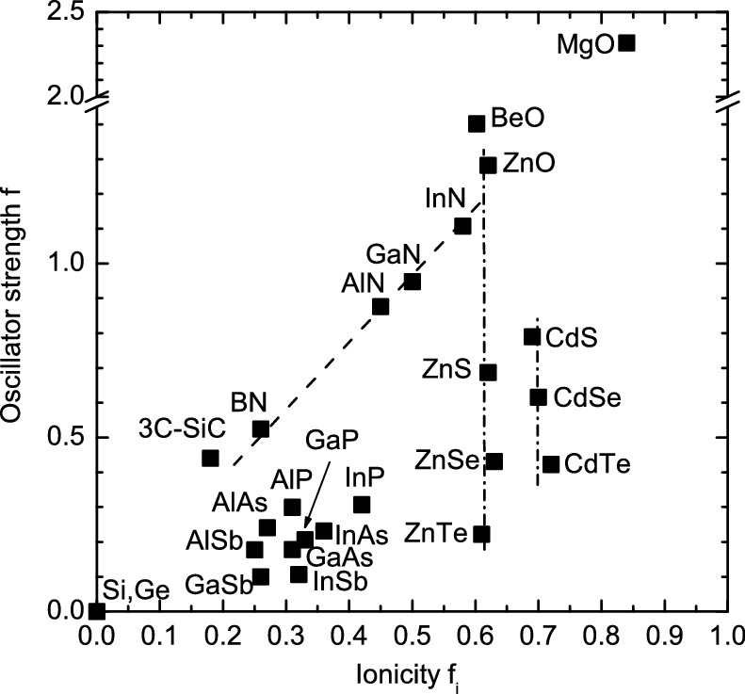

Fig. 9.50

Lattice absorption oscillator strength *f* from ([9.86](#u116076_4_En_9_Chapter-Equ89)) for various elemental, III–V and II–VI semiconductors as a function of their ionicity

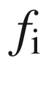

(cf. Table [2.​1](The_Physics_of_Semiconductors00001.docx#u116076_4_En_2_Chapter-Tab1)). *Dashed line* is linear dependence on ionicity for similar (reduced) mass, *dash-dotted lines* are guides to the eye for similar ionicity and varying mass

#### 9.10.2 Reststrahlenbande

The absorption of electromagnetic radiation by optical phonons is governed by the dielectric function that has been derived in ([9.84](#u116076_4_En_9_Chapter-Equ87)). For small damping, i.e.

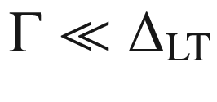

, the dielectric constant is negative between

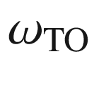

and

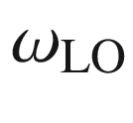

. From

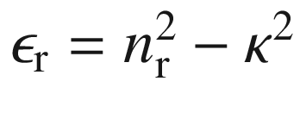

it follows that

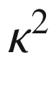

is much larger than

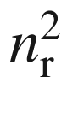

. Therefore, the reflectance ([9.17](The_Physics_of_Semiconductors00004.docx#u116076_4_En_9_Chapter-Equ17)) will be close to 1. This energy range is the so-called *reststrahlenbande*. This term stems from multiple reflections in this wavelength regime that suppresses neighboring spectral regions and thus achieves a certain monochromatization in the far-infrared spectral region. Within the semiconductor the absorption is large in the reststrahlenbande (Fig. [9.51](#u116076_4_En_9_Chapter-Fig51)).

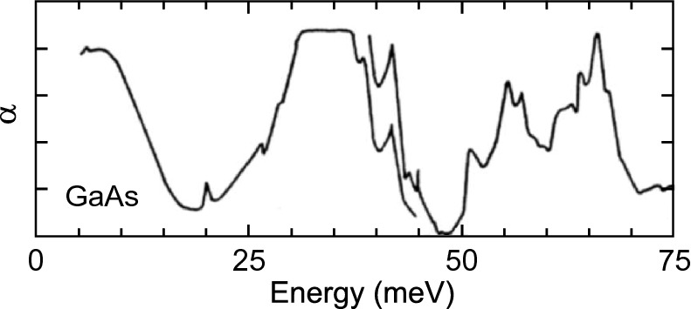

Fig. 9.51

Far-infrared absorption (linear scale) of GaAs. In the region around 35 meV is the reststrahlenbande with high absorption due to optical phonons. The sharp little peak at 45 meV is a LVM, probably from Al

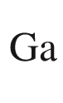

.

Adapted from [935]

#### 9.10.3 Polaritons

The coupled propagation of phonons and electromagnetic radiation is (without phonon damping) related to the dielectric function given in ([9.27](The_Physics_of_Semiconductors00004.docx#u116076_4_En_9_Chapter-Equ27)),

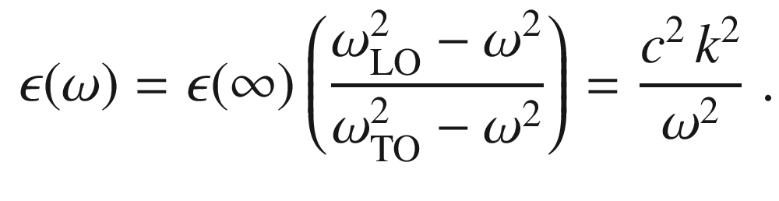

(9.87)

There are two branches of propagating waves (real *k*):

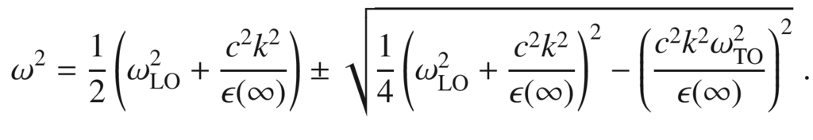

(9.88)

For

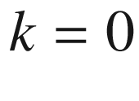

we find the solutions

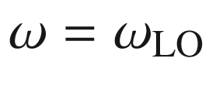

and

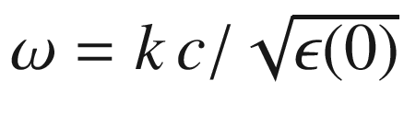

. For large *k* we find

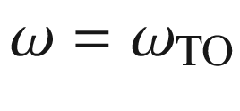

and

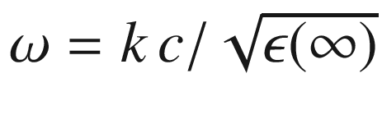

. These solutions are shown in Fig. [9.52](#u116076_4_En_9_Chapter-Fig52). Both branches have a phonon- and a photon-like part. The coupled state between the phonon and the photon field is called the (phonon-) polariton.

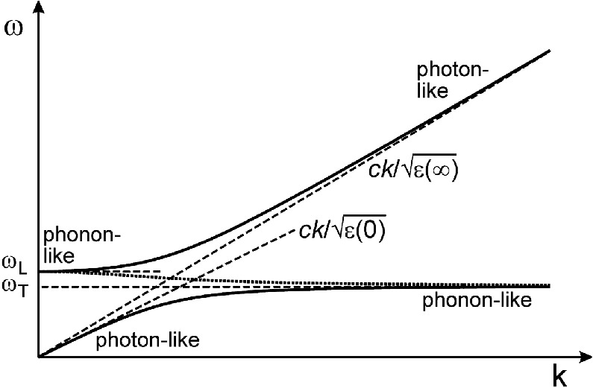

Fig. 9.52

Dispersion of the polariton. The *dotted line* displays the dispersion for a purely imaginary wavevector with the absolute value *k*

In the interval

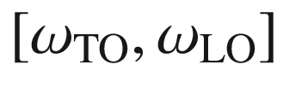

the wavevector is purely imaginary, i.e.

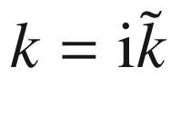

with real

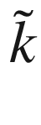

. For this case there is only one solution that is also depicted in Fig. [9.52](#u116076_4_En_9_Chapter-Fig52),

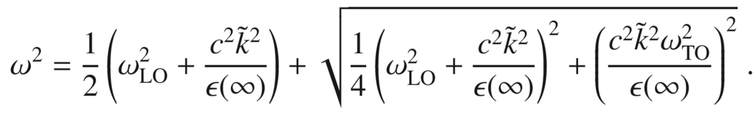

(9.89)

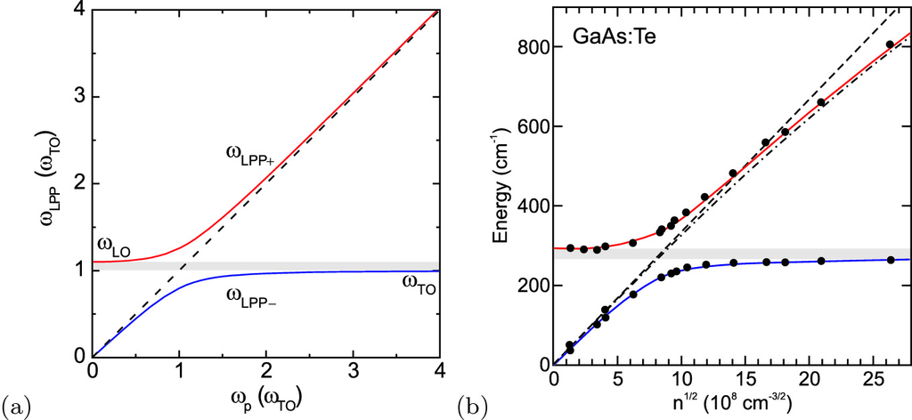

Fig. 9.53

**a** Frequency of the coupled longitudinal-phonon plasmon (LPP) modes (lower (upper) polariton branch in *blue* (*red*)) as a function of the plasma frequency. *Dashed line* shows uncoupled plasmon frequency (

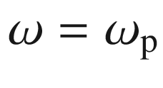

), *grey area* indicates spectral region between TO and LO modes. **b** Experimental data on the polariton energies in n-type GaAs with different carrier concentration

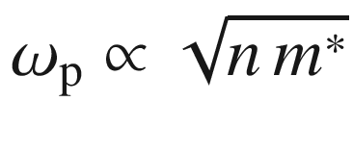

([9.77](#u116076_4_En_9_Chapter-Equ80)). *Dashed* (*dash-dotted*) *line* is plasmon frequency

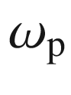

without (with) consideration of conduction band non-parabolicity (cf. Fig. [6.​37](The_Physics_of_Semiconductors00003.docx#u116076_4_En_6_Chapter-Fig37)b). Data from [918, 936]

#### 9.10.4 Phonon–Plasmon Coupling

The coupling of phonons and plasmons in the spectral region of the reststrahlenbande leads to the development of two new branches, the longitudinal phonon plasmon modes (LPP

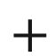

and LPP−), in the common dispersion. The dielectric function is

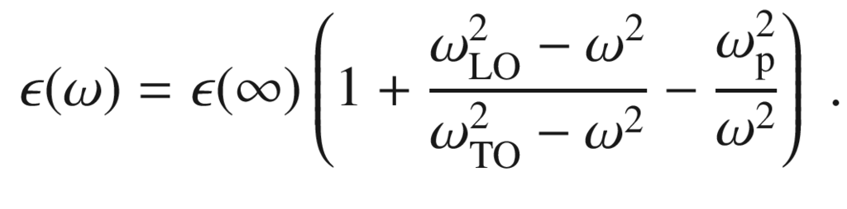

(9.90)

For

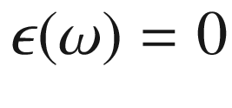

for



(coupling to photons) the two solutions

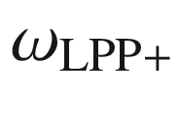

and

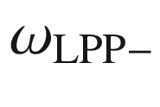

do not cross as a function of

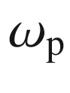

(Fig. [9.53](#u116076_4_En_9_Chapter-Fig53)),

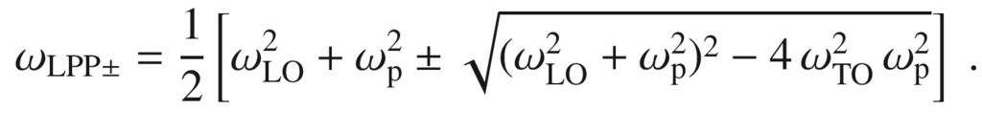

(9.91)

For small plasma frequencies

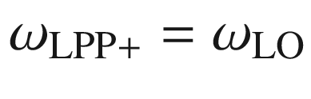

, i.e. the optical phonons couple to the electromagnetic field without change. Also

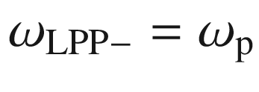

. For large carrier density, i.e.

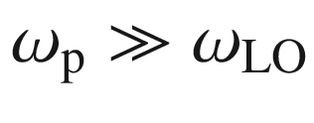

, we find

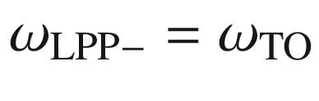

and

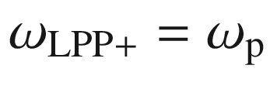

. Thus, the carriers have effectively screened the electric field of the phonon that had led to the increase of the TO to the LO frequency.

Footnotes

[1](The_Physics_of_Semiconductors00004.docx#u116076_4_En_9_Chapter-Fn1_source)

The more exact numerical value in ([9.1](The_Physics_of_Semiconductors00004.docx#u116076_4_En_9_Chapter-Equ1)) is 1239.84.

[2](The_Physics_of_Semiconductors00004.docx#u116076_4_En_9_Chapter-Fn2_source)

In [836], the absorption coefficient

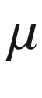

was defined via

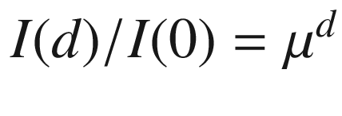

, i.e.

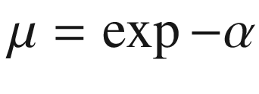

.

[3](The_Physics_of_Semiconductors00004.docx#u116076_4_En_9_Chapter-Fn3_source)

Here we assume that the valence-band states are filled and the conduction-band states are empty. If the conduction-band states are filled and the valence-band states are empty, the rate is that of stimulated emission.

[4](The_Physics_of_Semiconductors00004.docx#u116076_4_En_9_Chapter-Fn4_source)

The real and imaginary parts of the dielectric function are generally related to each other via the Kramers–Kronig relations.

[5](The_Physics_of_Semiconductors00004.docx#u116076_4_En_9_Chapter-Fn5_source)

A flat optical phonon dispersion is assumed.

[6](The_Physics_of_Semiconductors00004.docx#u116076_4_En_9_Chapter-Fn6_source)

Cf. ([7.​22](The_Physics_of_Semiconductors00003.docx#u116076_4_En_7_Chapter)); an electron bound to a donor can be considered as an exciton with an infinite hole mass.

[7](The_Physics_of_Semiconductors00004.docx#u116076_4_En_9_Chapter-Fn7_source)

Such parameter can be directly determined from spectroscopic broadening (as in [868]) or a time-resolved measurement of the decay of the coherent polarization (four-wave mixing) as in [869]. In the latter, the decay constant of the dephasing

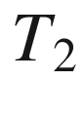

is related to the decay constant



of the FWM-signal by

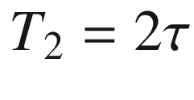

for homogeneous broadening. The Fourier transform of

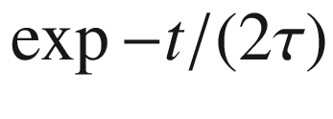

is a Lorentzian of the type

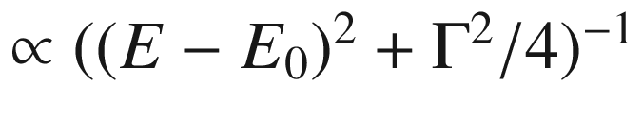

with

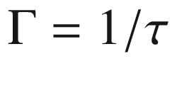

being the FWHM.

[8](The_Physics_of_Semiconductors00004.docx#u116076_4_En_9_Chapter-Fn8_source)

The dependence of the optical-phonon energies on *k* is typically too small to make spatial dispersion effects important. According to ([5.​19](The_Physics_of_Semiconductors00002.docx#u116076_4_En_5_Chapter))

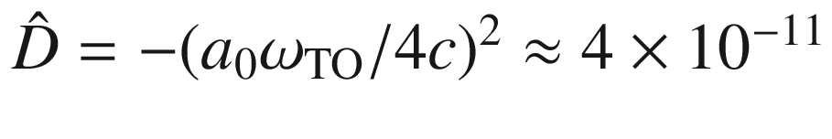

for typical material parameters (lattice constant

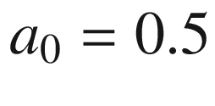

 nm, TO phonon frequency

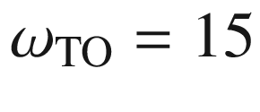

 THz).

[9](The_Physics_of_Semiconductors00004.docx#u116076_4_En_9_Chapter-Fn9_source)

The A line is due to excitons with

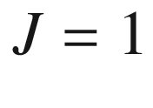

, resulting of coupling of the electron spin 1/2 with the hole angular momentum of 3/2. The B-line is a dipole forbidden line due to ‘dark’ excitons with

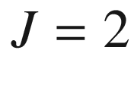

.

[10](The_Physics_of_Semiconductors00004.docx#u116076_4_En_9_Chapter-Fn10_source)

Also the recombination (Sect. [10.​3.​2](#u116076_4_En_10_Chapter)) is efficient and allows green GaP:N and yellow GaAsP:N light emitting diodes.

[11](#u116076_4_En_9_Chapter-Fn11_source)

Even at low temperature,

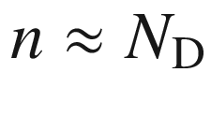

since

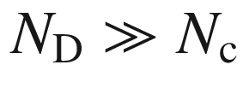

(cf. [594] and Sect. [7.​5.​7](The_Physics_of_Semiconductors00003.docx#u116076_4_En_7_Chapter)).

[12](#u116076_4_En_9_Chapter-Fn12_source)

The much higher free-electron density in metals shifts the plasma frequency to the UV, explaining the reflectivity of metals in the visible and their UV transparency.

[13](#u116076_4_En_9_Chapter-Fn13_source)

CdO is an indirect semiconductor, the optical band gap is the energy of the direct transition at the

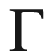

-point, typically obtained from extrapolation in the

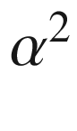

versus energy plot. The indirect transitions involve holes from other points in the Brillouin zone (cmp. Fig. [6.​13](The_Physics_of_Semiconductors00003.docx#u116076_4_En_6_Chapter-Fig13)).

© Springer Nature Switzerland AG 2021

M. Grundmann

The Physics of Semiconductors

Graduate Texts in Physics

<https://doi.org/10.1007/978-3-030-51569-0_10>

## 10. Recombination

Marius Grundmann[1](#u116076_4_En_10_Chapter-Aff11)

(1)

Felix Bloch Institute for Solid State Physics, Universität Leipzig, Leipzig, Germany

Marius Grundmann

Email:

[grundmann@physik.uni-leipzig.de](mailto:grundmann@physik.uni-leipzig.de)

*Les hommes discutent, la nature agit.*

*Men argue, nature acts.*

*Voltaire*

## Abstract

The various mechanisms and statistics of carrier recombination in semiconductors including band-band, excitonic, band-impurity (Shockley-Read-Hall kinetics) and Auger recombination are explained. Also recombination at extended defects and surfaces is treated. Using the diffusion-recombination theory, the one-dimensional carrier profiles for typical situations in experiments and devices are derived.

### 10.1 Introduction

In thermodynamic nonequilibrium excess charges can be present in the semiconductor. They can be created by carrier injection through contacts, an electron beam or the absorption of light with wavelength smaller than the band gap. After the external excitation is turned off, the semiconductor will return to the equilibrium state. The relaxation of carriers into energetically lower states (and energy release) is called recombination. The term stems from the electron recombining with the hole created after absorption of a photon. However, there are other recombination mechanisms. A dedicated textbook is [937].

In the simplest picture an excitation generates carriers with a rate *G* (carriers per unit volume and unit time). In the steady state (after all turn-on effects) a constant excess charge *n* carrier density is present. Then the generation exactly compensates the recombination processes. The principle of detailed balance even says that each microscopic process is balanced by its reverse process. If the time constant of the latter is



, *n* is given by

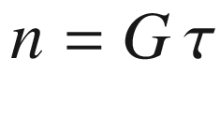

. This follows from the steady-state solution

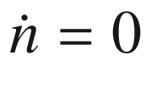

 of

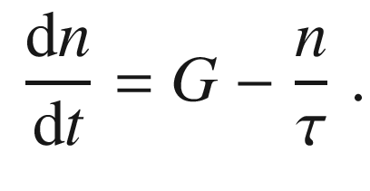

(10.1)

In the literature two limiting cases have been discussed, the *relaxation* and the *lifetime* semiconductor, depending on the relation of two time constants. The one time constant

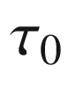

is the relaxation time constant due to recombination as discussed in the following. The smaller

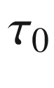

is, the faster excited electrons and holes recombine and ‘disappear’. Fast lifetimes are typically present in direct semiconductors (compared to indirect ones), semiconductors with high defect density and amorphous semiconductors. The other time constant is

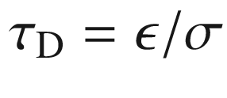

, the dielectric relaxation time; it describes the transport of carriers due to mobility (and diffusion). Large dielectric relaxation times are present in semiconductors with high mobility (low defect density, small carrier mass), small

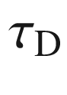

typically for hopping conduction. The relaxation case is given for

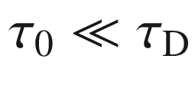

; carriers will recombine quickly and it is hard to build up non-equilibrium carriers and separate them with an applied electric field. In the recombination case

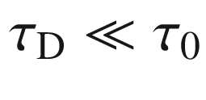

, non-equilibrium carriers can assume non-uniform distributions and an applied electrical field generates separate quasi-Fermi levels for electrons and holes.[1](#u116076_4_En_10_Chapter-Fn1) (cmp. Sect. [7.​6](The_Physics_of_Semiconductors00003.docx#u116076_4_En_7_Chapter)).

### 10.2 Band–Band Recombination

The band–band recombination is the relaxation from an electron in the conduction band into the valence (the empty state there is the hole). In a direct semiconductor, electrons can make an optical transition between the bottom of the conduction band to the top of the valence band. In an indirect semiconductor, this process is only possible with the assistance of a phonon and is thus much less probable.

#### 10.2.1 Spontaneous Emission

We consider the spontaneous recombination of an electron of energy

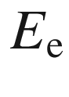

and a hole of energy

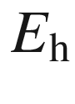

(Fig. [10.1](#u116076_4_En_10_Chapter-Fig1)a).

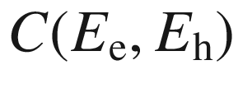

is a constant proportional to the matrix element of the optical transition (cf. Sect. [9.​6](The_Physics_of_Semiconductors00004.docx#u116076_4_En_9_Chapter)). The spontaneous recombination rate

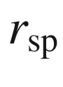

at photon energy

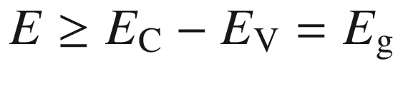

is (assuming energy conservation, i.e.

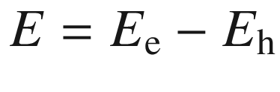

, but without *k*-conservation in a dense plasma [938]),

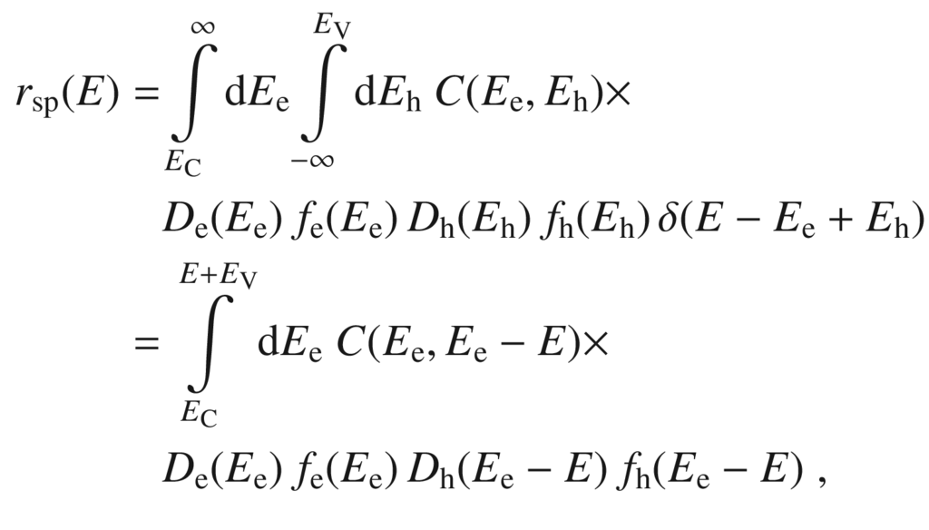

(10.2)

where

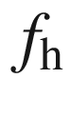

denotes the hole occupation

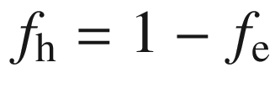

.

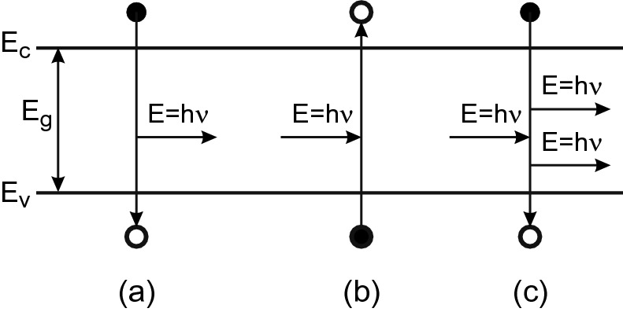

Fig. 10.1

Processes of band–band recombination: **a** spontaneous emission, **b** absorption and **c** stimulated emission. A *full* (*empty*) *circle* represents an occupied (unoccupied) electron state

The lineshape of the band–band recombination with *k*-conservation[2](#u116076_4_En_10_Chapter-Fn2) is proportional to the joint density of states ([9.​42](The_Physics_of_Semiconductors00004.docx#u116076_4_En_9_Chapter)) and the Fermi distribution function. At small excitation and at low doping it can be approximated by the Boltzmann distribution function and the lineshape is given as

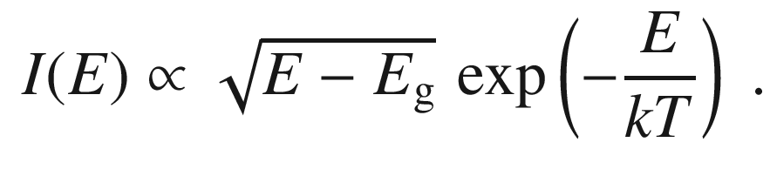

(10.3)

An experimental spectrum is shown in Fig. [10.2](#u116076_4_En_10_Chapter-Fig2) together with a fit according to ([10.3](#u116076_4_En_10_Chapter-Equ3)). The expected FWHM of the peak is

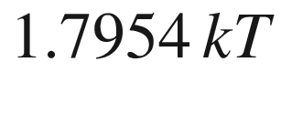

, which is about 46 meV at

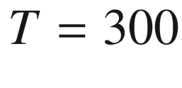

 K. At low sample temperature, the temperature of the carrier gas is typically higher than the lattice temperature, depending on the cooling mechanisms (carrier–carrier scattering, optical phonon emission, acoustic phonon emission, recombination,



) and the excitation rate. The carrier temperature in GaAs, determined from the Boltzmann tail of spontaneous emission (photoluminescence) is depicted in Fig. [10.3](#u116076_4_En_10_Chapter-Fig3) as a function of excitation density; clearly it increases with increasing excitation.

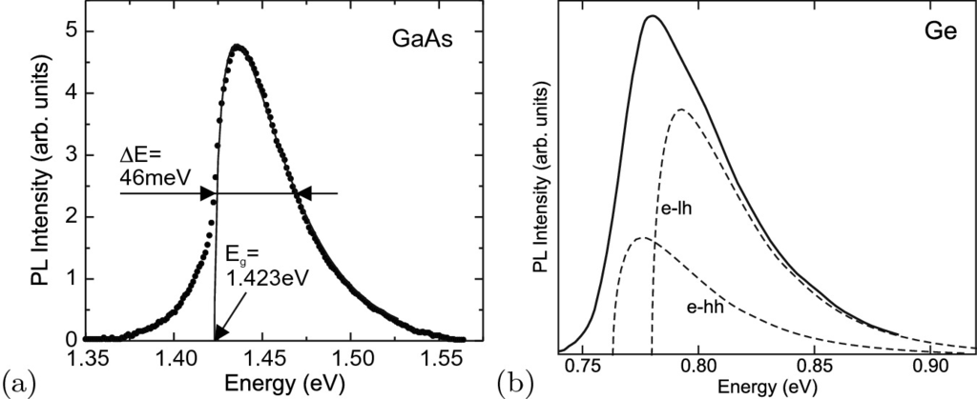

Fig. 10.2

**a** Photoluminescence spectrum of an undoped LPE-grown epitaxial GaAs layer at room temperature and low cw (

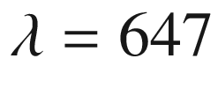

 nm) excitation density (10 W/cm

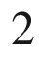

). The *solid line* is a lineshape fit with ([10.3](#u116076_4_En_10_Chapter-Equ3)) and

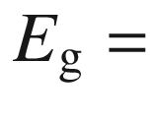

1.423 eV and

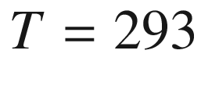

 K. (**b**) Room temperature, direct (e

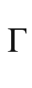

–h

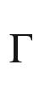

) recombination from heavily n-doped (

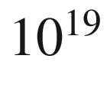

 cm

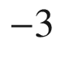

) germanium (1

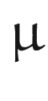

m thick Ge layer on silicon (001)) with biaxial (thermal) tensile strain. The strain-split valence band edge (Fig. [6.​50](The_Physics_of_Semiconductors00003.docx#u116076_4_En_6_Chapter-Fig50)) causes the e–hh and e–lh transitions (individual contributions with lineshape according to ([10.3](#u116076_4_En_10_Chapter-Equ3)) shown as *dashed lines*) to occur at different energies.

Adapted from [939]

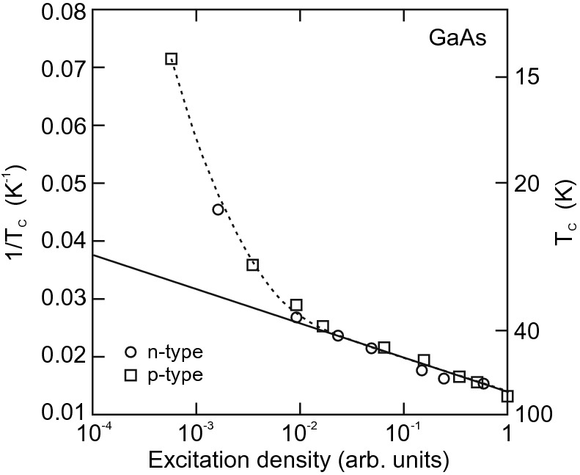

Fig. 10.3

Carrier temperature

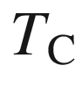

in GaAs as a function of excitation density at a lattice temperature of 1.6 K. The *dashed line* is guide to the eye, the *solid line* corresponds to an activation energy of 33 meV, similar to the GaAs optical phonon energy.

Adapted from [940]

The recombination rate in indirect semiconductors is small since the transition is phonon-assisted. For silicon, an internal quantum efficiency in the

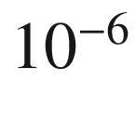

-range has been reported [941]. For germanium, the direct transition is energetically fairly close to the fundamental, indirect L–

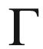

band edge transition (Fig. [9.​15](The_Physics_of_Semiconductors00004.docx#u116076_4_En_9_Chapter-Fig15)). The energy difference can be reduced from its bulk value of 136 meV by tensile strain. Additionally, the direct transition can be favored by heavily n-doping and filling the L conduction band minimum states (see Sect. [9.​9.​2](The_Physics_of_Semiconductors00004.docx#u116076_4_En_9_Chapter)). In this case, direct recombination from the conduction band

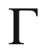

-minimum can be observed [939] and the effective energy difference has been lowered to about 100 meV.

#### 10.2.2 Absorption

A similar consideration is made for the absorption process (Fig. [10.1](#u116076_4_En_10_Chapter-Fig1)b). An electron is transferred upon light absorption from a valence-band state (occupied) to a conduction-band state that must be empty. The coefficient is

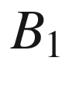

. Also, the process is proportional to the light intensity, represented by the density of occupied photon states

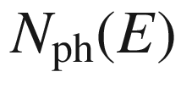

,

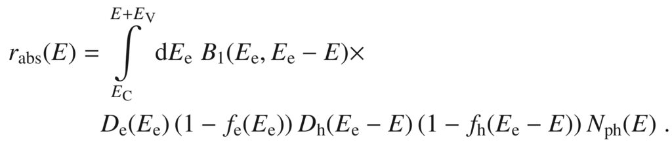

(10.4)

#### 10.2.3 Stimulated Emission

In this case, an incoming photon ‘triggers’ the transition of an electron in the conduction band into an empty state in the valence band. The emitted photon is in phase with the initial photon (Fig. [10.1](#u116076_4_En_10_Chapter-Fig1)c). The rate is (with coefficient

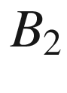

):

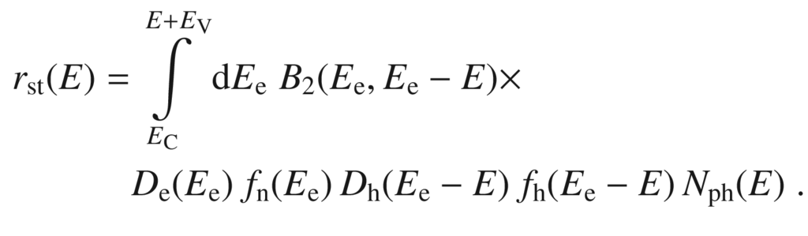

(10.5)

The photon density

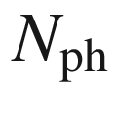

at a given energy is given by Planck’s law and the Bose–Einstein distribution (Appendix E)

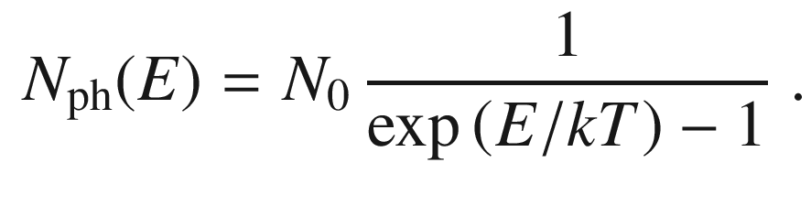

(10.6)

The pre-factor is the density of states of the electromagnetic field[3](#u116076_4_En_10_Chapter-Fn3)

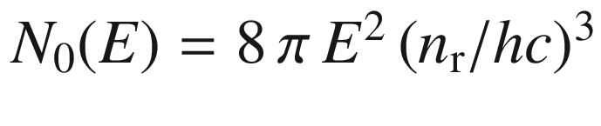

.

#### 10.2.4 Net Recombination Rate

In thermodynamical equilibrium the rates fulfill

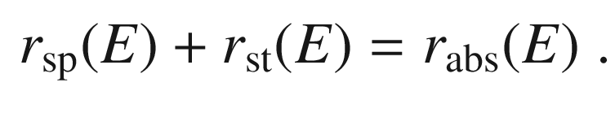

(10.7)

Since for absorption and stimulated emission the same quantum-mechanical matrix element is responsible,

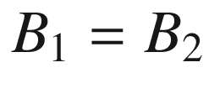

. If the population functions are Fermi-Dirac distributions with quasi-Fermi levels

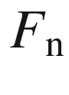

and

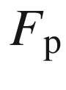

(Sect. [7.​6](The_Physics_of_Semiconductors00003.docx#u116076_4_En_7_Chapter)), the detailed balance ([10.7](#u116076_4_En_10_Chapter-Equ7)) yields

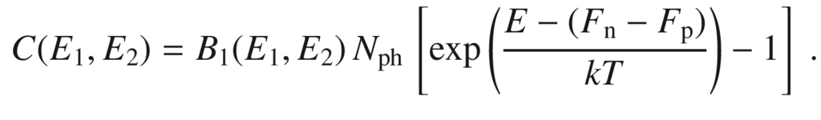

(10.8)

In thermodynamic equilibrium, i.e.

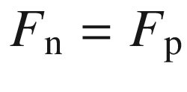

,

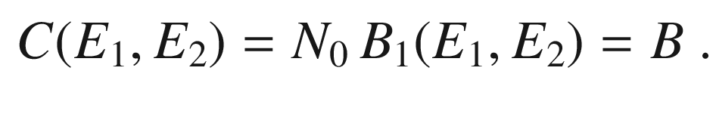

(10.9)

If the constant *B*, the bimolecular recombination coefficient,  is independent of the energy *E*, the integration for the net bimolecular recombination rate

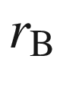

 can be executed analytically and we find

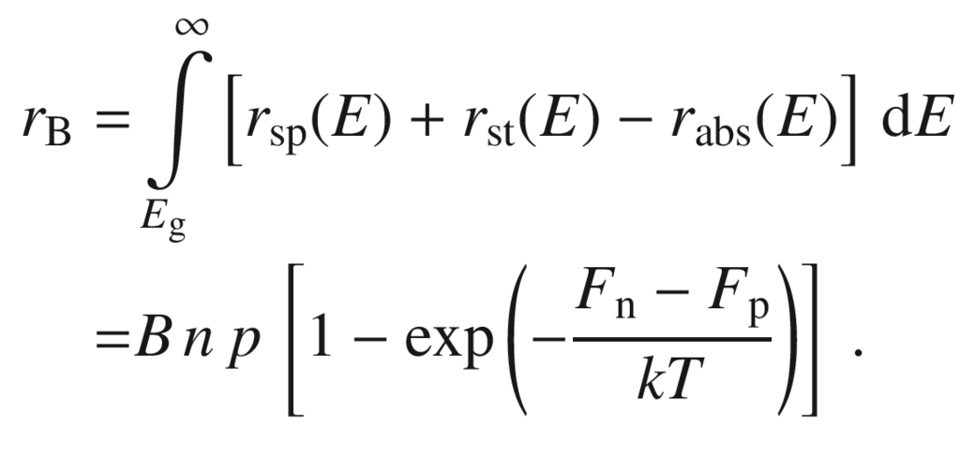

(10.10)

In thermodynamic equilibrium, of course,

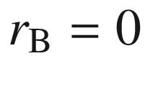

. The recombination rate *Bnp* is then equal to the thermal generation rate

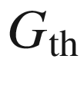

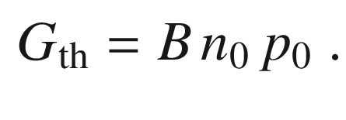

(10.11)

The bimolecular recombination rate typically used in Shockley–Read–Hall (SRH) [942, 943] kinetics is

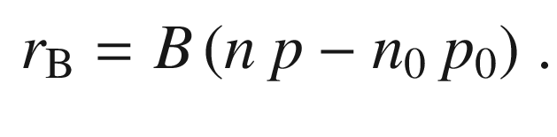

(10.12)

Values for the coefficient *B* are given in Table [10.1](#u116076_4_En_10_Chapter-Tab1). In the case of carrier injection, *np* is larger than in thermodynamical equilibrium, i.e.

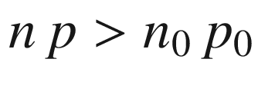

, and the recombination rate is positive, i.e. light is emitted. If the carrier density is smaller than in thermodynamical equilibrium, e.g.. in a depletion region, absorption is larger than emission. This effect is also known as ‘negative luminescence’ [944] and plays a role particularly at elevated temperatures and in the infrared spectral region.Table 10.1

Bimolecular recombination coefficient at room temperature for a number of semiconductors. Data for GaN from [945], Si from [946], SiC from [947], other values from [948]

| Material | *B* (cm  $$^3$$  /s) |
| --- | --- |
| GaN | 1.1  $$\times 10^{-8}$$ |
| GaAs | 1.0  $$\times 10^{-10}$$ |
| AlAs | 7.5  $$\times 10^{-11}$$ |
| InP | 6.0  $$\times 10^{-11}$$ |
| InAs | 2.1  $$\times 10^{-11}$$ |
| 4H-SiC | 1.5  $$\times 10^{-12}$$ |
| Si | 1.1  $$\times 10^{-14}$$ |
| GaP | 3.0  $$\times 10^{-15}$$ |

#### 10.2.5 Recombination Dynamics

The carrier densities *n* and *p*, are decomposed into the densities

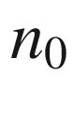

and

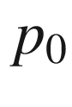

in thermodynamic equilibrium  and the excess-carrier densities

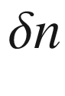

and

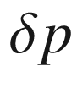

, respectively

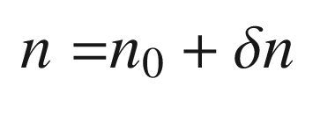

(10.13a)

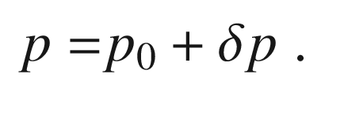

(10.13b)

Here, only neutral excitations are considered, i.e.

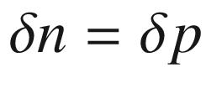

. Obviously the time derivative fulfills

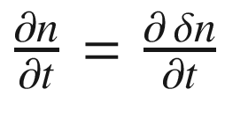

, and correspondingly for the hole density. The equation for the dynamics



(10.14)

can be written as

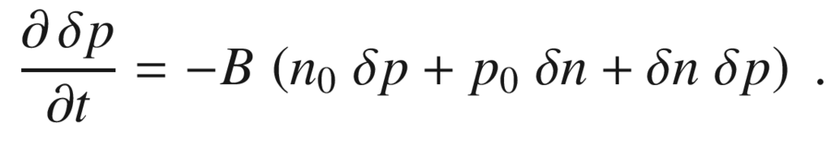

(10.15)

The general solution of ([10.15](#u116076_4_En_10_Chapter-Equ16)) is given by

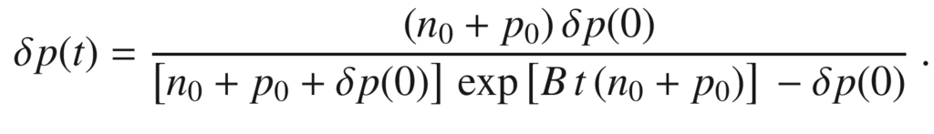

(10.16)

In the following, we discuss some approximate solutions of ([10.15](#u116076_4_En_10_Chapter-Equ16)). First, we treat the case of a small (neutral) excitation, i.e.

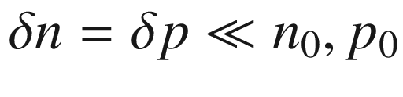

. The dynamic equation is in this case

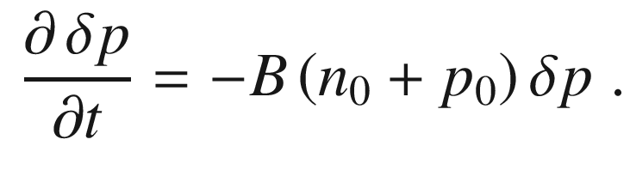

(10.17)

Then the decay of the excess-carrier density is exponential with a time constant (lifetime)



given by

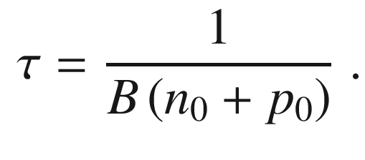

(10.18)

In an n-type semiconductor additionally

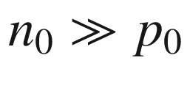

, and thus the minority carrier lifetime

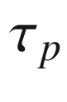

 is

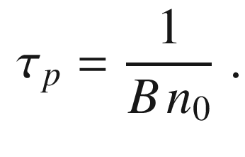

(10.19)

If the nonequilibrium carrier densities are large, i.e.

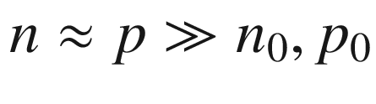

, e.g. for strong injection, the kinetics obeys

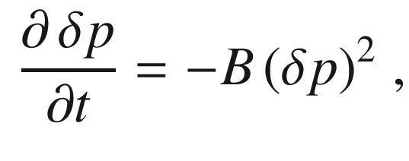

(10.20)

and the transient has the form

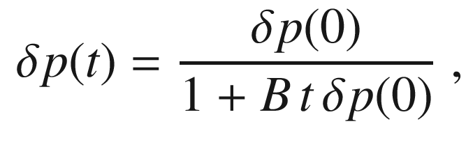

(10.21)

where

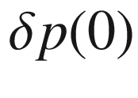

is the excess hole density at time

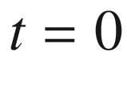

. Such a decay is called *hyperbolic* and the recombination is bimolecular. The exponential decay time is formally

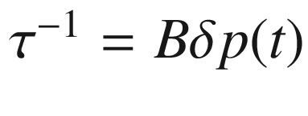

and is thus time and density dependent. A detailed discussion of minority carrier lifetime is given in [949].

#### 10.2.6 Lasing

The net rate for stimulated emission and absorption is

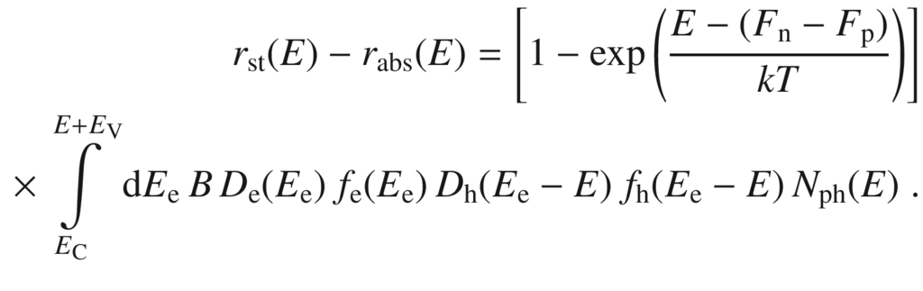

(10.22)

The net rate at photon energy

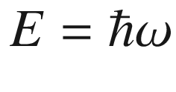

is only larger than zero (i.e. dominating stimulated emission) when

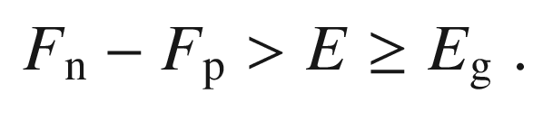

(10.23)

When the difference of the quasi-Fermi levels  is larger than the band gap, the carrier population is inverted, i.e. close to the band edges the conduction-band states are more strongly populated with electrons than the valence-band states, as shown in Fig. [10.4](#u116076_4_En_10_Chapter-Fig4). An incoming optical wave of energy *E* will then be net amplified by stimulated emission. Equation ([10.23](#u116076_4_En_10_Chapter-Equ24)) is also called the thermodynamic laser condition. We note that lasing requires further conditions as discussed in Sect. [23.​4](The_Physics_of_Semiconductors00008.docx#u116076_4_En_23_Chapter).

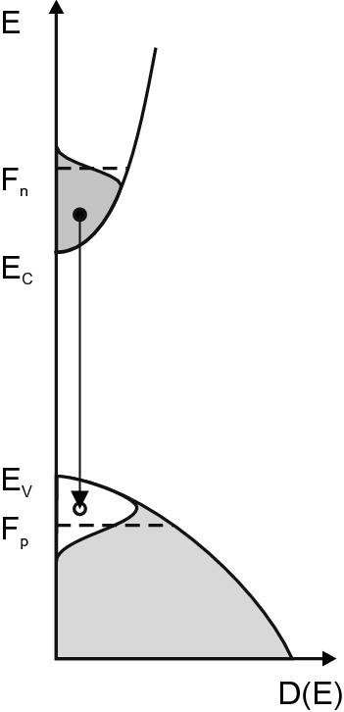

Fig. 10.4

Charge-carrier distribution during inversion, necessary for lasing. *Shaded areas* are populated with electrons. A stimulated transition between an electron and a hole is indicated

### 10.3 Exciton Recombination

#### 10.3.1 Free Excitons

The observation of free-excitons is limited for semiconductors with a small exciton binding energies (such as in GaAs) to low temperatures. However, for large exciton binding energy, recombination from free-excitons is observed even at room temperature, as shown in Fig. [10.5](#u116076_4_En_10_Chapter-Fig5) for ZnO.

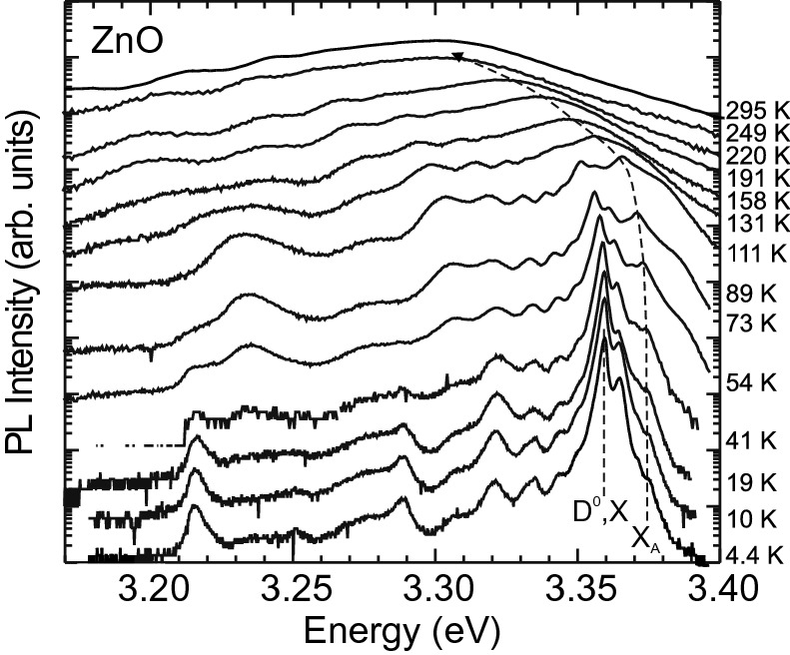

Fig. 10.5

Temperature-dependent luminescence spectra of a ZnO thin film (on sapphire). At low temperatures, the spectra are dominated by donor-bound exciton transitions (Al

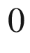

,X)). The *vertical dashed line* indicates the low-temperature position of the donor-bound exciton transition (D

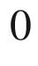

,X). The *curved dashed line* visualizes the energy position of the free-exciton transition (X

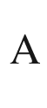

) that becomes dominant at room temperature

A low temperature recombination spectrum of silicon is shown in Fig. [10.6](#u116076_4_En_10_Chapter-Fig6). In pure silicon, phonon-assisted exciton recombination (cmp. Sect. [10.4](#u116076_4_En_10_Chapter-Sec13)) is observed involving acoustic (I

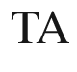

) and optical (I

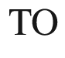

) phonons. The weakly observed no-phonon line (I



) is forbidden in perfect Si.

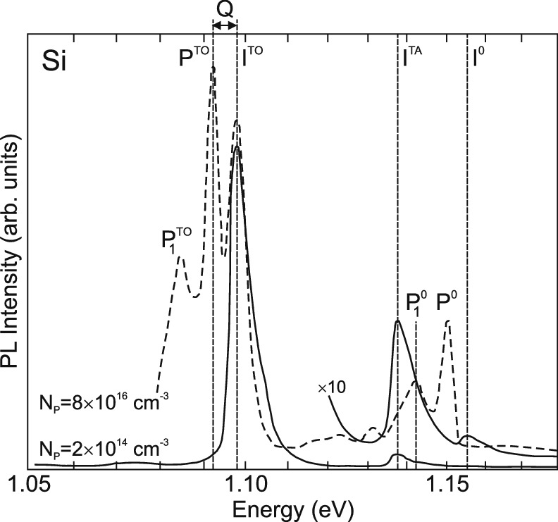

Fig. 10.6

Low temperature recombination spectra from silicon with low (*solid lines*) and sizeable (*dashed line*) phosphorus dopant concentration. Spectrum for

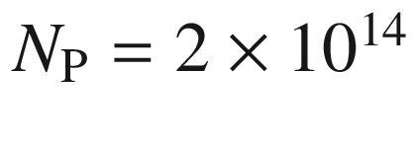

 cm

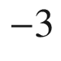

(

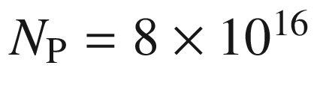

 cm

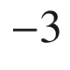

) taken at 26 K (15 K). Transitions in pure Si are label with ‘I’, transitions involving P donors are labeled with ‘P’. *Q* indicates the dissociation energy of the bound exciton.

Adapted from [950]

#### 10.3.2 Bound Excitons

Excitons can localize at impurities, defects or other potential fluctuations and subsequently recombine [951, 952]. Excitons can be bound to neutral or ionized donors and acceptors impurities [953]. Also they can be bound to isoelectronic impurities, the most prominent example being N in GaP [954] (cmp. Sect. [9.​7.​9](The_Physics_of_Semiconductors00004.docx#u116076_4_En_9_Chapter)) or isoelectronic clusters [955]. The recombination of excitons localized in quantum wells (Sect. [12.​4](#u116076_4_En_12_Chapter)) and quantum dots (Sect. [14.​4.​4](The_Physics_of_Semiconductors00006.docx#u116076_4_En_14_Chapter)) is discussed later.

The transition energy

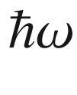

of an exciton bound to a neutral impurity is

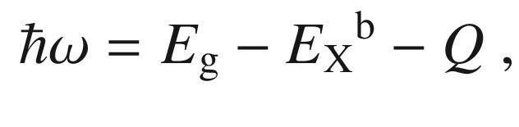

(10.24)

where *Q* is the binding (or localization) energy of the exciton to the impurity. The binding energy of an exciton to an ionized impurity is denoted with

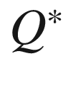

. A transition involving an exciton bound to a neutral donor is denoted (D



,X); correspondingly (D

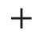

,X), also denoted as (h,D

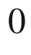

), and (A

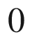

,X). Values for donor-bound excitons in various semiconductors are listed in Table [10.2](#u116076_4_En_10_Chapter-Tab2). The (D

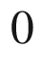

,X) complex is stable for

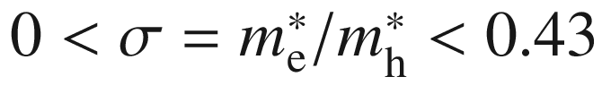

according to [956]. The (D

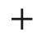

,X) peak can occur on the low- or high-energy side of the (D

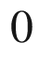

,X) recombination. Whether

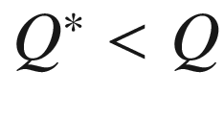

or

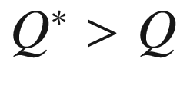

depends on

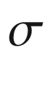

being smaller or larger than 0.2, respectively [956], and is fulfilled for many semiconductors, e.g. GaAs, GaN, CdS, and ZnSe.

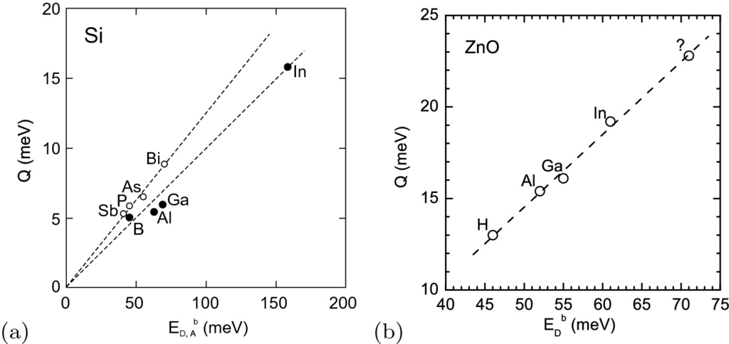

Fig. 10.7

Energy *Q* required to remove an exciton from a neutral impurity ([10.24](#u116076_4_En_10_Chapter-Equ25)) as a function of the ionization energy

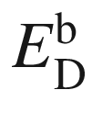

(*open circles*) or

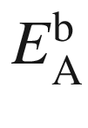

(*solid circles*) of the involved impurity in (**a**) silicon (experimental data from [965]) and (**b**) ZnO (experimental data from [966])

Table 10.2

Localization energy *Q* (

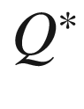

) of excitons on selected impurities (ionized impurities, D

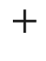

or A

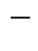

, respectively) in various semiconductors.

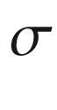

is the ratio of effective electron and hole (polaron) masses. EMD: effective mass donor

| host | donor | *Q* (meV) | $$Q^*$$  (meV) | $$Q^*/Q$$ | $$\sigma $$ | Ref. |
| --- | --- | --- | --- | --- | --- | --- |
| GaAs | $$\begin{array}{l} \mathrm {EMD} \\ \mathrm {Zn} \end{array}$$ | $$\begin{array}{l} 0.88 \\ 8.1 \end{array}$$ | $$\begin{array}{l} 1.8 \\ 31.1 \end{array}$$ | $$\begin{array}{l} 2.0 \\ 3.8 \end{array}$$ | 0.28 | [957] |
| GaN | $$\begin{array}{l} \mathrm {EMD} \\ \mathrm {Mg} \end{array}$$ | $$\begin{array}{l} 6.8 \\ 20 \end{array}$$ | $$\begin{array}{l} 11.2 \\ \text { } \end{array}$$ | $$\begin{array}{l} 1.6 \\ \text { } \end{array}$$ | 0.36 | [959] |
| AlN | $$\begin{array}{l} \mathrm {Si} \\ \mathrm {Mg} \end{array}$$ | $$\begin{array}{l} 16 \\ 40 \end{array}$$ |  |  |  | [960] |
| CdS | EMD | 6.6 | 3.8 | 0.6 | 0.17 | [961] |
|  | Al | 4.9 | 5.4 | 1.1 |  |  |
| ZnSe | Ga | 5.1 | 6.6 | 1.3 | 0.27 | [962, 963] |
|  | In | 5.4 | 7.5 | 1.4 |  |  |
|  | Al | 15.5 | 3.4 | 0.21 |  |  |
| ZnO | Ga | 16.1 | 4.1 | 0.25 | 0.3 | [964] |
|  | In | 19.2 | 8.5 | 0.44 |  |  |

Recombination in silicon due to excitons involving phosphorus donors is depicted in Fig. [10.6](#u116076_4_En_10_Chapter-Fig6). The (D



,X) transition in Si:P is labeled ‘P



’ (

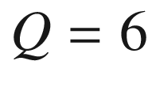

 meV). Other P-related transitions are discussed in [950]. In Si, the binding energy to the impurity is about one tenth of the binding energy of the impurity (Haynes’s rule [951, 965]), i.e.

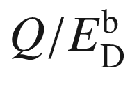

and

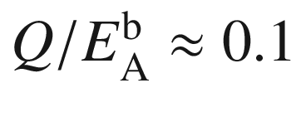

(Fig. [10.7](#u116076_4_En_10_Chapter-Fig7)a). In GaP the approximate relations

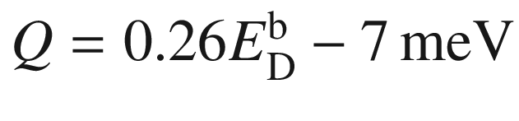

and

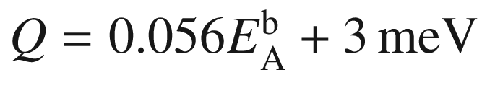

have been found [954]. For donors in ZnO, the relation

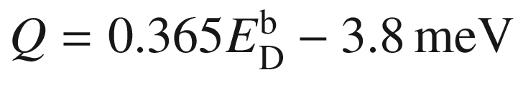

holds (Fig. [10.7](#u116076_4_En_10_Chapter-Fig7)b) [966]. In Fig. [10.8](#u116076_4_En_10_Chapter-Fig8), the recombination spectrum of GaAs:C is shown that exhibits recombination from excitons bound to the acceptor (carbon) and shallow donors. The exciton is more strongly bound to an ionized donor (D

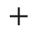

) than to a neutral donor.

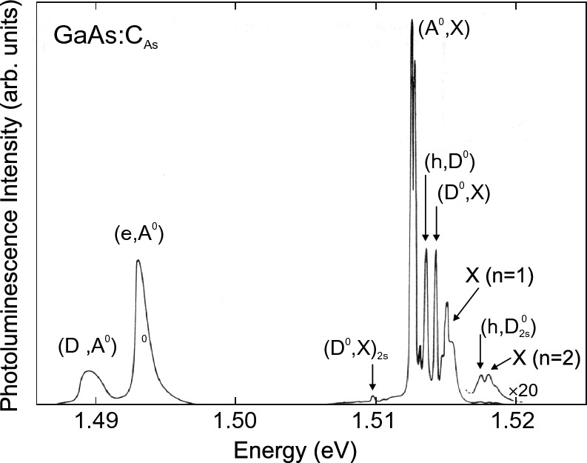

Fig. 10.8

Photoluminescence spectrum (

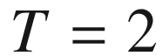

 K,

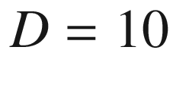

 mW cm

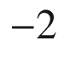

) of GaAs:C

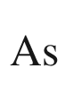

(

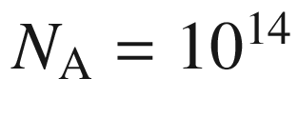

 cm



) with donor- and acceptor-related bound-exciton recombination around 1.512 eV, (e,A



), (h,D



) and (D



,A



) pair and free-exciton recombination.

Adapted from [957]

Varying the concentration of a specific impurity and observing the corresponding change in the intensity of the (D



,X) transition allows to identify the chemical species to which the exciton is bound. This can be achieved via the comparison of different samples or more elegantly by introducing radioactive isotopes. This is shown in Fig. [10.9](#u116076_4_En_10_Chapter-Fig9) for In in ZnO; the (

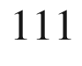

In



,X) transition disappears with the characteristic time constant close to that (97 h) of the nuclear decay of

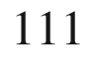

In into stable

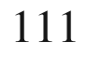

Cd. However, in such experiments it should be considered that the decay product and accompanying high-energy radiation can create new electronic and structural defects, respectively.

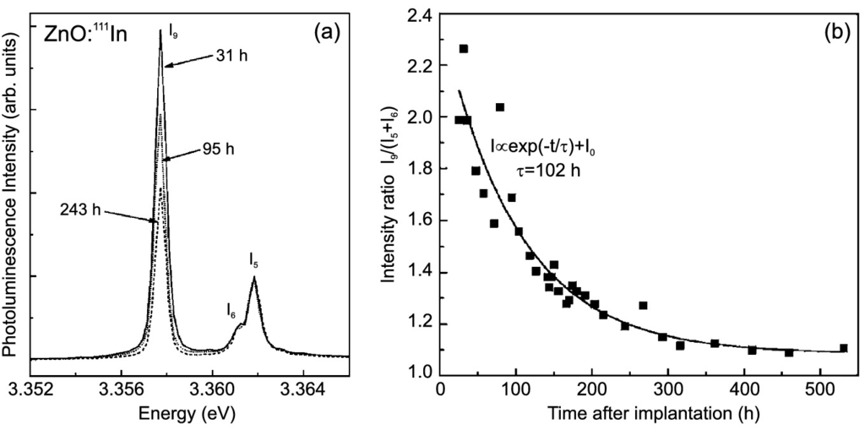

Fig. 10.9

**a** Low-temperature photoluminescence spectrum of ZnO implanted with

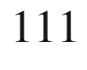

In featuring the so-called I



-line. Spectra are recorded at various times after implantation as labeled. **b** Intensity of I



-line as a function of time.

Adapted from [967]

The peak labeled (D

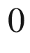

,X)

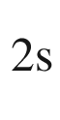

in Fig. [10.8](#u116076_4_En_10_Chapter-Fig8) is called a two-electron satellite (TES) [968]. High-resolution spectra of the TES in GaAs [581, 969] are shown in Fig. [10.10](#u116076_4_En_10_Chapter-Fig10)a. The TES recombination is a (D



,X) recombination that leaves the donor in an excited state as schematically shown in Fig. [10.10](#u116076_4_En_10_Chapter-Fig10)b. Therefore a hydrogen-like series with

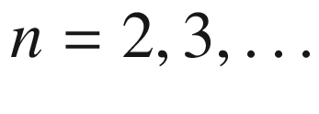

is observed with energies

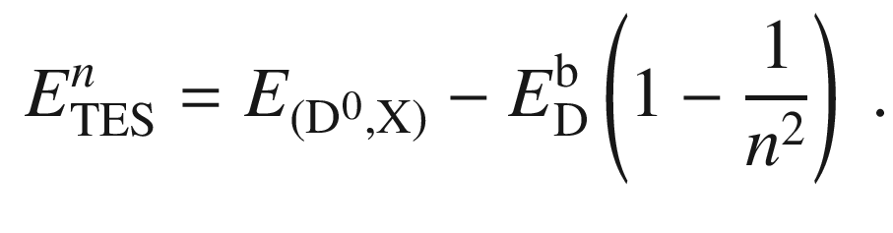

(10.25)

The effect of isotope disorder  on the sharpness and splitting of impurity states has been investigated in [970, 971]. The recombination of excitons bound to Al, Ga and In in natural silicon (92.23%

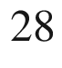

Si, 4.67%

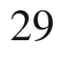

Si, 3.10%

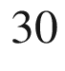

Si) is split into three lines due to the valley-orbit splitting [972] of electron states at the band minimum (Fig. [10.11](#u116076_4_En_10_Chapter-Fig11)). Each of these (A



,X) lines is split by 0.01 cm

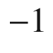

for Si:Al due to a symmetry reduction of the 4-fold degenerate A



ground state, as observed in the presence of applied axial strain or an electric field. The comparison to spectra from enriched

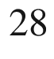

Si shows that the observed splitting without external perturbation is due to isotope disorder that causes random strains and splits the A



ground state into two doublets [971] (Fig. [10.11](#u116076_4_En_10_Chapter-Fig11)). Similarly, the (unsplit) phosphorus-induced (D



,X) transition in enriched Si is found to be much sharper (

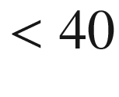



eV) than in natural Si (330

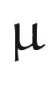

eV) [970]. At higher resolution, a hyperfine splitting of 485 neV due to the

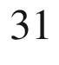

P nuclear spin

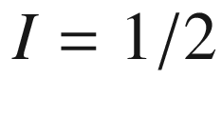

(

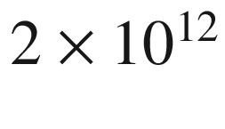

 cm

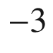

) in isotopically pure (99.991%)

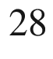

Si (

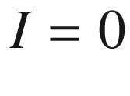

) is observed for the (P



,X) recombination [973]. In a magnetic field, the Zeeman-split lines have a FWHM of about 150 neV.

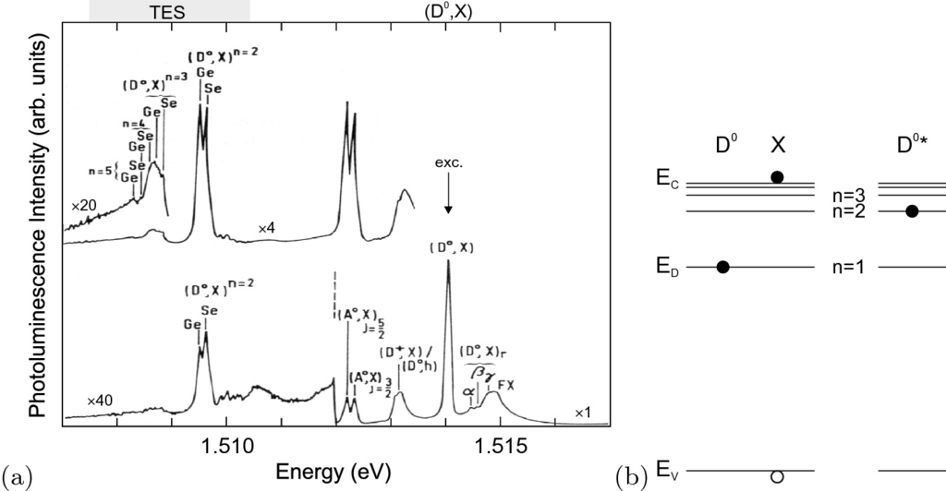

Fig. 10.10

**a** Photoluminescence spectrum (

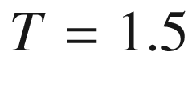

 K,

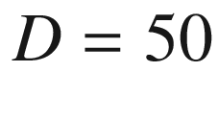

 mW cm

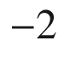

) of high-purity GaAs with two donors (Ge and Se/Sn). The lower spectrum has been excited 6 meV above the band gap, the upper spectrum has been resonantly excited with the laser set to the (D



,X) transition and exhibits

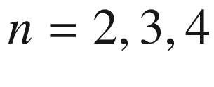

, and 5 TES transitions.

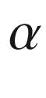

,

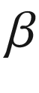

,

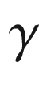

denote excited (hole rotational) states of the (D



,X) complex. Adapted from [969]. **b** Schematic representation of the

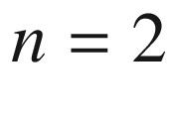

TES process, *left*: initial, *right*: final state

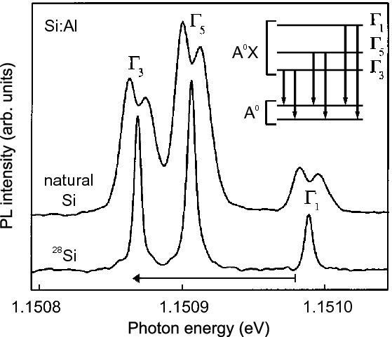

Fig. 10.11

High-resolution photoluminescence (PL) spectra of (A



,X) recombination in natural and



Si-enriched silicon doped with aluminum (

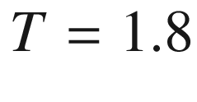

 K). The

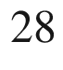

Si PL spectrum is shifted up in energy by 0.114 meV, as indicated by the arrow, to compensate for the shift in band gap. The *inset* shows a level scheme for the recombination in natural silicon.

Adapted from [971], reprinted with permission, ©(2002) APS

In Fig. [10.12](#u116076_4_En_10_Chapter-Fig12) the recombination of excitons bound to the N isoelectronic impurity in lowly doped GaP is shown. The efficient recombination of nitrogen-bound electrons with holes at the

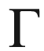

point is due to the wave-function component of the localized electron at

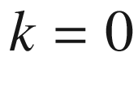

[690] (Fig. [7.​40](The_Physics_of_Semiconductors00004.docx#u116076_4_En_7_Chapter-Fig40)). The decay time of the A exciton is about 40 ns [974] and thus larger than the typical lifetime of excitons in direct semiconductors (ns-range). The forbidden B exciton has a much longer lifetime of 4



s [974].

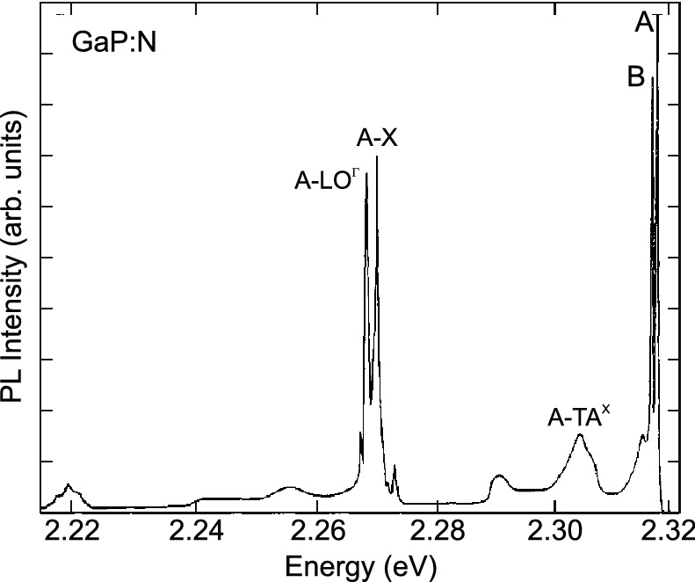

Fig. 10.12

Photoluminescence spectrum (

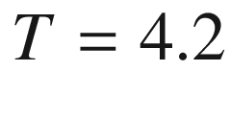

 K) of GaP:N (

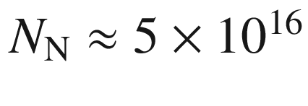

 cm

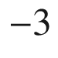

). The A exciton is bound to an isolated nitrogen impurity, cmp. to Fig. [9.​28](The_Physics_of_Semiconductors00004.docx#u116076_4_En_9_Chapter-Fig28).

Adapted from [690]

In the case of In in GaAs it has been found that down to the regime of

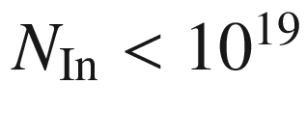

 cm



the indium does not act as a substitutional isoelectronic impurity but still fully participates in the composition of a pseudo-binary system (Sect. [6.​5](The_Physics_of_Semiconductors00003.docx#u116076_4_En_6_Chapter)). Recombination from excitons bound to single indium atoms or In–In pairs could not be found. The energy shift of donor- and acceptor-bound excitons in the dilute limit (Fig. [10.13](#u116076_4_En_10_Chapter-Fig13)) follows the band-gap dependence established for larger indium concentrations. The non-occurrence of localization effects is attributed to the small effective electron mass in InAs [544].

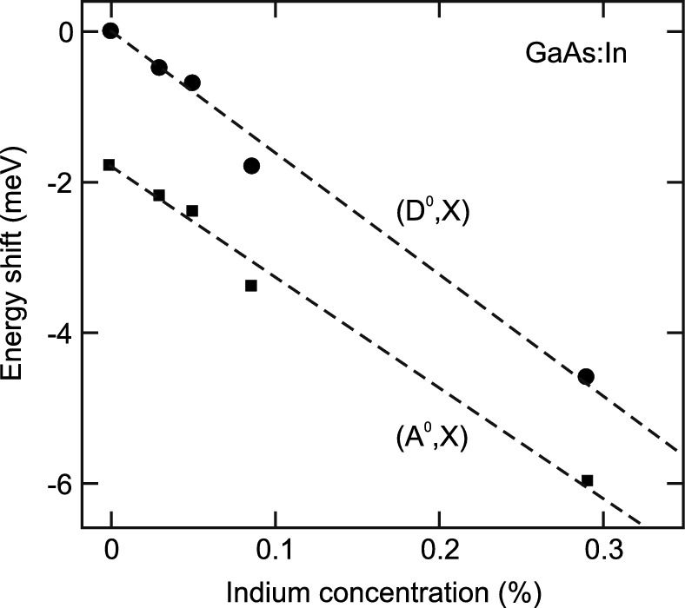

Fig. 10.13

Spectral position of neutral donor- and acceptor-bound exciton photoluminescence transition (

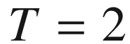

 K) in GaAs doped with different amounts of indium relative to the donor-bound exciton luminescence in pure GaAs (1.5146 eV). Adapted from [975]

The luminescence intensity *I*(*T*) of bound exciton lines is quenched with increasing temperature due to ionization of the excitons from the impurities. The temperature dependence can be modeled using the relation [976]

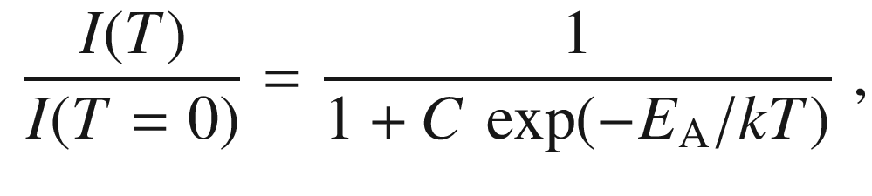

(10.26)

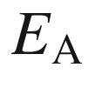

being the thermal activation energy and *C* a pre-factor. Often the activation energy is found equal to the localization energy,

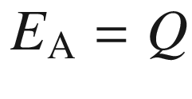

(Fig. [10.14](#u116076_4_En_10_Chapter-Fig14), cmp. Table [10.2](#u116076_4_En_10_Chapter-Tab2)). If several processes contribute, additional exponential terms can be added with further activation energies. For acceptor-bound excitons in GaAs two processes are found to contribute, the ionization from the impurity into a free exciton (

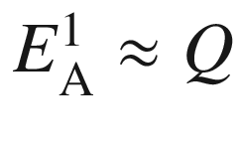

) and into an electron-hole pair (

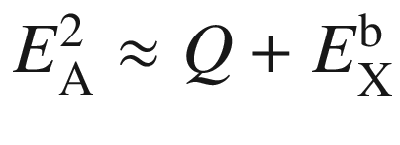

) [976]. In [977] the model is refined by considering the temperature dependence of the parameter *C* due to the ionization of the impurity itself.

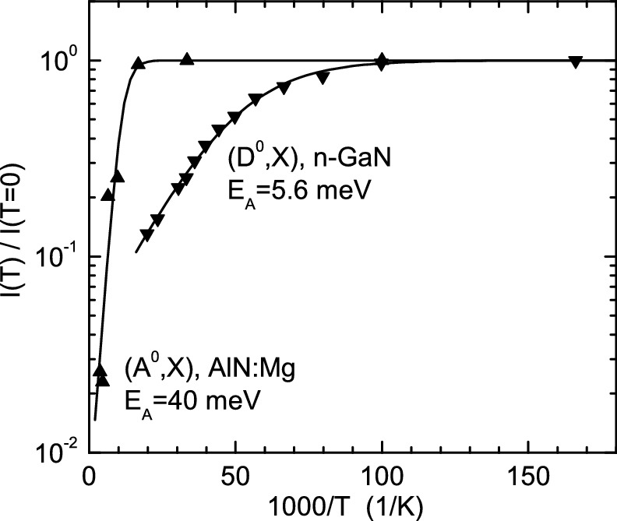

Fig. 10.14

(Temperature dependent PL intensity of (D



,X) in GaN and (A0,X) in AlN:Mg recombination. *Solid lines* are fits with ([10.26](#u116076_4_En_10_Chapter-Equ27)).

Data from [960, 978]

So far *single* excitons bound to a center have been discussed. Also bound exciton *complexes* [979] containing up to six excitons have been observed at sufficient excitation density, e.g. for substitutional boron [980] or phosphorus [981] and interstitial Li [982] in silicon. In a multi-valley semiconductor several electrons are available to form bound excitons which follow approximately a shell model and exhibit further fine structure.

#### 10.3.3 Alloy Broadening

The bound-exciton recombination peak in a binary compound is spectrally fairly sharp (Sect. [10.3.2](#u116076_4_En_10_Chapter-Sec11)), even in the presence of isotope disorder (Fig. [10.11](#u116076_4_En_10_Chapter-Fig11)). In an alloy (see Sect. [3.​7](The_Physics_of_Semiconductors00001.docx#u116076_4_En_3_Chapter)), the random distribution of atoms (with different atomic order number *Z*) causes a significant broadening effect of the luminescence (and absorption) line, the so-called *alloy broadening* [983, 984]. As an example, we treat Al



Ga

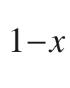

As. The exciton samples, at different positions of the lattice, different coordinations of Ga and Al atoms. If the experiment averages over these configurations, an inhomogeneously broadened line is observed.

The cation concentration

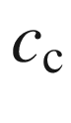

for the zincblende lattice is given as

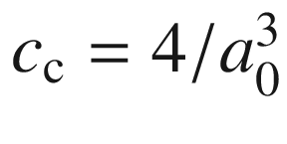

, for the wurtzite lattice as

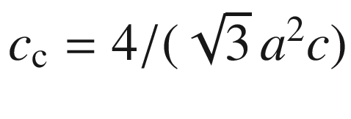

. For example,

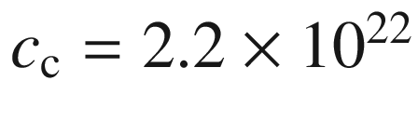

 cm



for Al



Ga

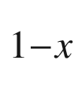

As in the entire composition range

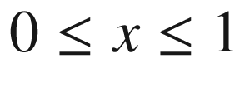

since the lattice constant does not vary significantly, and

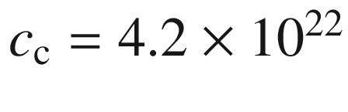

 cm



for wurtzite Mg



Zn

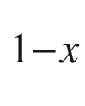

O [985]. In a random alloy, the probability *p*(*N*) to find exactly *N* Ga atoms in a given volume *V* (with a total of

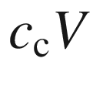

cations) is given by the binomial distribution

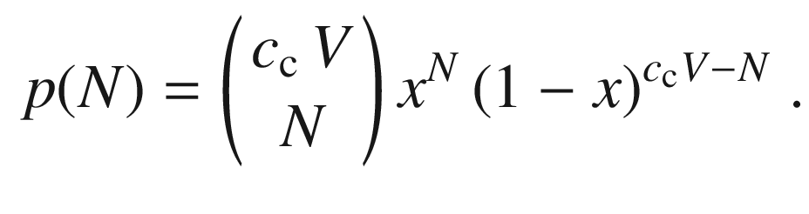

(10.27)

The sampling volume for a luminescence event is the exciton volume (cf. ([9.​51](The_Physics_of_Semiconductors00004.docx#u116076_4_En_9_Chapter))) that is given for the free-exciton (in 1s hydrogen state) as [983, 986]

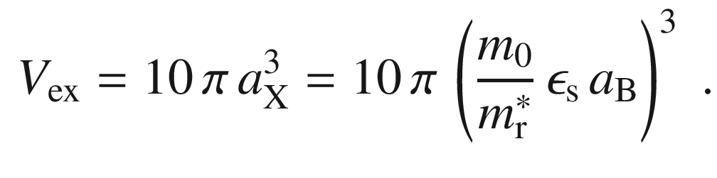

(10.28)

One should note that due to the variation of the involved material parameters

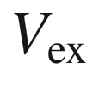

depends itself on *x*. In GaAs there are about

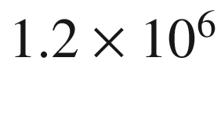

cations in the exciton volume. In Al



Ga

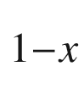

As, there are on average

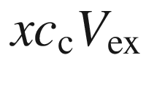

Al atoms in the exciton volume. The fluctuation is given by the standard deviation of the binomial distribution [986]

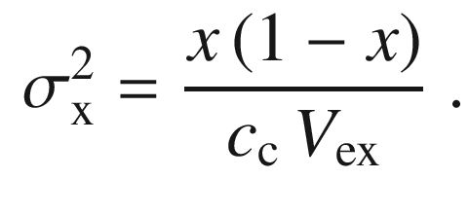

(10.29)

The corresponding energetic broadening (full width at half-maximum) of the spectral line is given by

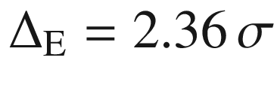

with

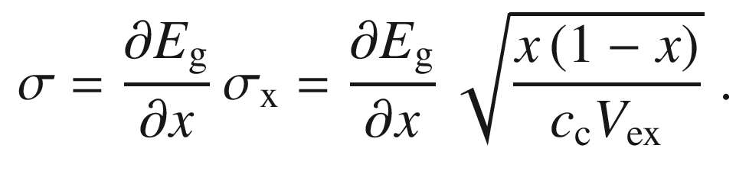

(10.30)

We note that instead of the quantum mechanically correct factor

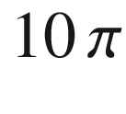

 [983, 986], often the factor

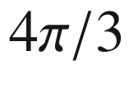

[984] is used, resulting in larger theoretical broadening.

Experimental data for Cd



Se



in Fig. [10.15](#u116076_4_En_10_Chapter-Fig15)a are consistent with ([10.30](#u116076_4_En_10_Chapter-Equ31)). The theoretical dependence ([10.30](#u116076_4_En_10_Chapter-Equ31)) is shown in Fig. [10.15](#u116076_4_En_10_Chapter-Fig15)b also for Al



Ga

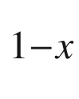

As together with experimental data and found to disagree [987]. Since the exciton volume is much smaller (cf. Sect. [9.​7.​6](The_Physics_of_Semiconductors00004.docx#u116076_4_En_9_Chapter)) than in Al



Ga



As, alloy broadening in Mg



Zn



O is much larger for a given for given *x*.

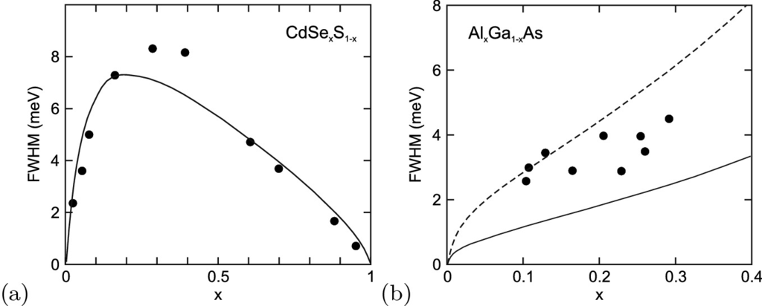

Fig. 10.15

**a** Spectral width of the photoluminescence from CdS



Se

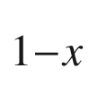

alloys. *Solid line* is theory according to ([10.30](#u116076_4_En_10_Chapter-Equ31)). Adapted from [983]. (**b**) Spectral width of the bound exciton recombination in Al



Ga



As with various Al content within the direct-bandgap regime. *Solid line* is ([10.30](#u116076_4_En_10_Chapter-Equ31)) with ([10.28](#u116076_4_En_10_Chapter-Equ29)), *dashed line* with pre-factor

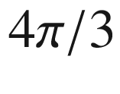

instead of

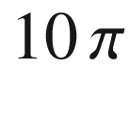

.

Adapted from [987]

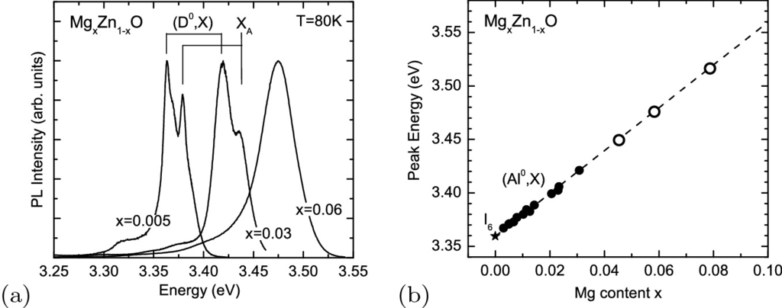

Fig. 10.16

**a** Photoluminescence spectra (

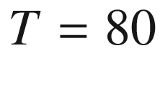

 K, scaled) of three Mg



Zn



O alloy layers on sapphire with three different Mg-contents,

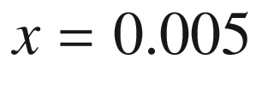

,

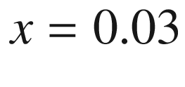

, and

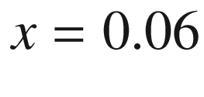

as labeled. The energy positions of (D



,X) and X

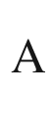

peaks are marked. Adapted from [977]. **b** Peak energy of the photoluminescence spectrum (

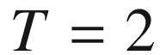

 K) of ZnO (I



-line, *star*) and various Mg



Zn

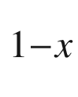

O alloys (*circles*). For

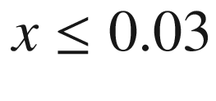

(*filled circles*) the (D



,X) recombination peak (Al donor) can be spectrally separated from the free exciton (X

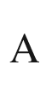

) recombination. For the samples with higher Mg content (*empty circles*) a single recombination peak is present at all temperatures. The *dashed line* is a linear least square fit for the alloys with

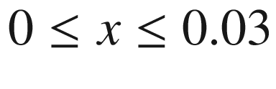

, showing that also for

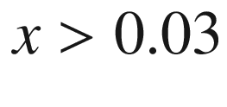

the low temperature recombination peak is due to donor-bound excitons.

Adapted from [988]

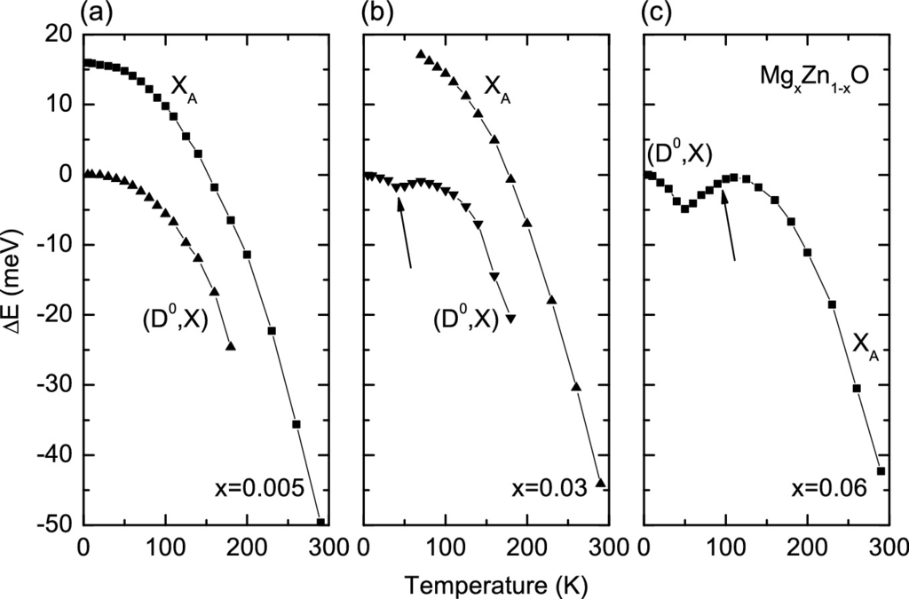

Fig. 10.17

Temperature dependence of the shift of energy position of (D



,X) and X

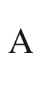

photoluminescence peak in Mg



Zn



O alloys with three different Mg-contents, (**a**)

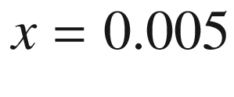

, (**b**)

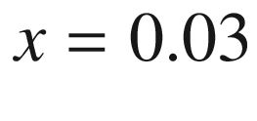

, (**c**)



. The energy positions are given relative to the low temperature position of the respective (D



,X) peaks.

Adapted from [977]

The spectral broadening due to alloy disorder masks the fine structure of recombination lines near the band edge present for binary semiconductors. Often for all temperatures only a single recombination line appears for alloys. Spectra for three different Mg



Zn



O alloys are shown in Fig. [10.16](#u116076_4_En_10_Chapter-Fig16)a. The increasing inhomogeneous broadening is obvious, causing a single peak for

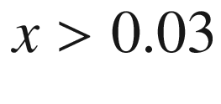

. The temperature dependence of the peak positions is shown in Fig. [10.17](#u116076_4_En_10_Chapter-Fig17) for the same samples. For

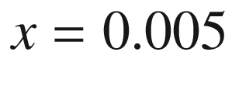

the bound exciton (Al-donor) (D



,X) and free exciton (X

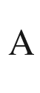

) recombination lines can still be resolved despite the inhomogeneous broadening of

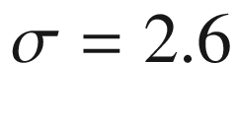

 meV. At low temperature the luminescence intensity is dominated by (D

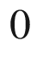

,X) recombination, at room temperature by free exciton (X



) recombination. Both peaks are present at low temperatures and exhibit a red-shift with increasing temperatures due to the shrinking of the band gap (Fig. [10.17](#u116076_4_En_10_Chapter-Fig17)a). The (D



,X) peak vanishes at about 180 K due to ionization of the excitons from the donors (

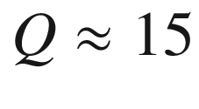

 meV, similar as in pure ZnO).

For larger Mg-content of

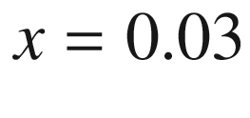

the two peaks can still mostly be separated (

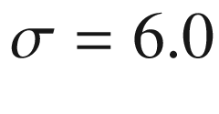

 meV). The (D



,X) energy position shows a small dip (about 2 meV) due to exciton localization in the alloy disorder potential (arrow in Fig. [10.17](#u116076_4_En_10_Chapter-Fig17)b). At low temperatures excitons are frozen in local potential minima and have a non-thermal (non-Boltzmann) population. With increasing temperature they can overcome energy barriers and thermalize, leading to a shift of the recombination peak to lower energies. Further increase of temperature populates higher levels and leads to a shift of the recombination peak to higher energies. Superimposed is the red-shift due to the band gap shrinkage. This so-called “S”-shape effect of *E*(*T*) is discussed in Sect. [12.​4](#u116076_4_En_12_Chapter) in detail with regard to exciton localization in a quantum well disorder potential.

For

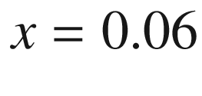

only a single photoluminescence peak is observed for the alloy (

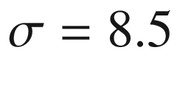

 meV). The (D



,X) peak is the dominant for the Mg



Zn



O alloys at low temperatures even in the presence of large alloy broadening (Fig. [10.16](#u116076_4_En_10_Chapter-Fig16)(b)). The peak changes its nature from (D



,X) at low temperatures to X



at room temperature. In between, first exciton thermalization (red-shift) in the disorder potential and subsequently exciton ionization from the donors (blue-shift, arrow in Fig. [10.17](#u116076_4_En_10_Chapter-Fig17)c) are observed [977]. Such exciton ionization from impurities has also been observed for (Al,Ga)N:Si [628, 989].

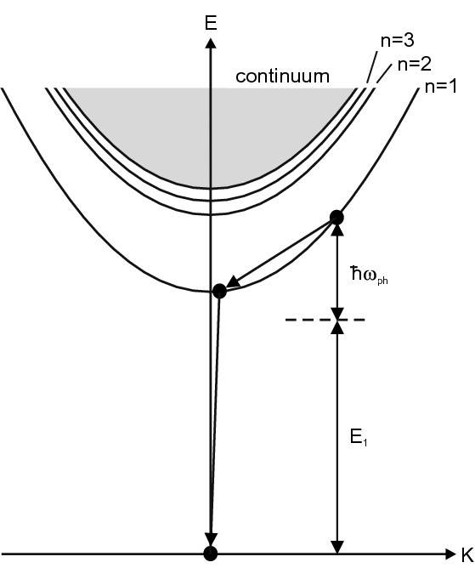

Fig. 10.18

Schematic representation of 1 LO exciton scattering of an exciton at

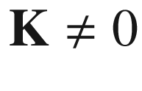

to an intermediate state with

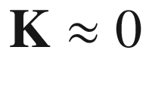

and subsequent radiative decay.

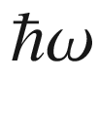

represents the phonon energy and

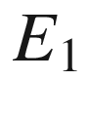

the energy of the emitted photon

### 10.4 Phonon Replica

The momentum selection rule for free-exciton recombination allows only excitons with

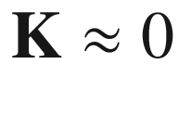

(for



, cf. ([9.​49](The_Physics_of_Semiconductors00004.docx#u116076_4_En_9_Chapter))) to recombine. The fine structure of this recombination is connected to polariton effects (cf. Sect. [9.​7.​8](The_Physics_of_Semiconductors00004.docx#u116076_4_En_9_Chapter)). Excitons with large



can recombine if a phonon or several phonons are involved [990] that provide the necessary momentum

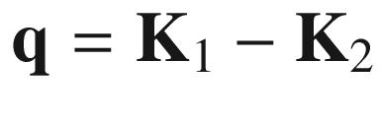

, with

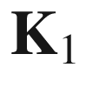

(

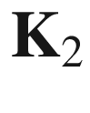

) being the wavevector of the initial (intermediate) exciton state (Fig. [10.18](#u116076_4_En_10_Chapter-Fig18)). A so-called *zero-phonon* line at energy

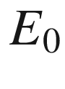

is then accompanied by *phonon replica* below

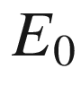

at integer multiples (at low temperature) of the (LO) phonon energy

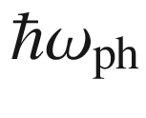

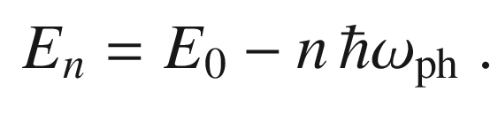

(10.31)

Phonon replicas have been observed in many polar semiconductors such as CdS [991] and ZnSe [992]. A sequence of such phonon replica, as observed in GaN [993], is depicted in Fig. [10.19](#u116076_4_En_10_Chapter-Fig19)a.

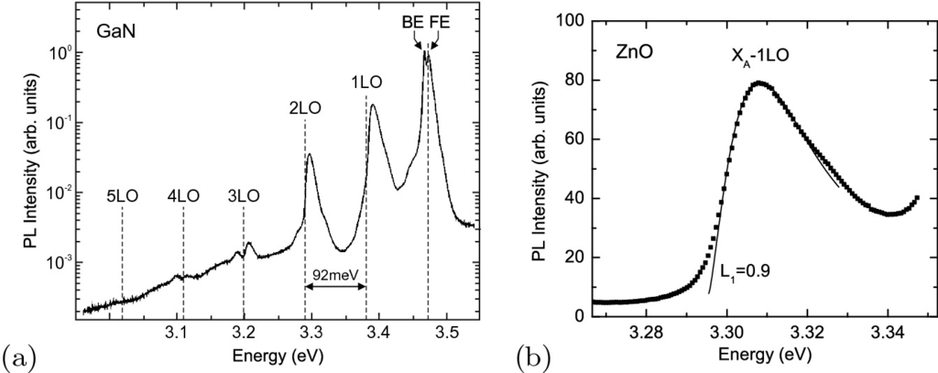

Fig. 10.19

**a** Photoluminescence spectrum of GaN (grown on SiC substrate) at

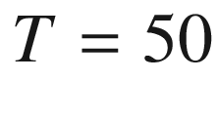

 K. In addition to emission from free (FE) and bound (BE) excitons several phonon replica (labeled as 1LO–5LO) are observed. *Vertical dashed lines* indicate energy positions of multiple LO-phonon energies (

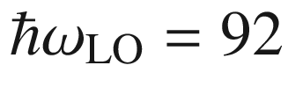

 meV) below the FE peak. Adapted from [993]. **b** Photoluminescence spectrum of 1 LO phonon-assisted recombination peak at

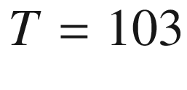

 K (from the data of Fig. [10.5](#u116076_4_En_10_Chapter-Fig5)). Data points (*dots*) and lineshape fit (*solid line*) according to ([10.32](#u116076_4_En_10_Chapter-Equ33)) with the parameters

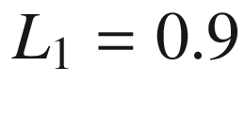

and

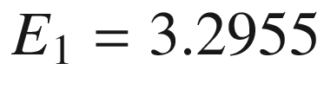

 eV (and background)

The lineshape of the *n*-

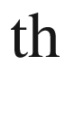

phonon-assisted line is proportional to the exciton population at a given excess energy, which is proportional to the density of states and the Boltzmann distribution function [994]

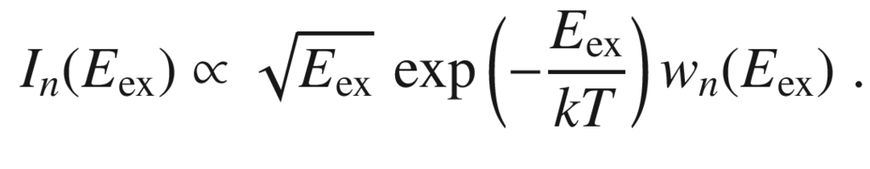

(10.32)

Here,

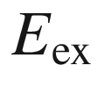

represents the exciton kinetic energy. The factor

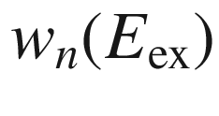

accounts for the

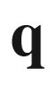

-dependence of the matrix element. It is typically expressed as

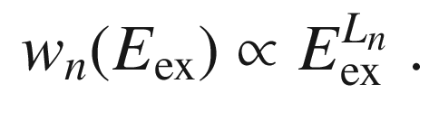

(10.33)

Accordingly, as temperature dependent refinement of ([10.31](#u116076_4_En_10_Chapter-Equ32)), the energy separation

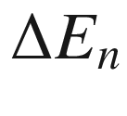

of the energy of the peak maximum of phonon replica from

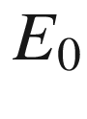

is given by

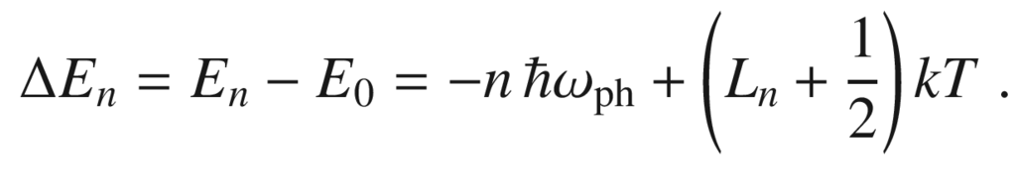

(10.34)

It is found theoretically that

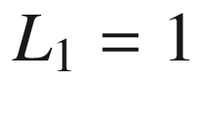

and

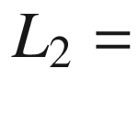

0 [994]. These relations are approximately fulfilled for GaN [995]. A lineshape fit for the 1 LO phonon-assisted transition in ZnO is shown in Fig. [10.19](#u116076_4_En_10_Chapter-Fig19)b.

In Fig. [10.20](#u116076_4_En_10_Chapter-Fig20)a the ‘green band’ emission of ZnO is shown as presented in [996]. This band is mostly attributed to a Cu impurity; recently, evidence has grown from isotope decay and annealing studies that it is related to the zinc vacancy [997] (Fig. [10.20](#u116076_4_En_10_Chapter-Fig20)b). The zero phonon line is followed by many replica with a maximum at about 6 LO phonons. The intensity

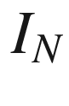

of the *N*-th replica is given by [998, 999]

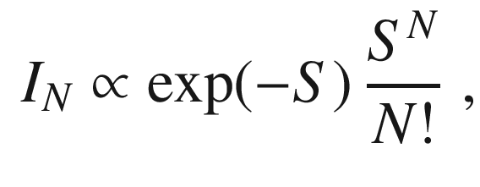

(10.35)

where *S* is the so-called Huang–Rhys parameter. In [997], a coupling parameter of

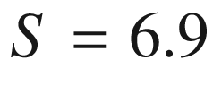

has been determined.

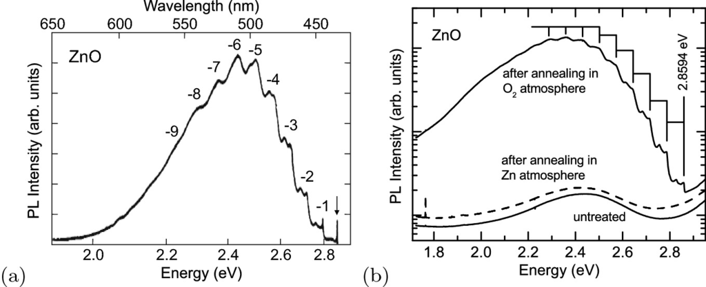

Fig. 10.20

**a** Luminescence spectrum of ZnO in the visible. The *arrow* denotes the zero-phonon line at 2.8590 eV. The numbers of the phonon replica are labeled. Adapted from [996]. **b** Luminescence spectra (*solid lines*) of a ZnO bulk crystal before (‘untreated’) and after annealing in O



atmosphere at

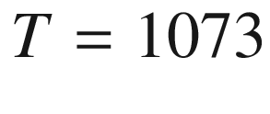

 K. After annealing in Zn atmosphere at the same temperature, the green band disappears again (*dashed line*).

From [997]

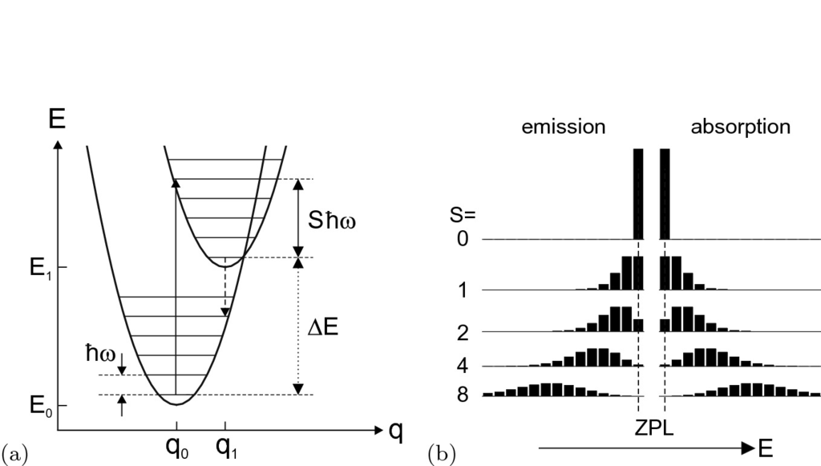

Fig. 10.21

**a** Configuration diagram of two states that differ in their configuration coordinate by

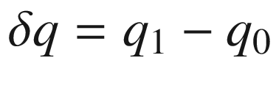

. Both are coupled to phonons of energy

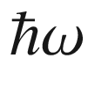

. The absorption maximum (*solid vertical line*) and emission maximum (*dashed vertical line*) are shifted with respect to the zero-phonon line (*dotted vertical line*) with energy

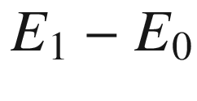

. The Huang–Rhys parameter is

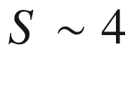

. (**b**) Intensity of zero-phonon line (‘ZPL’) and phonon replica ([10.35](#u116076_4_En_10_Chapter-Equ36)) for emission and absorption processes with different values of the Huang–Rhys parameter *S* as labeled

Equation ([10.35](#u116076_4_En_10_Chapter-Equ36)) is obtained from the consideration of transitions in the configuration diagram [998, 1000] (Fig. [10.21](#u116076_4_En_10_Chapter-Fig21)), using the Born–Oppenheimer approximation. Here the electronic wavefunctions are separated from the vibrational wavefunctions, leading to the Franck–Condon principle, that optical transitions occur with the positions of the nuclei fixed and thus vertical in the configuration diagram Fig. [10.21](#u116076_4_En_10_Chapter-Fig21). Assuming low temperatures, only the lowest state is (partially) occupied. The Huang–Rhys parameter, the average number of phonons involved in the transition, is related to the displacement

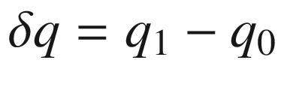

of the two configurations

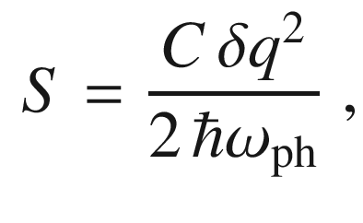

(10.36)

where *C* is the ‘spring constant’ of the parabola,

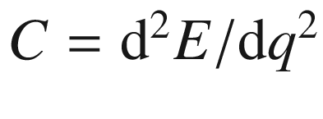

.

For small

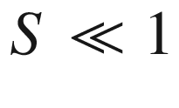

, we are in the weak coupling regime and the zero-phonon line is the strongest. In the strong coupling regime,

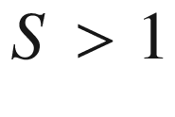

, the maximum is (red-) shifted from the zero-phonon line. We note that in absorption, phonon replica occur on the high-energy side of the zero-phonon absorption. For large *S* the peak intensities are close to a Gaussian. The correspondence of emission and absorption is nicely seen for excitons on isoelectronic oxygen traps in ZnTe [1001]. The oxygen is on substitutional Te site. Up to seven phonon replica are visible in Fig. [10.22](#u116076_4_En_10_Chapter-Fig22) around the zero-phonon or A-line with a separation of about 26 meV, the optical phonon energy in ZnTe. The Huang-Rhys parameter is about 3–4. Other peaks are due to acoustic phonons.

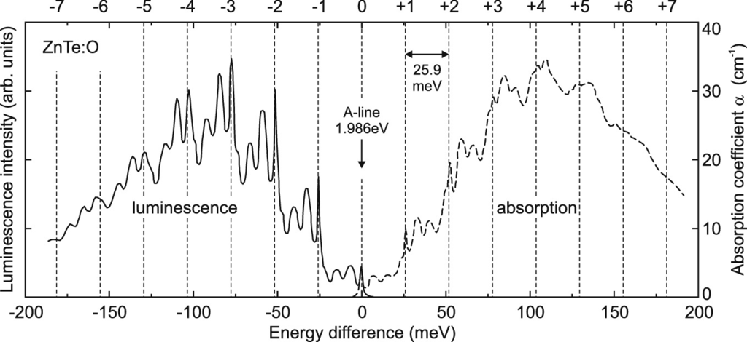

Fig. 10.22

Photoluminescence (*solid line*) and absorption (*dashed line*) spectra of excitons bound to substitutional oxygen in ZnTe at

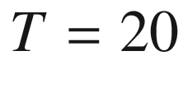

 K. The energy position is relative to the A-line at 1.9860 eV. The *vertical dashed lines* have a separation of 25.9 meV.

Adapted from [1001]

### 10.5 Self-Absorption

Luminescence that is emitted within the semiconductor can be (re-)absorbed before it may reach the surface and can leave the crystal. This effect is called self-absorption. It is particularly strong for radiation with an energy where the absorption

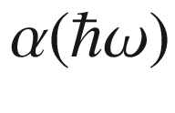

is high, i.e. above the band gap of a direct semiconductor. Similarly to the penetration depth

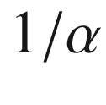

for radiation entering the crystal, emission approximately occurs only from a layer of such thickness. For typical values of

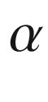

in the range of

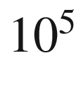

 cm

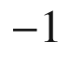

, the ‘skin’ of the semiconductor that emits light with energy above the band gap is 100 nm. For light at the low energy side of the band gap or with energy within the band gap (deep levels), the emission depth can be much larger.

After re-absorption, the energy has another chance to relax non-radiatively, thus reducing the quantum efficiency. Alternatively it can be reemitted, either at the same energy or at a lower energy. Possibly several re-absorption processes occur before a photon eventually leaves the semiconductor (‘photon recycling’). Such processes are important in LED structures where photon extraction has to be optimized (Sect. [23.​3.​4](The_Physics_of_Semiconductors00008.docx#u116076_4_En_23_Chapter)). Emission on phonon replica (Sect. [10.4](#u116076_4_En_10_Chapter-Sec13)) is red-shifted from the energy range of strong absorption and thus suffers no (or only little) self-absorption. This can be seen from the spectrum of a thick ZnO crystal excited homogeneously (via two-photon absorption with a red Ruby laser), Fig. [10.23](#u116076_4_En_10_Chapter-Fig23). The zero phonon line (at

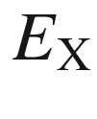

), originating from the

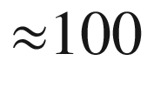

 nm skin of the samples and being by far the strongest in thin films (Fig. [10.5](#u116076_4_En_10_Chapter-Fig5)), is practically absent and emission on the phonon replica collected from the entire volume dominates the spectrum.

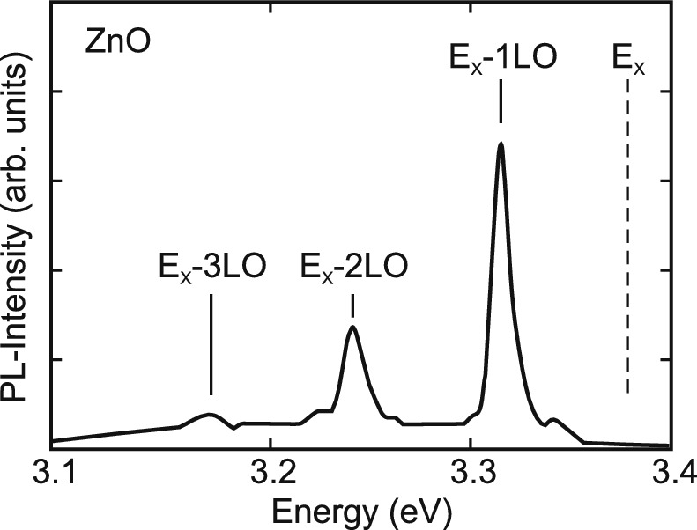

Fig. 10.23

Photoluminescence spectrum (at

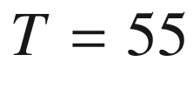

 K) from bulk ZnO excited homogeneously via two-photon excitation by a Q-switched ruby laser (pulse width 40 ns).

Adapted from [1002]

### 10.6 Donor–Acceptor Pair Transitions

Optical transitions can occur between neutral donors and acceptors. The (spatially indirect) donor–acceptor pair (DAP) recombination is present in (partially) compensated semiconductors and follows the scheme

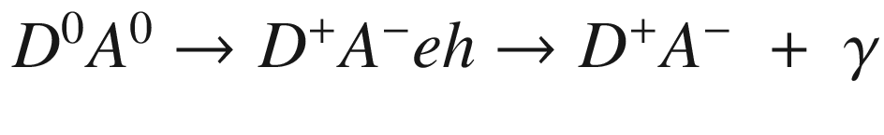

, where

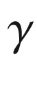

is a photon with the energy



. The energy of the emitted photon is given by

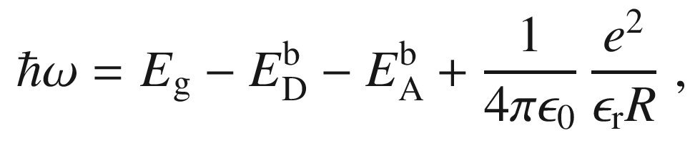

(10.37)

where *R* is the distance between the donor and the acceptor for a specific pair. Since *R* is discrete, the DAP recombination spectrum consists of several discrete lines. If the donor and acceptor occupy the same sublattice, e.g.. O and C both substituting P sites in GaP, the spatial distance of the donor and acceptor is

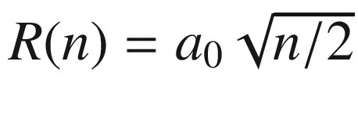

, where

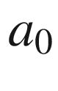

is the lattice constant and *n* is an integer. However, for certain ‘magic’ numbers

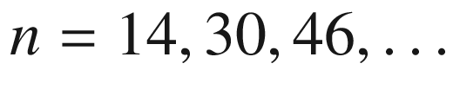

no lattice points exist and therefore the corresponding lines are missing (labeled ‘G’ in Fig. [10.24](#u116076_4_En_10_Chapter-Fig24)). No such gaps exist in DA spectra where donors and acceptors occupy different sublattices, e.g. GaP:O,Zn (see also Fig. [10.24](#u116076_4_En_10_Chapter-Fig24)). In this case, the spatial separation is given by

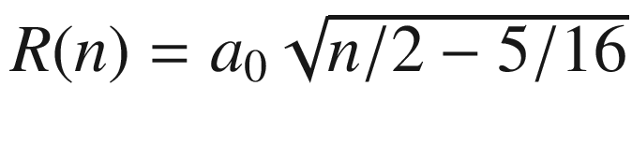

. If significant broadening is present, the lines are washed out and a donor–acceptor pair band forms.

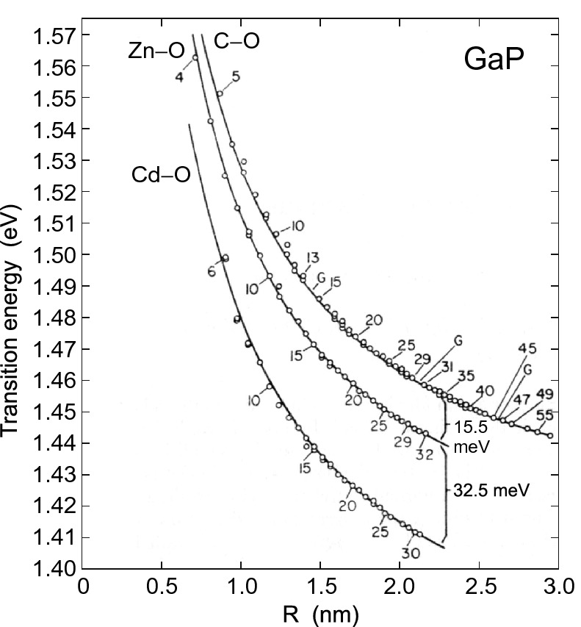

Fig. 10.24

Transition energies in GaP (

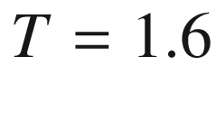

 K) of the donor–acceptor recombination involving the deep oxygen donor and C, Zn, and Cd acceptors, respectively. The lines follow ([10.37](#u116076_4_En_10_Chapter-Equ38)) for

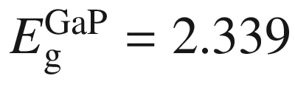

 eV,

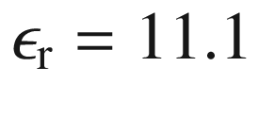

and

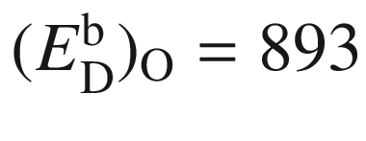

 meV,

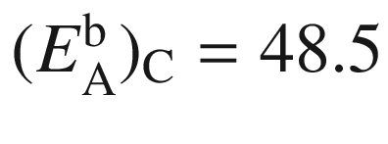

 meV,

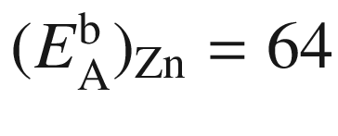

 meV, and

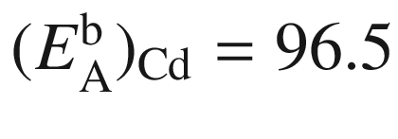

 meV. Predicted missing modes for GaP:C,O are labeled with ‘G’.

Adapted from [1003]

### 10.7 Inner-Impurity Recombination

The transitions of electrons between different states of an impurity level can be nonradiative or radiative. As an example, the radiative transition of electrons in the Fe

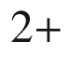

state in InP

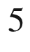

T

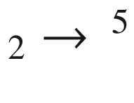

E (Fig. [10.25](#u116076_4_En_10_Chapter-Fig25)) and its fine structure were observed first in [1005] at around 0.35 eV.

Certain defects, also termed ‘color centers’, have been investigated towards their ability to act as efficient single photon source. If a single defect is optically excited, it can emit a photon. However, it cannot be excited further. Also, it cannot emit another photon before it has been excited again. This can be measured through the correlation function for the time difference of emitted photons going to zero for zero time difference. A popular example of such center is the NV center in diamond, the complex of a vacancy and a nitrogen impurity [1006, 1007]. The emission rate saturates at about

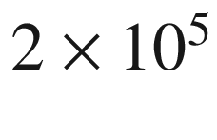

 photons/s (pick up with microscope objective). The sensitivity of the spectrum to magnetic fields makes the NV center a nanoscopic magnetic field sensor [1008]. Also the spins on the center are fairly isolated and can be manipulated coherently.

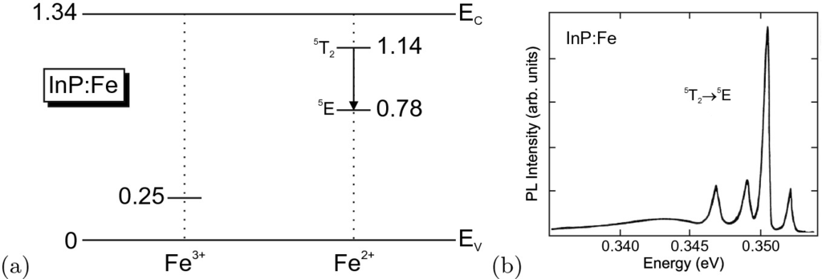

Fig. 10.25

**a** Schematic band diagram of InP with levels of Fe impurities in the

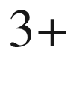

and

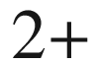

charge states at low temperature. All energies are given in eV. The *arrow* denotes the optical transition from an excited Fe

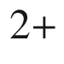

state to the Fe



ground state. (**b**) Photoluminescence spectrum (at

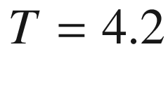

 K) of InP:Fe sample with [Fe]=

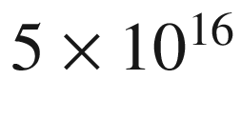

 cm



. Part (**b**) adapted from [1004]

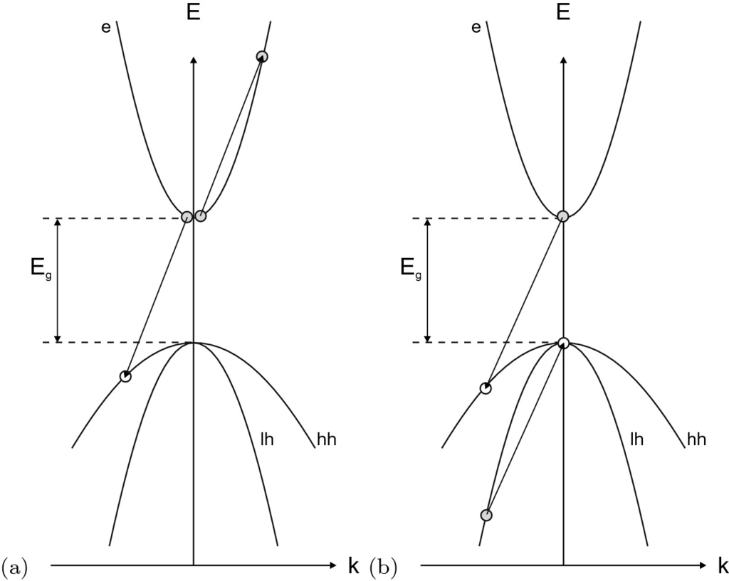

Fig. 10.26

Schematic representation of Auger recombination. An electron recombines with a hole and transfers the energy to **a** another electron in the conduction band, **b** another electron in the valence band

### 10.8 Auger Recombination

In competition with the radiative, bimolecular recombination is the Auger recombination (Fig. [10.26](#u116076_4_En_10_Chapter-Fig26)). In the Auger process, the energy that is released during the recombination of an electron and hole is not emitted with a photon but, instead, transferred to a third particle. This can be an electron (eeh, Fig. [10.26](#u116076_4_En_10_Chapter-Fig26)a) or a hole (hhe, Fig. [10.26](#u116076_4_En_10_Chapter-Fig26)b). The energy is eventually transferred nonradiatively from the hot third carrier via phonon emission to the lattice. The probability for such process is

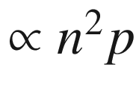

if two electrons are involved and

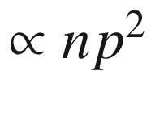

if two holes are involved. The Auger process is a three-particle process and becomes likely for high carrier density, either through doping, in the presence of many excess carriers, or in semiconductors with small band gap. Auger recombination is the inverse of the impact ionization (cf. Sect. [8.​4.​4](The_Physics_of_Semiconductors00004.docx#u116076_4_En_8_Chapter)). Phonon-assisted Auger recombination relaxes the momentum conservation rule for the involved charge carriers at the cost of an additional particle being involved in the scattering process. It has been pointed out that this process is dominating in bulk material [1010, 1011] and quantum wells [1012].

In thermodynamic equilibrium the rates for Auger recombination and thermal Auger generation  must be equal, thus

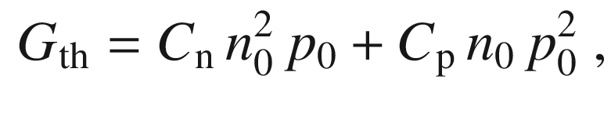

(10.38)

where

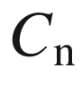

and

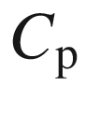

denote the Auger recombination coefficients. The equation for the dynamics in the presence of excess carriers (if solely Auger recombination is present) is given as

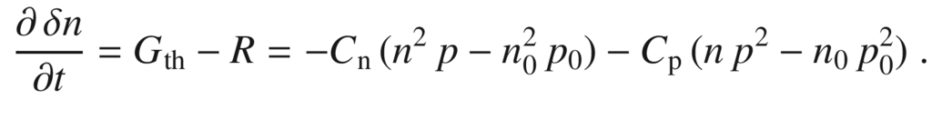

(10.39)

The Auger recombination rate typically used in SRH kinetics is

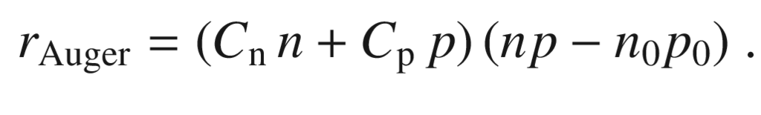

(10.40)

Typical values for the Auger recombination coefficients are given in Table [10.3](#u116076_4_En_10_Chapter-Tab3).Table 10.3

Auger recombination coefficients for some semiconductors. Data for InSb from [1013], SiC from [947], others from [948]

| material | $$C_{\mathrm {n}}$$  (cm  $$^6$$  /s) | $$C_{\mathrm {p}}$$  (cm  $$^6$$  /s) |
| --- | --- | --- |
| 4H-SiC | 5  $$\times 10^{-31}$$ | 2  $$\times 10^{-31}$$ |
| Si, Ge | 2.8  $$\times 10^{-31}$$ | 9.9  $$\times 10^{-32}$$ |
| GaAs, InP | 5.0  $$\times 10^{-30}$$ | 3.0  $$\times 10^{-30}$$ |
| InSb | $$1.2 \times 10^{-26}$$ | |

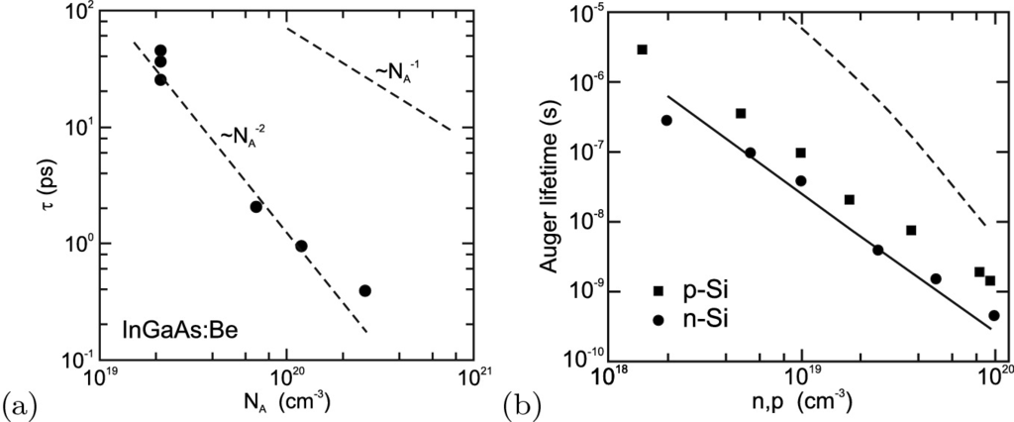

Fig. 10.27

**a** Experimental values of the electron lifetime in heavily p-doped (In,Ga)As on InP at room temperature. The *dashed lines* show dependencies of Auger (

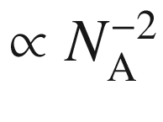

,

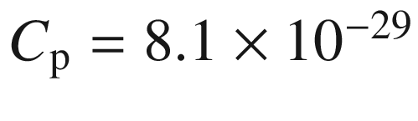

 cm

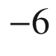

 s

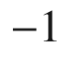

) and band-band recombination (

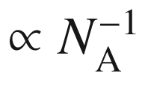

,

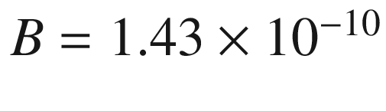

 cm



 s



). Adapted from [1014]. (**b**) Experimental Auger lifetimes in p-type (*squares*) and n-type (*circles*) silicon at 300 K. The *dashed* (*solid*) *line* is theory for p-type (n-type) material.

Adapted from [1015]

In Fig. [10.27](#u116076_4_En_10_Chapter-Fig27)a the electron lifetime in heavily p-doped (In,Ga)As (lattice matched to InP) is shown [1014]. It follows

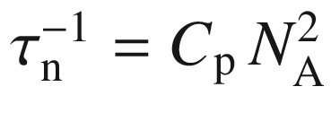

as expected from ([10.39](#u116076_4_En_10_Chapter-Equ40)) for p-type material. The Auger process in silicon has been discussed in detail [1015]. In Fig. [10.27](#u116076_4_En_10_Chapter-Fig27)b experimental data for n-type and p-type Si are summarized. Auger theory can predict the lifetimes in n-type material. The predicted rate in p-type material is too small, thus a phonon-assisted process is evoked [1015].

### 10.9 Band–Impurity Recombination

A very important recombination process is the capture of carriers by impurities. This process is in competition with all other recombination processes, e.g. the radiative recombination and the Auger mechanism. The band–impurity recombination is the inverse process to the carrier release from impurities and intimately related to carriers statistics (Chap. [7](The_Physics_of_Semiconductors00003.docx#u116076_4_En_7_Chapter)). It is particularly important at low carrier densities, for high dopant concentration and in indirect semiconductors since for these the bimolecular recombination is slow. This process is generally considered to be non-radiative since no photons close to the band edge are emitted.[4](#u116076_4_En_10_Chapter-Fn4)

#### 10.9.1 Shockley–Read–Hall Kinetics

The theory of capture on and recombination involving impurities is called Shockley–Read–Hall (SRH) kinetics [942]. An example of radiative band–impurity recombination (of the type shown in Fig. [10.28](#u116076_4_En_10_Chapter-Fig28)a) is shown in Fig. [10.8](#u116076_4_En_10_Chapter-Fig8) for the (e,A



) recombination at the carbon acceptor in GaAs.

We consider electron traps [1016] (see Fig. [10.28](#u116076_4_En_10_Chapter-Fig28)) with a concentration

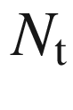

with an energy level

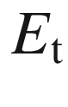

. In thermodynamic equilibrium they have an electron population

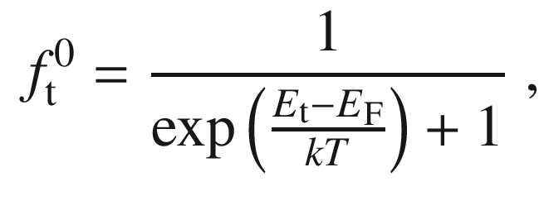

(10.41)

where

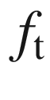

is the nonequilibrium population of the trap. Then the capture rate

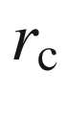

is proportional to the unoccupied traps and the electron concentration,

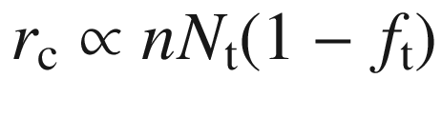

. The proportionality factor has the form

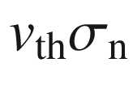

, where

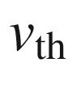

is the thermal velocity

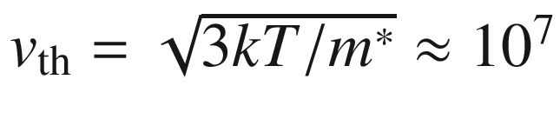

 cm/s and

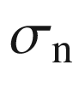

is the capture cross section that is of atomic scale, typically

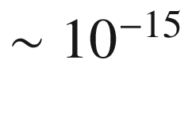

cm

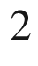

. The capture cross section can be related to the optical absorption cross section [588, 589].

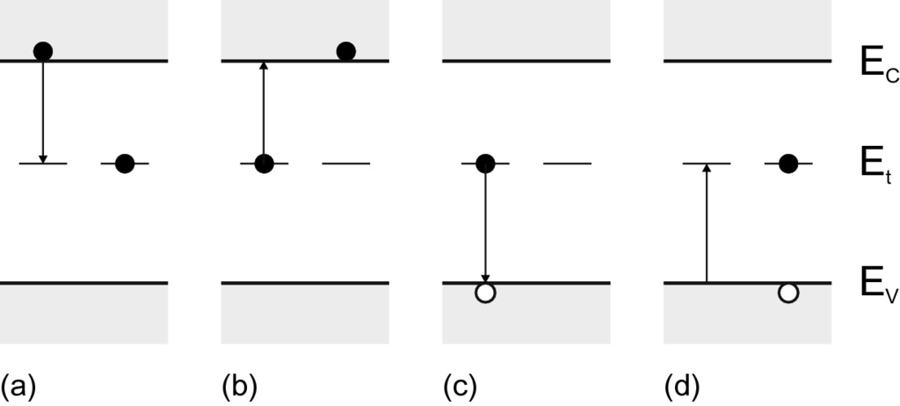

Fig. 10.28

Band-to-impurity processes at an impurity with one level (*left*: initial, *right*: final state in each part): **a** electron capture (from conduction band), **b** electron emission (into conduction band), **c** hole capture (from valence band), **d** hole emission (into valence band). The *arrows* indicate the transition of the electron

In order to make the following calculation more transparent, we put the effective-mass ratio

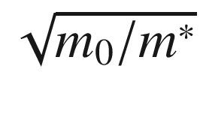

into

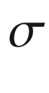

in the following and thus have the same thermal velocity

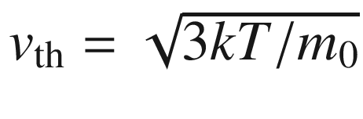

for electrons and holes. The capture rate of electrons is

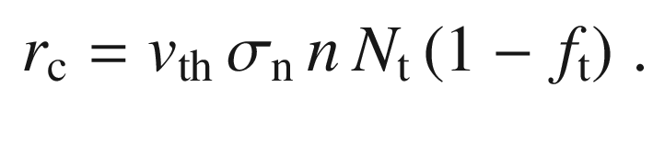

(10.42)

The emission rate from filled traps is

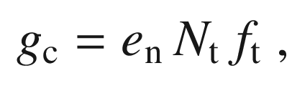

(10.43)

where

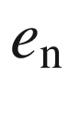

denotes the emission probability. In a similar way, the emission and capture rates for holes can be written:

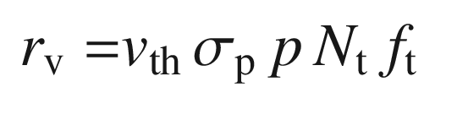

(10.44)

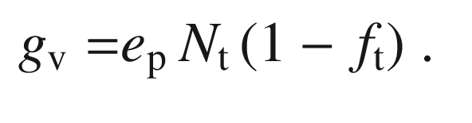

(10.45)

In thermodynamical equilibrium, capture and generation rates are equal, i.e.

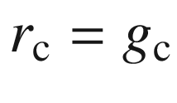

and

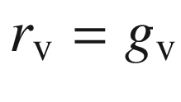

. Thus, the emission probability is

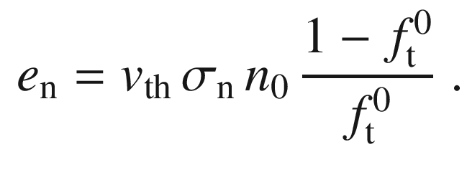

(10.46)

Using

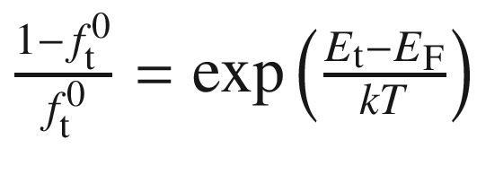

, ([7.​10](The_Physics_of_Semiconductors00003.docx#u116076_4_En_7_Chapter)) and ([7.​11](The_Physics_of_Semiconductors00003.docx#u116076_4_En_7_Chapter)) the emission probabilities can be written as

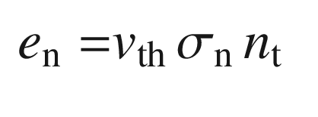

(10.47)

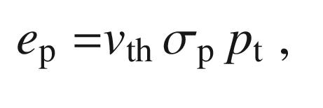

(10.48)

with

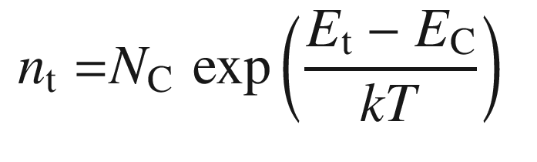

(10.49)

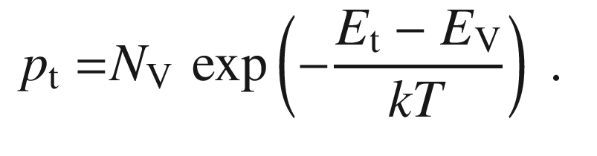

(10.50)

We note that

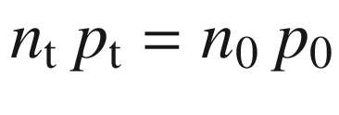

(cf. ([7.​15](The_Physics_of_Semiconductors00003.docx#u116076_4_En_7_Chapter))).

The temperature dependence of the thermal velocity is

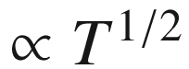

, the temperature dependence of the band-edge density of states is

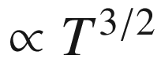

([7.​8](The_Physics_of_Semiconductors00003.docx#u116076_4_En_7_Chapter)) and ([7.​9](The_Physics_of_Semiconductors00003.docx#u116076_4_En_7_Chapter)). Thus, the temperature dependence of the emission rate

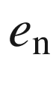

is (apart from the exponential term)

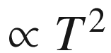

if

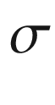

is temperature independent. Charge conservation requires in nonequilibrium (and of course in equilibrium)

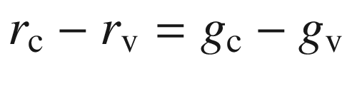

. From this we obtain the population of the trap in nonequilibrium:

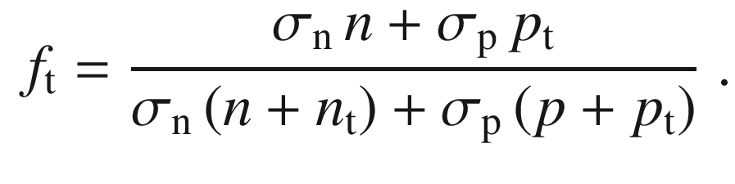

(10.51)

The recombination rate

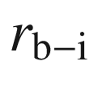

of the band–impurity recombination is then

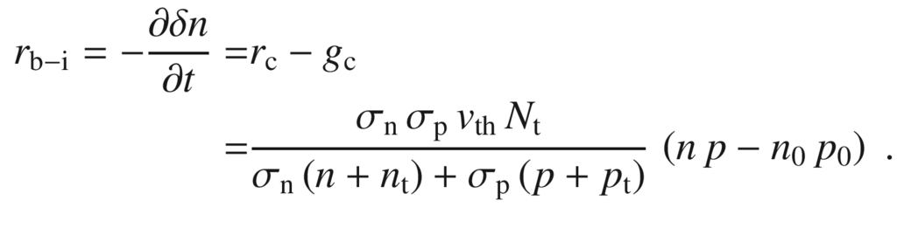

(10.52)

Using the ‘lifetimes’

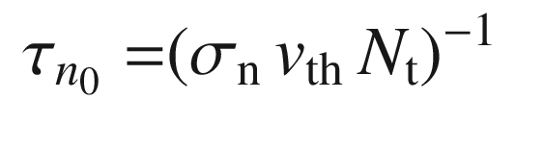

(10.53)

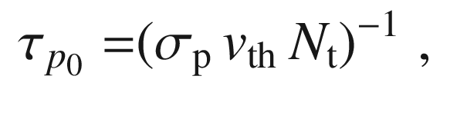

(10.54)

this is typically written as

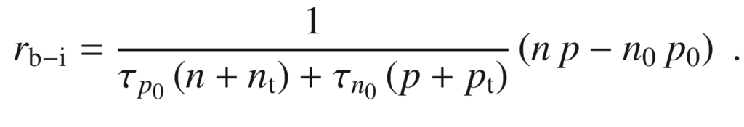

(10.55)

For an n-type semiconductor the Fermi level is above

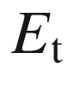

and the traps are mostly full. Thus hole capture is the dominating process. The equation for the dynamics simplifies to

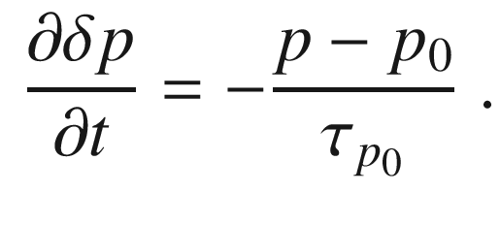

(10.56)

Thus, an exponential decay with minority-carrier lifetime

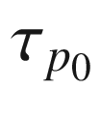

(or

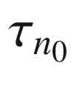

for p-type material) occurs.

A recombination center is most effective when it is close to the middle of the band gap (midgap level). The condition

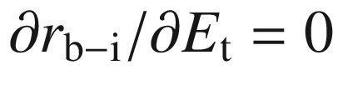

leads to the trap energy

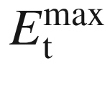

with the maximum recombination rate being located at

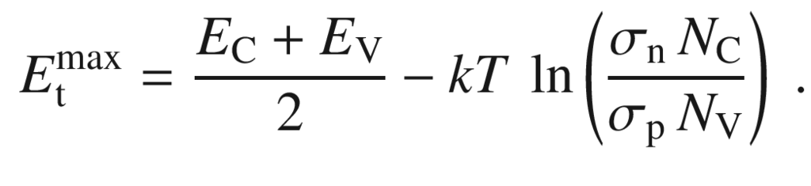

(10.57)

The curvature

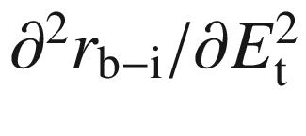

at

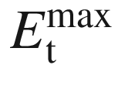

is proportional to

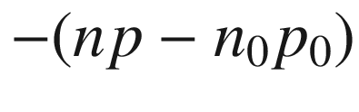

and thus indeed is negative in the presence of excess carriers. However, the maximum can be fairly broad.

The SRH kinetic presented here is valid for low densities of recombination centers. A more detailed discussion and a more general model can be found in [1018].

A typical example for a recombination center is gold in silicon. The minority carrier lifetime decreases from

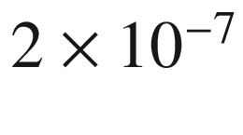

 s to

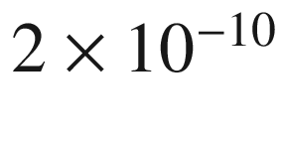

 s upon increase of the Au concentration from

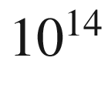

to

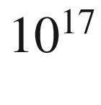

 cm



. The incorporation of recombination centers is an important measure for the design of high-frequency devices [1019]. Due to importance in silicon technology the recombination properties of many metals in silicon have been investigated, in particular Fe-contamination and the role of FeB-complexes [1020–1022].

A reduction in minority-carrier lifetime can also be achieved by irradiation with high-energy particles and the subsequent generation of point defects with energy levels at midgap.

In Fig. [10.29](#u116076_4_En_10_Chapter-Fig29) various data on minority carrier lifetime in silicon are compiled. Over some doping range, a dependence of the lifetime

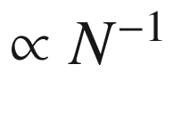

as in ([10.54](#u116076_4_En_10_Chapter-Equ55)) prevails. For doping beyond the

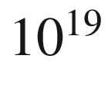

 cm



range, Auger recombination (Sect. [10.8](#u116076_4_En_10_Chapter-Sec17)) with

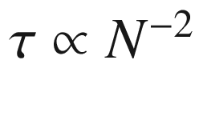

is dominant. A more detailed discussion can be found in [1023, 1024]. Generally the lifetimes are temperature dependent [1025] as expected from ([10.52](#u116076_4_En_10_Chapter-Equ53)).

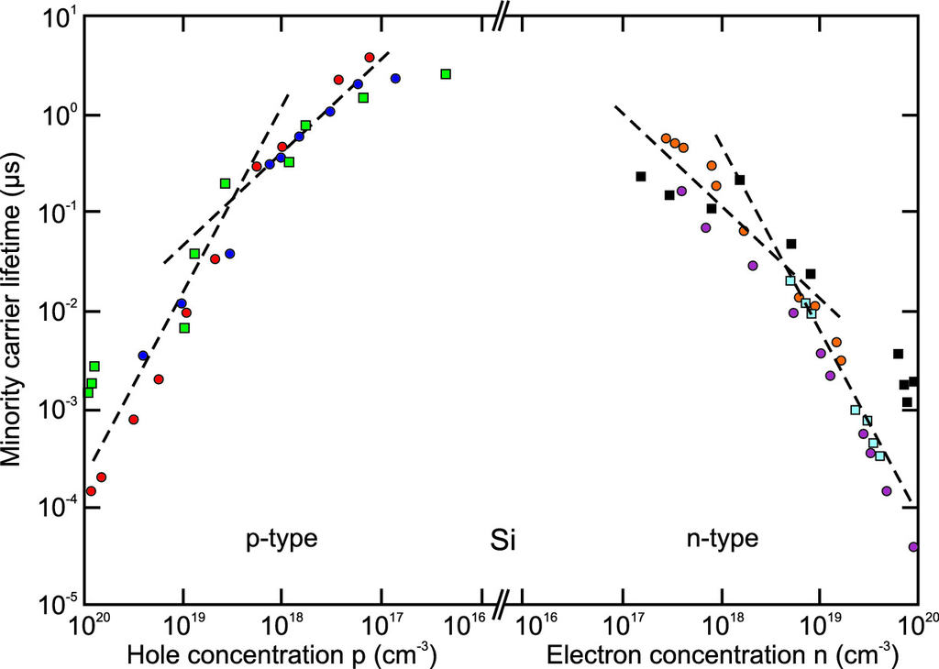

Fig. 10.29

Minority carrier lifetime at room temperature as a function of majority carrier concentration in n-type and p-type silicon. The *dashed lines* have the slopes

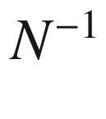

and

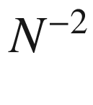

.

Data from [1024]

#### 10.9.2 Multilevel Traps

Traps with multiple levels in the band gap have generally similar but more complicated dynamics as compared to single-level traps. Lifetimes are an average over negatively and positively charged states of the trap.

### 10.10 ABC Model

Summarizing the results on band-impurity recombination (Sect. [10.9](#u116076_4_En_10_Chapter-Sec18)), bimolecular recombination (Sect. [10.2](#u116076_4_En_10_Chapter-Sec2)) and Auger recombination (Sect. [10.8](#u116076_4_En_10_Chapter-Sec17)), the total recombination rate *R* can be written simplified as

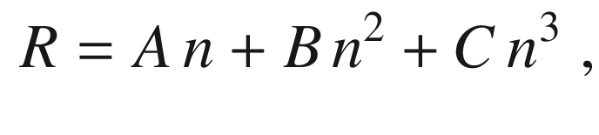

(10.58)

where *A* is the coefficient for the band-impurity recombination, *B* the bimolecular recombination coefficient and *C* the Auger recombination coefficient; *n* denotes the carrier density. This model is known as the ‘ABC’ model. It can be refined separating effects of electrons and holes and including higher terms. Often such model is used to investigate recombination in devices as a function of injection, e.g. [1026, 1027].

The internal radiative quantum efficiency

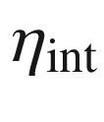

is given by ratio of the radiative recombination rate and the total recombination rate,

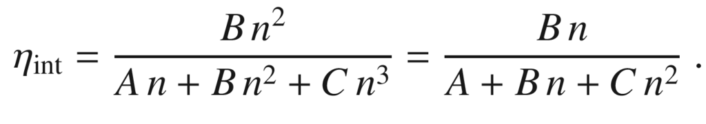

(10.59)

### 10.11 Field Effect

The emission of electrons from a trap is thermally activated with an ionization energy

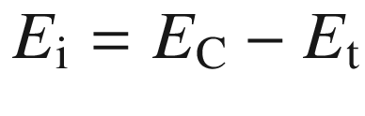

. If the trap is in a strong electric field *E*, the emission probability can change. An acceptor-like trap after removal of the electron is neutral and its potential is short range. A donor has a long-range Coulomb potential after ionization. In an electric field, these potentials are modified as visualized in Fig. [10.30](#u116076_4_En_10_Chapter-Fig30). Various additional processes can now occur.

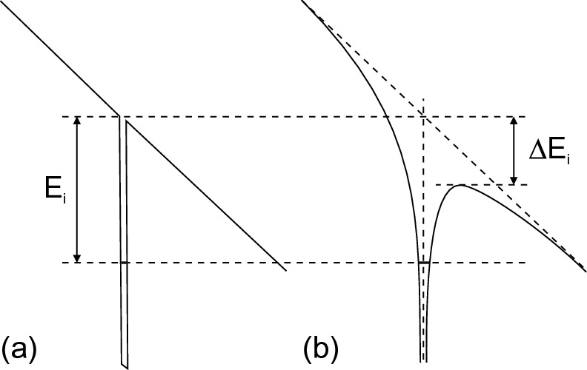

Fig. 10.30

Field effect at **a** a

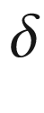

-like potential and **b** a Coulomb potential

#### 10.11.1 Thermally Activated Emission

For the

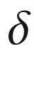

-like potential the ionization energy remains unchanged. For the Coulomb potential the barrier in the field direction is lowered by

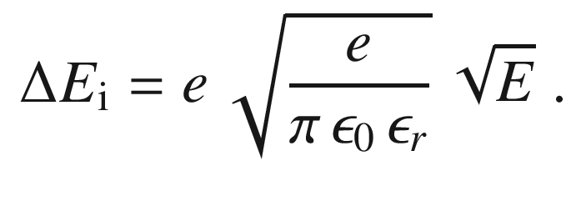

(10.60)

The emission rate



is increased in the field by

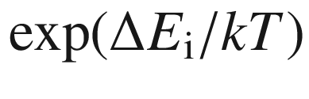

. This effect is called the Poole–Frenkel effect [1028] and can be quite important. For silicon and

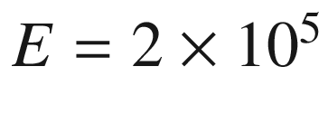

 V/cm and

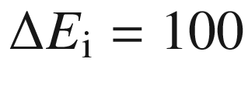

 meV a 50-fold increase of the emission rate at room temperature is expected. As an example the Poole–Frenkel effect for the electron emission from (neutral) interstitial boron in silicon (

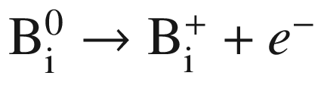

) is shown in Fig. [10.31](#u116076_4_En_10_Chapter-Fig31), following the enhancement of

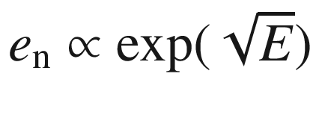

. The extrapolation to

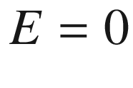

agrees with the EPR result [275, 1029].[5](#u116076_4_En_10_Chapter-Fn5)

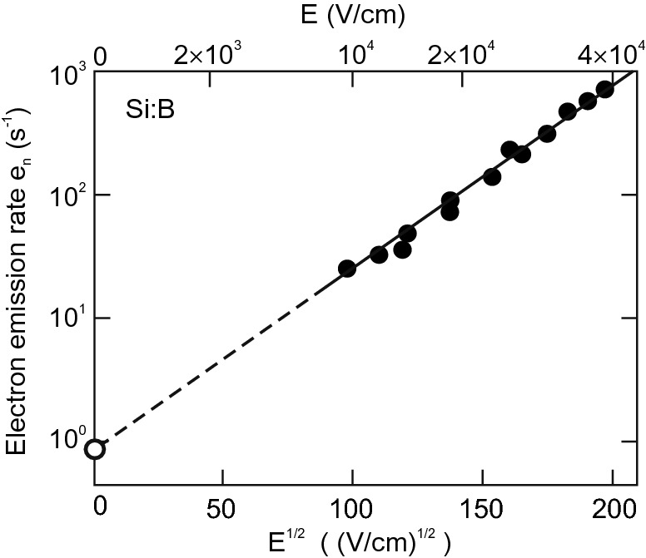

Fig. 10.31

Field effect for electron emission from interstitial boron in silicon (

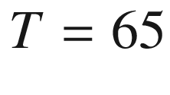

 K). The *filled circles* represent experimental data from DLTS, the data point marked with an *empty circle* is from EPR (zero field). The *line* is a linear fit and extrapolation.

Adapted from [1029]

#### 10.11.2 Direct Tunneling

Carriers can tunnel from the trap level through the barrier in the field direction into the conduction band. This process is temperature independent. The transmission factor of a barrier is (in WKB approximation) proportional to

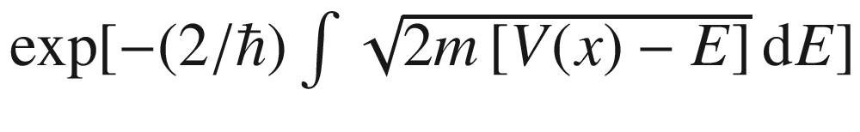

. The emission probability for a triangular barrier is then

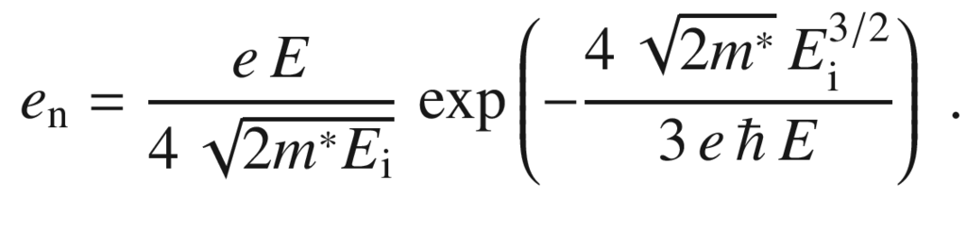

(10.61)

In the case of a Coulomb-like potential the argument of the exponent in ([10.61](#u116076_4_En_10_Chapter-Equ62)) needs to be multiplied by a factor

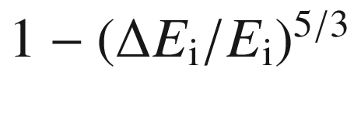

with

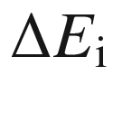

from ([10.60](#u116076_4_En_10_Chapter-Equ61)).

#### 10.11.3 Assisted Tunneling

In a thermally assisted tunneling process the electron on the trap level is first excited to a virtual level

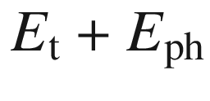

by phonon absorption and then tunnels out of the trap (photon-assisted tunneling). From the energetically higher level the tunneling rate is higher. The probability is proportional to

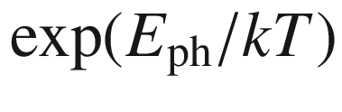

. The additional energy can also be supplied by a photon (photon-assisted tunneling).

### 10.12 Recombination at Extended Defects

#### 10.12.1 Surfaces

A surface (cmp. Chap. [11](#u116076_4_En_11_Chapter)) is typically a source of recombination, e.g. through midgap levels induced by the break of crystal symmetry. The recombination at surfaces is modeled as a recombination current

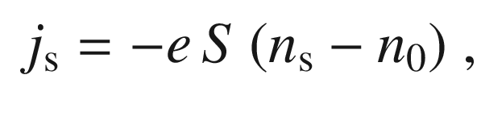

(10.62)

where

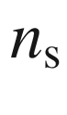

is the carrier density at the surface and *S* is the so-called *surface recombination velocity*.

The surface recombination velocity for GaAs is shown in Fig. [10.32](#u116076_4_En_10_Chapter-Fig32). For InP, if the surface Fermi level is pinned close to midgap, the surface recombination velocity increases from

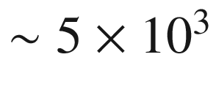

 cm/s for a doping level of

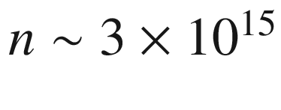

 cm



to

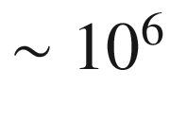

 cm/s for a doping level of

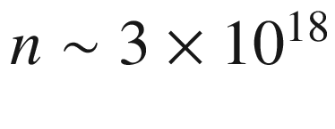

 cm



[1030]. For Si, the surface recombination rate depends on the treatment of the surface and lies in the range between 1–

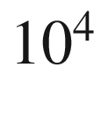

 cm/s [1031, 1032]. The Si-SiO



interface can exhibit

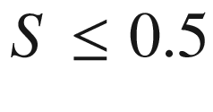

 cm/s. Time-resolved measurements and detailed modeling for Si have been reported in [1033].

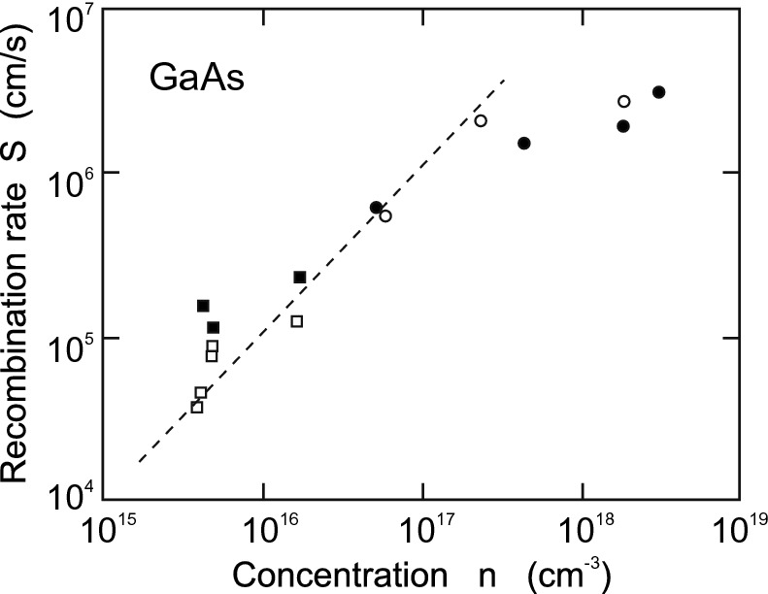

Fig. 10.32

Surface recombination velocity for GaAs as a function of n-type doping concentration. Different experimental points correspond to different surface treatment methods. *Dashed line* is a guide to the eye. Experimental data from [1034]

The recombination velocity at surfaces can be reduced using suitable passivation schemes. Typically inert layers or chemical treatments are used. Surface passivation can be accomplished in two fundamentally different ways: Either the surface defect states themselves are removed or an internal electrical field is established that screens excess charge carriers from the surface defects. Sulfur chemistry is a popular treatment of GaAs surfaces. A review of the passivation schemes for III–V semiconductors can be found in [1035].

#### 10.12.2 Grain Boundaries

Grain boundaries can be a source of non-radiative recombination. This is technologically important for solar cells made from polycrystalline silicon (cf. Sect. [22.​4.​6](The_Physics_of_Semiconductors00008.docx#u116076_4_En_22_Chapter)). The grain boundary can be understood as an inner surface in the crystal. Modeling of recombination at a grain boundary can be done using an interface recombination velocity [1036, 1037] or considering deep traps [1038]. The minority carrier lifetime decreases with decreasing grain boundary area *A* (Fig. [10.33](#u116076_4_En_10_Chapter-Fig33)a). The carrier loss at a grain boundary can be imaged directly via the efficiency of the collection of an electron beam induced current (EBIC) as shown in Fig. [10.33](#u116076_4_En_10_Chapter-Fig33)b. The minority carrier lifetime is only unaffected when the average distance to a grain boundary is much larger than the minority carrier diffusion length,

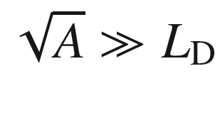

, otherwise the entire grain volume is subject to non-radiative recombination.

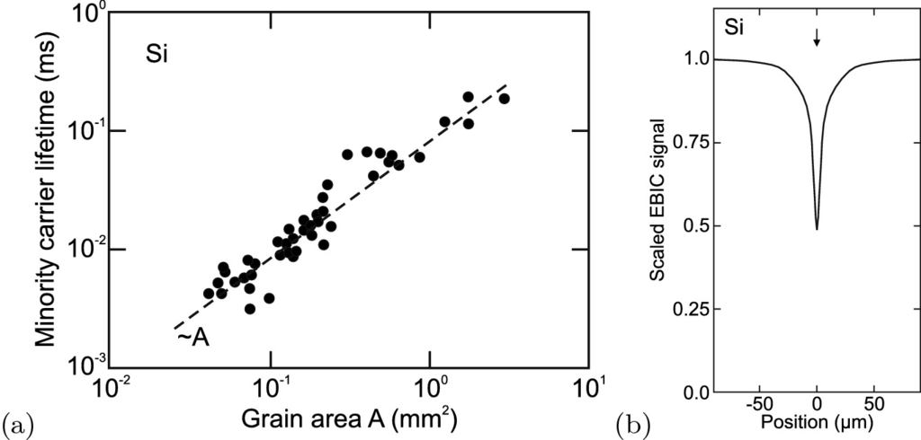

Fig. 10.33

**a** Minority carrier lifetime in (p-type) silicon as a function of grain boundary size. The *dashed line* has the slope

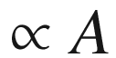

. Data from [1039]. **b** Linescan of the electron beam induced current (EBIC) perpendicular to a single grain boundary in silicon. The arrow denotes the position of the grain boundary.

Compiled from [1040]

The recombination velocity at grain boundaries can be reduced, similar to that at surfaces, using suitable passivation schemes. A famous one is the chlorine treatment of polycrystalline CdTe used in thin film solar cells [1041].

#### 10.12.3 Dislocations

Also dislocations typically act as recombination centers, sometimes called carrier sinks. In Fig. [10.34](#u116076_4_En_10_Chapter-Fig34) it can be seen that the minority carrier lifetime depends on the dislocation density

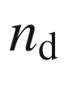

and follows a

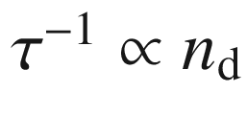

law, as if each dislocation is a recombination center [1042]. The non-radiative recombination makes dislocations appear as ‘dark line defects’ in luminescence imaging [1043]. In [1044] also the decrease of carrier lifetime around (misfit) dislocations has been imaged. The effect of dislocations on the radiative recombination efficiency depends on the diffusion length [1044].

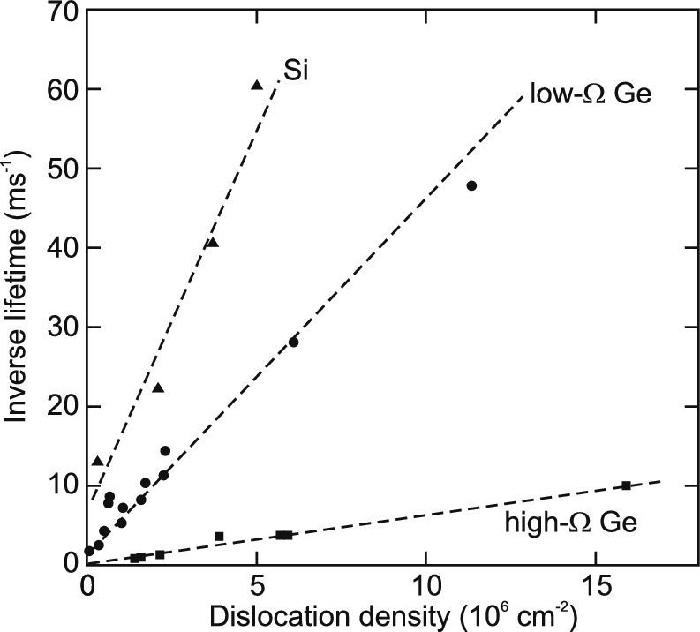

Fig. 10.34

Inverse minority carrier lifetime in n-type silicon (40

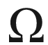

 cm), low resistivity Ge (3–5

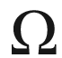

 cm) and high resistivity Ge (30–40

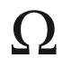

 cm).

Data from [1042]

### 10.13 Excess-Carrier Profiles

In this section, some typical excess-carrier profiles (in one-dimensional geometry) are discussed that arise from certain excitation conditions. The excess-carrier density

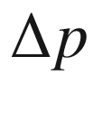

(here holes in an n-type semiconductor, i.e.

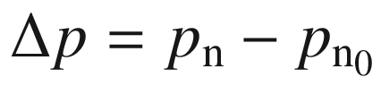

) is determined by the diffusion equation (cf. ([8.​65a](The_Physics_of_Semiconductors00004.docx#u116076_4_En_8_Chapter)))

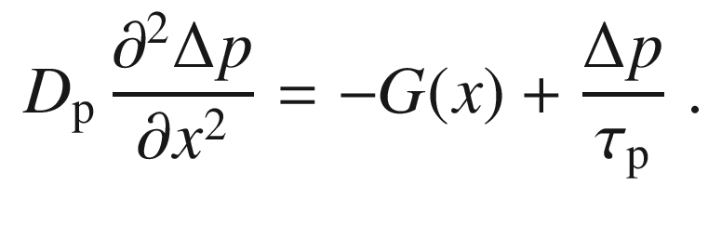

(10.63)

#### 10.13.1 Generation at Surface

First, the generation of excess carriers in a semi-infinite piece of semiconductor shall occur only at the surface at

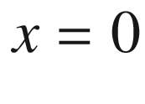

(strong absorption limit). The generation is zero everywhere else and the excitation is incorporated via the boundary condition

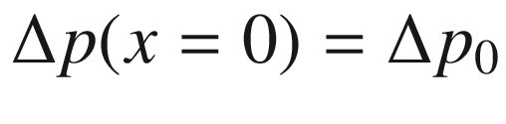

. The general solution for the homogeneous equation ([10.63](#u116076_4_En_10_Chapter-Equ64)), i.e.

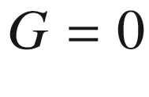

, is

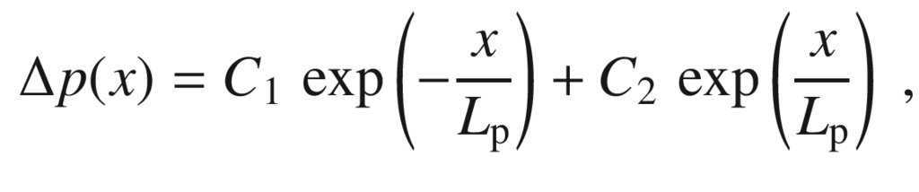

(10.64)

with the diffusion length

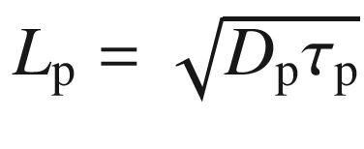

. Taking the boundary condition

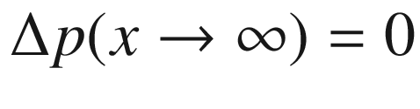

the solution is (

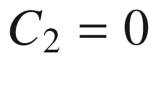

)

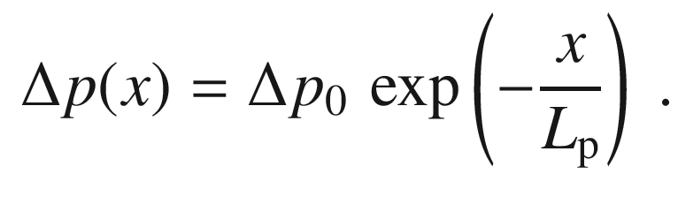

(10.65)

In order to connect

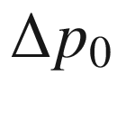

with the total generation rate per unit area

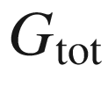

, we calculate

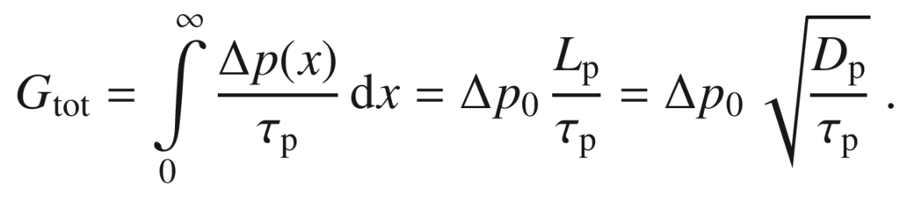

(10.66)

If a slab of finite thickness *d* is considered, the boundary condition on the back surface comes into play. Assuming a contact that extracts all excess charge carriers,

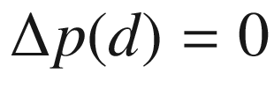

. In conjunction with ([10.64](#u116076_4_En_10_Chapter-Equ65)), we find

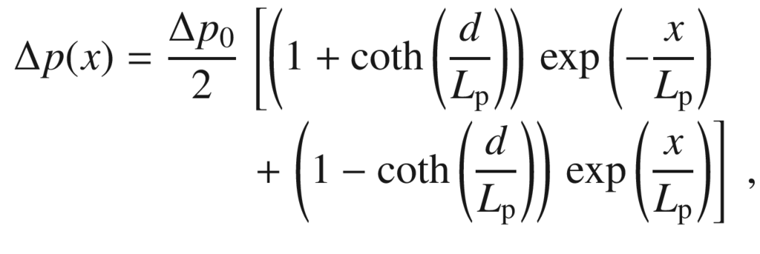

(10.67)

with

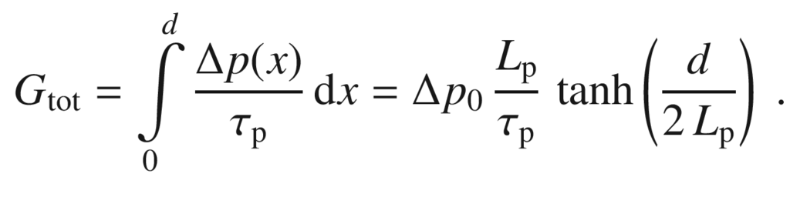

(10.68)

Generally, the excited electrons and holes diffuse into the bulk at different speed due to their different diffusion length (or mobility). As consequence, a spatial separation of electrons and hole densities occurs which leads to an electric field, the Dember field   [1045–1047]. The illuminated surface becomes positive compared to the dark case since

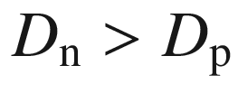

. A treatment of the non-neutral diffusion situation is given in [1048]. As shown in Fig. [10.35](#u116076_4_En_10_Chapter-Fig35), the non-equal electron and hole densities create locally a non-zero charge density

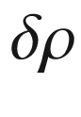

and an associated potential

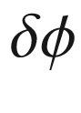

; for a silicon material parameters (

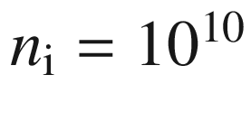

 cm

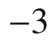

), the Dember voltage is calculated as

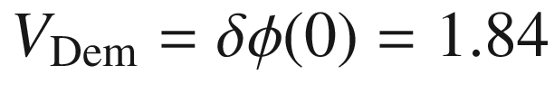

 meV for a generation rate of

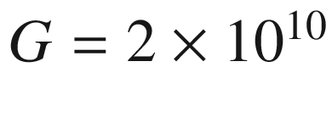

/(cm

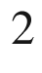

 s). Extensions of the theory have been given considering traps [1049] and the effect of finite sample thickness and surface recombination [1050] (under certain conditions, the sign of the field can be reverse).

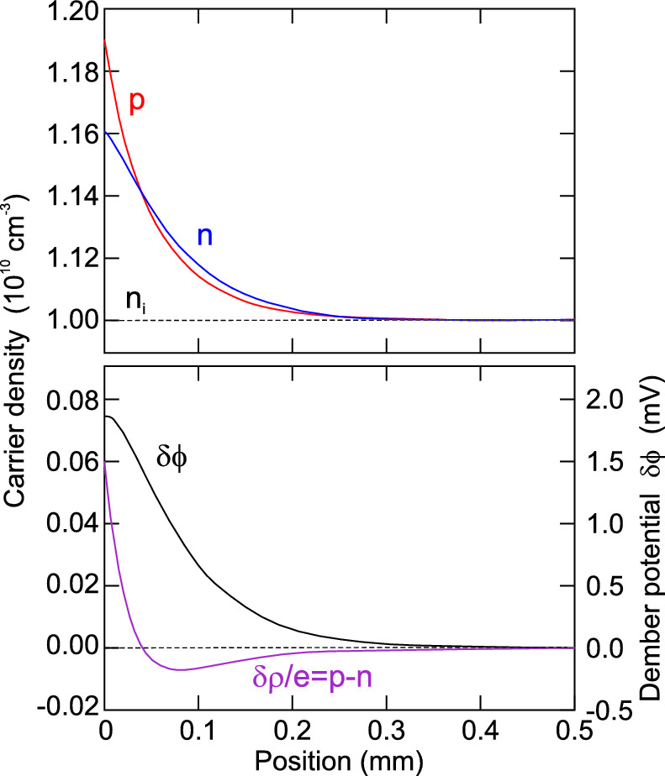

Fig. 10.35

Charge carrier density profiles (in a semi-infinite slab) for electrons and holes as well as their difference

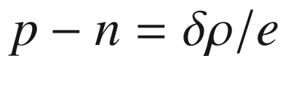

, as well as the associated Dember potential

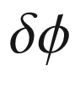

. The ratio of electron and hole mobility in this model calculation (using silicon material parameters) was 5.

Adapted from [1048]

#### 10.13.2 Generation in the Bulk

Now, a generation rate following ([9.​16](The_Physics_of_Semiconductors00004.docx#u116076_4_En_9_Chapter)), realistic for photodiodes and solar cells, is considered,

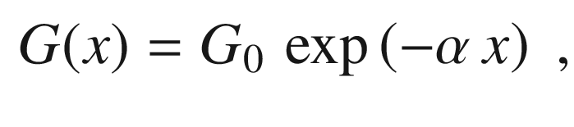

(10.69)

i.e. due to light absorption with the (wavelength-dependent) absorption coefficient



. The total generation rate is

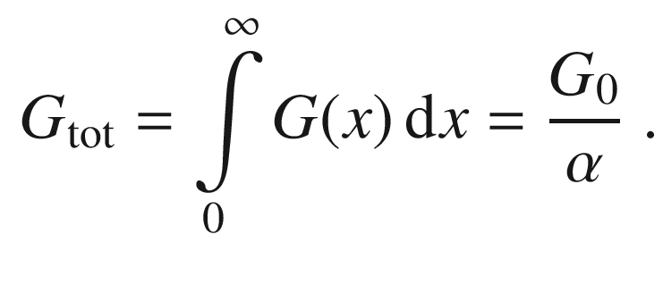

(10.70)

The total generation rate is equal to the number of photons per second

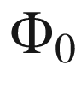

that enter the semiconductor.

The solution of ([10.63](#u116076_4_En_10_Chapter-Equ64)) is the sum of the homogeneous solution ([10.64](#u116076_4_En_10_Chapter-Equ65)) and a particular solution that is given by

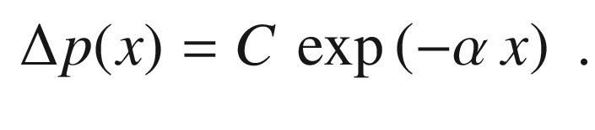

(10.71)

The constant *C* is determined to be

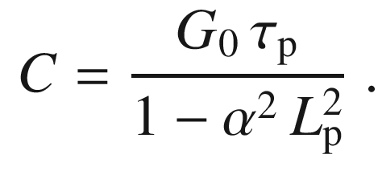

(10.72)

Therefore, the solution is

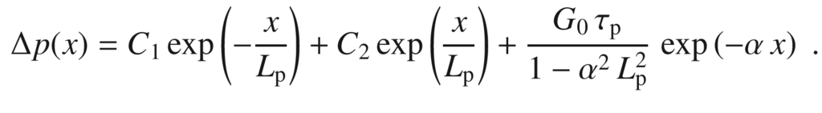

(10.73)

Using again



(leading to



) and a recombination velocity *S* at the front surface, i.e.

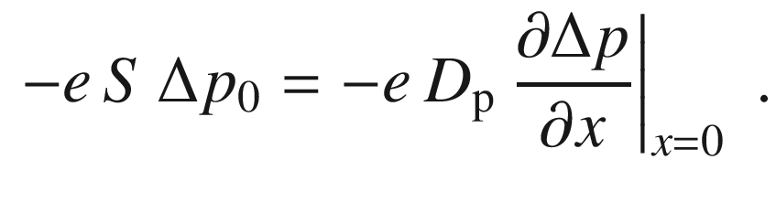

(10.74)

The solution is given as

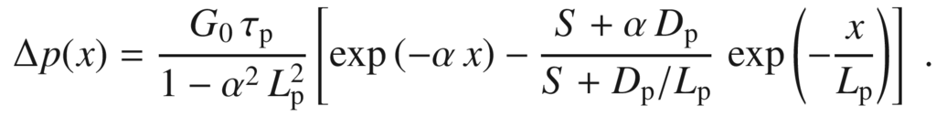

(10.75)

For vanishing surface recombination,

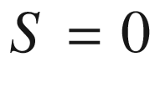

, the solution is (Fig. [10.36](#u116076_4_En_10_Chapter-Fig36))

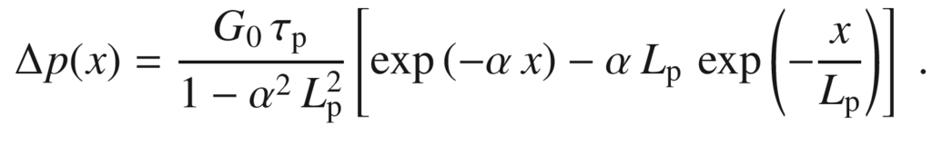

(10.76)

For

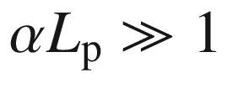

, ([10.65](#u116076_4_En_10_Chapter-Equ66)) is recovered. This dependence is the excess-carrier profile if the absorption is strong, which is a tendency for short wavelengths. The current at the surface,

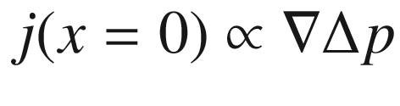

, is zero.

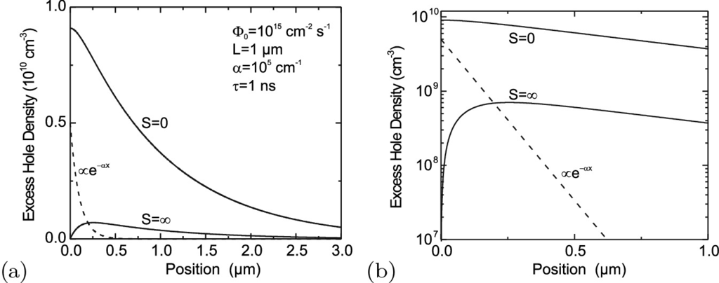

Fig. 10.36

Excess carrier density profile ([10.75](#u116076_4_En_10_Chapter-Equ76)) in **a** linear and **b** semi-logarithmic plot for

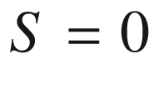

and

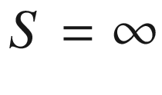

. Other parameters are given in panel (**a**)

In the case of very strong surface recombination,

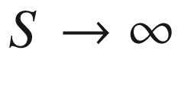

, ([10.75](#u116076_4_En_10_Chapter-Equ76)) becomes

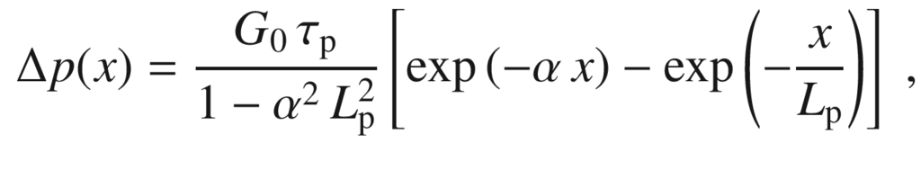

(10.77)

with

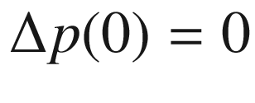

(Fig. [10.36](#u116076_4_En_10_Chapter-Fig36)). The current at the surface is (

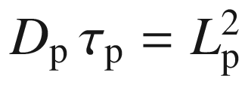

)

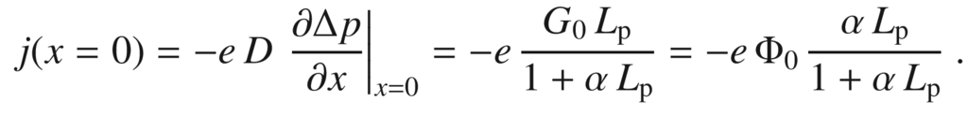

(10.78)

Footnotes

[1](#u116076_4_En_10_Chapter-Fn1_source)

In the relaxation case, the separation of quasi-Fermi levels is

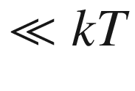

.

[2](#u116076_4_En_10_Chapter-Fn2_source)

Excitonic effects are neglected here, e.g. for temperatures

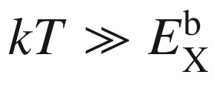

. Such effects are discussed in Sect. [10.3](#u116076_4_En_10_Chapter-Sec9).

[3](#u116076_4_En_10_Chapter-Fn3_source)

The total number of photon states in vacuum between the frequencies zero and

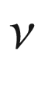

is

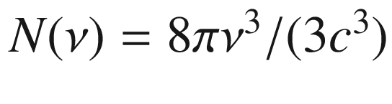

. With

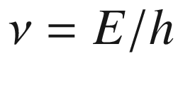

and

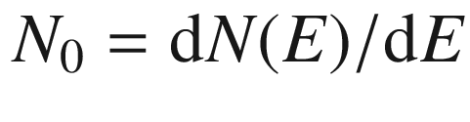

and considering

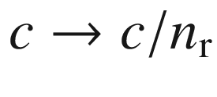

we obtain the given value for

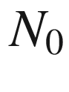

.

[4](#u116076_4_En_10_Chapter-Fn4_source)

Depending on the energetic depth of the trap, mid or far infrared photons can be emitted.

[5](#u116076_4_En_10_Chapter-Fn5_source)

The slope of the line in Fig. [10.31](#u116076_4_En_10_Chapter-Fig31) is slightly smaller than expected from ([10.60](#u116076_4_En_10_Chapter-Equ61)).

# Part IISelected Topics

© Springer Nature Switzerland AG 2021

M. Grundmann

The Physics of Semiconductors

Graduate Texts in Physics

<https://doi.org/10.1007/978-3-030-51569-0_11>

## 11. Surfaces

Marius Grundmann[1](#u116076_4_En_11_Chapter-Aff11)

(1)

Felix Bloch Institute for Solid State Physics, Universität Leipzig, Leipzig, Germany

Marius Grundmann

Email:

[grundmann@physik.uni-leipzig.de](mailto:grundmann@physik.uni-leipzig.de)

*Gott schuf das Volumen, der Teufel die Oberfläche.*

*God created the bulk; surfaces were made by the devil.*

*attributed to W. Pauli*

## Abstract

The specifics of semiconductors surfaces, their symmetry, equilibrium crystal shape, reconstructions, steps and faceting are summarized, being important for epitaxy. Physical surface properties such as vibrational and electronic states are discussed.

### 11.1 Introduction

Obviously every crystal has a surface all around it, connecting it to the surrounding world. This represents a brutal perturbation of the bulk periodicity with the consequence of a whole new world of physics at the surface. With regard to semiconductor technology, the surface properties are of large importance in a number of instances:

The crystal growth of semiconductors always occurs at a surface. This subject will be discussed in Chap. [12](#u116076_4_En_12_Chapter).

The surface is subject to interaction with the chemistry of the surrounding atmosphere. This is of essential importance for catalysis, e.g., oxidation of CO at noble metals or photocatalytic water splitting, e.g., using TiO



, into oxygen and hydrogen [1051, 1052]. Photocatalysis is briefly discussed in Sect. [22.​1](The_Physics_of_Semiconductors00008.docx#u116076_4_En_22_Chapter). The interaction and reaction with the surrounding atmosphere can lead modifications of the semiconductor such as change of conductivity, e.g.., in SnO



, which can be used in the construction of gas detectors [1053–1055].

Surface passivation and barriers, e.g., using photoresist, silicon oxides or nitrides, are often necessary in practical devices in order to avoid surface recombination (Sect. [10.​12.​1](#u116076_4_En_10_Chapter)) or the interaction with atmospheric oxygen or water.

But surface physics is interesting in its own right, investigating the properties of a complex mostly two-dimensional system. ‘Pure’ surfaces are studied using crystals cleaved in ultra-high vacuum or carefully prepared atomically clean surfaces. A special case are two-dimensional materials, also termed atomic sheets, such as graphene; these will be discussed in Sect. [13.​1](The_Physics_of_Semiconductors00006.docx#u116076_4_En_13_Chapter).

At the surface the atoms rearrange, compared to their bulk positions, vertically and laterally, also forming new bonds (surface reconstructions). The mechanical properties (surface phonons) and electronic properties (surface states) are different from the bulk modes. Detailed treatments of surface physics and its experimental methods can be found in [695, 1056–1058].

### 11.2 Surface Crystallography

The surface symmetry, i.e. the two-dimensional spatial periodicity of the constituent atoms, is described with the ten two-dimensional point groups (Table B.1). The point symmetries are 1-, 2-, 3-, 4-, and 6-fold rotational symmetry (Fig. [3.​9](The_Physics_of_Semiconductors00002.docx#u116076_4_En_3_Chapter-Fig9)) with or without mirror plane(s). The two-dimensional point symmetries of popular substrate orientations are compiled in Table [11.1](#u116076_4_En_11_Chapter-Tab1); the different symmetry of the first layer and the half-space are notable. The combination of five 2D Bravais lattices (cmp. Sect. [3.​3.​1](The_Physics_of_Semiconductors00001.docx#u116076_4_En_3_Chapter)) with the 10 2D point groups leads to the 17 two-dimensional space groups (wallpaper groups) [1059].Table 11.1

Two-dimensional point symmetries of common substrates with ideal low-index surfaces

| Crystal | Surface | 1st layer | 1st & 2nd layers | Half space |
| --- | --- | --- | --- | --- |
| Rocksalt | (001) | 4 mm | 4 mm | 4 mm |
| (110) | 2 mm | 2 mm | 2 mm |
| (111) | 6 mm | 3 m | 3 m |
| Diamond | (001) | 4 mm | 2 mm | 2 mm |
| (110) | 2 mm | 2 mm | 2 mm |
| (111) | 6 mm | 3 m | 3 m |
| Zincblende | (001) | 4 mm | 2 mm | 2 mm |
| (110) | 1 m | 1 m | 1 m |
| (111) | 6 mm | 3 m | 3 m |
| Wurtzite | (00.1) | 6 mm | 3 m | 3 m |
| (10.1) | 2 mm | 2 mm | 1 m |
| (11.0) | 2 mm | 2 mm | 1 m |

For the treatment of surface in reciprocal space, the three-dimensional



-vector is split into the two-dimensional component

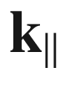

parallel and the one-dimensional component

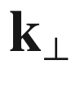

perpendicular to the surface,

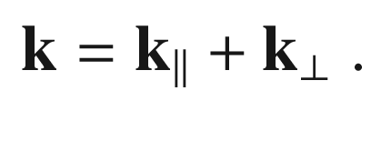

(11.1)

The three most important Brillouin zones in two-dimensional



-space are depicted in Fig. [11.1](#u116076_4_En_11_Chapter-Fig1). Often the special points of the 2D Brillouin zones are denoted with a bar over the letter.

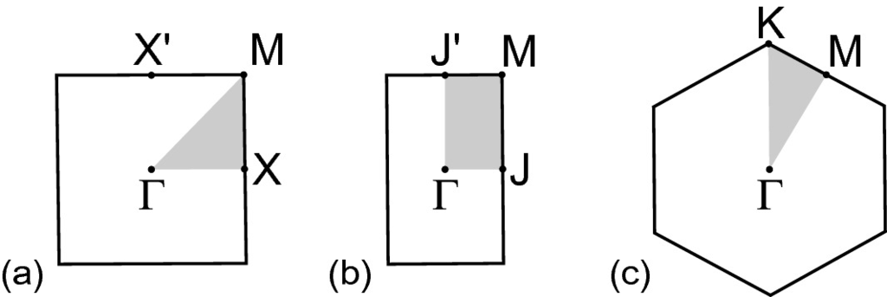

Fig. 11.1

Two-dimensional Brillouin zones for **a** square, **b** rectangular and **c** hexagonal surface symmetry. Special points are labelled and the *grey areas* indicate the smallest irreducible area

### 11.3 Surface Energy

The surface energy, more precisely the surface energy per area

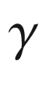

, is related to the work that is necessary to split a crystal in two parts. Such process will leave broken (‘dangling’) bonds. This energy will depend on the crystal orientation as is already clear from the fact that there are easy cleaving planes (Sect. [5.​4.​2](The_Physics_of_Semiconductors00002.docx#u116076_4_En_5_Chapter)). The surface energy will also depend on the surface reconstruction (see Sect. [11.4](#u116076_4_En_11_Chapter-Sec4)), i.e. the rearrangement of surface bonds and atoms. Generally, the reduction of the number of dangling bonds on a surface lowers its energy, while the distortion of bonds increases its energy.

The anisotropy of the surface energy for a given orientation *hkl*,

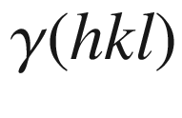

, determines the equilibrium crystal shape (ECS) at a given temperature (below melting temperature). The crystallite is assumed to be of at least mesoscopic size such that energy effects due to edges and apexes can be neglected compared to the surface energy terms. As an example theoretically calculated surface energy values for covalent semiconductors are listed in Table [11.2](#u116076_4_En_11_Chapter-Tab2). The equilibrium shape of silicon has been observed for

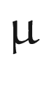

m-sized bulbs as shown in Fig. [11.2](#u116076_4_En_11_Chapter-Fig2)a for

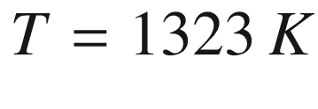

; the experimental anisotropy of surface energy of silicon is shown in Fig. [11.2](#u116076_4_En_11_Chapter-Fig2)b.Table 11.2

Surface energy (in J/m

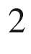

) for various C, Si and Ge surfaces. Data from [1060]

| Material | $$\{111\}$$ | $$\{110\}$$ | $$\{100\}$$ | $$\{311\}$$ |
| --- | --- | --- | --- | --- |
| C | 8.12 | 7.48 | 9.72 | 8.34 |
| Si | 1.82 | 2.04 | 2.39 | 2.12 |
| Ge | 1.32 | 1.51 | 1.71 | 1.61 |

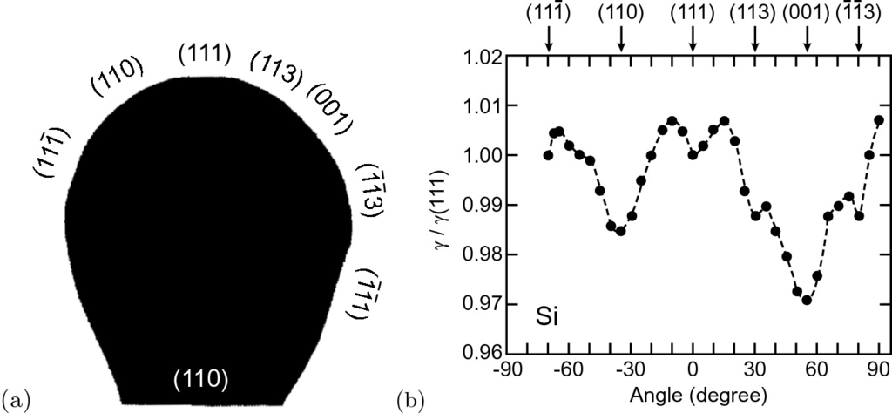

Fig. 11.2

**a** Equilibrium crystal shape (cross section in

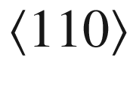

azimuth) of 1.06

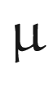

m diameter Si bulb at

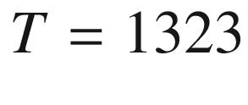

 K with facet orientations as labelled. **a** Anisotropy of surface energy (relative to

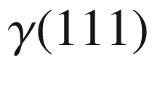

) for Si, the *dashed line* is guide to the eye.

Adapted from [1061]

### 11.4 Surface Reconstruction

When in a *Gedankenexperiment* the bulk crystal is split such that a surface with defined orientation develops, many bonds are cut. These dangling bonds can be saturated with other atoms such as hydrogen. In particular under vacuum conditions, the dangling bonds will rearrange and form new bonds such as dimers along the surface, lowering the total energy. This surface reconstruction displays two-dimensional periodicity of a surface unit cell.

Since the forces from the split-away half-space are missing, the atomic planes will rearrange vertically[1](#u116076_4_En_11_Chapter-Fn1) and the surface-near layers will exhibit slightly different lattice spacing than in bulk. In [1062] the surface reconstructions of many semiconductors are reviewed. In Fig. [11.3](#u116076_4_En_11_Chapter-Fig3)a the rearrangement of surface atoms on GaAs(110) is depicted as an example. The anion is moved up, the cation moved down, preserving the bond length, rotating the bond by about

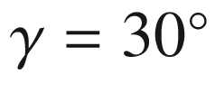

for various III–V semiconductors [1063] (Fig. [11.3](#u116076_4_En_11_Chapter-Fig3)b). The height difference of the top anion and cation

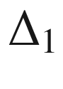

scales with the bulk lattice constant (Fig. [11.3](#u116076_4_En_11_Chapter-Fig3)c). The details are specific to materials and orientations.

Different reconstructions occur for different thermodynamical conditions, some of them being metastable, as depicted for GaAs(100) in Fig. [11.4](#u116076_4_En_11_Chapter-Fig4). Several different surface reconstructions can also be present simultaneously at a surface within different domains.

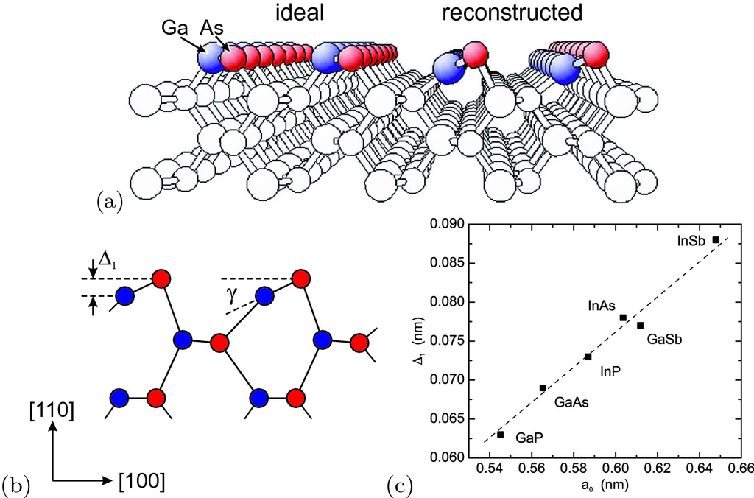

Fig. 11.3

**a** Schematic drawing of the GaAs(110) surface after cutting bonds (‘ideal’) and actual atomic rearrangement with asymmetric dimer in the reconstructed state. Adapted from [1064]. **b** Schematic of the III–V (110) surface relaxation (*red circles*: anions, *blue circles*: cations) with bond rotation

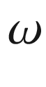

and atom shift

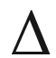

. **c** Experimental values for he relaxation

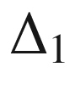

as shown in panel (**b**) for various semiconductors vs. their bulk lattice constant

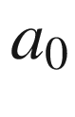

; *dashed line* is straight line as guide to the eye.

Data from [1063]

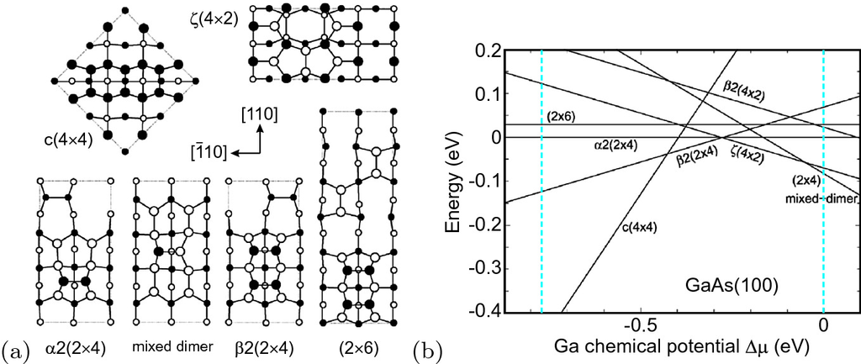

Fig. 11.4

**a** Various reconstructions of the GaAs(100) surface. *Filled* (*empty*) *circles* represent As (Ga) atoms. Atom positions in the top two atomic layers are indicated by *larger symbols*. **b** The relative formation energy per (

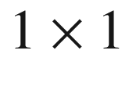

) unit cell of various reconstructions as a function of the Ga chemical potential. *Vertical dashed lines* mark the approximate anion- and cation-rich limits of the thermodynamically allowed range of

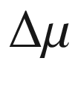

.

Adapted from [1065]

The stable reconstruction of the Si(111) surface is the somewhat complicated

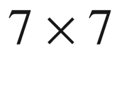

reconstruction which is schematically depicted in Fig. [11.5](#u116076_4_En_11_Chapter-Fig5)a as proposed in [1066] (‘DAS’ dimer-adatom-stacking fault model’). A STM image of this surface has been reported first in [1067] and is depicted in Fig. [11.5](#u116076_4_En_11_Chapter-Fig5)b. Details of this surface are also recently a subject of interest [1068].

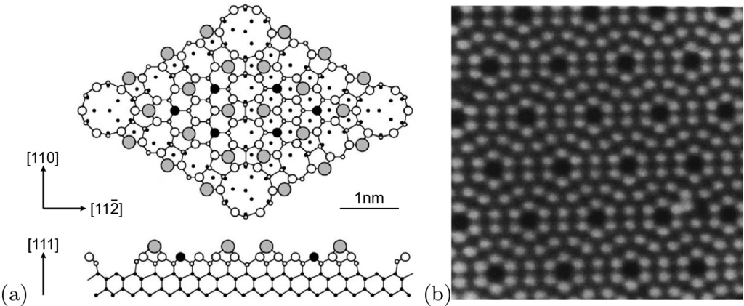

Fig. 11.5

**a** Schematic drawing of the

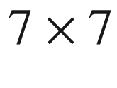

reconstruction of Si(111) surface. The *large grey circles* represent adatoms, the *small balck circles* rest atoms. Adapted from [1066] **b** STM image (empty states) of such surface.

Adapted from [1067]

### 11.5 Surface Morphology

The surface reconstruction is related to the local atomic arrangement of the surface atoms. On larger length scales, surfaces can exhibit roughness in general and various specific morphologies, among them steps, step bunches, facets, hillocks or pits. When atomically flat terraces are separated by steps of equal heights, the surface is termed *vicinal*. The step height can be an atomic monolayer or more. The step edges can be straight, smoothly curved or rugged, depending on the formation energy of kinks. If the substrate surface is inclined by a small ‘off-cut’ angle

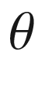

with respect to a low index plane, for a step height *h* the average terrace width *L* is given by

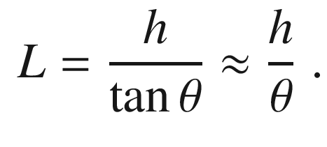

(11.2)

The Si(001) surface (under certain conditions) exhibits monoatomic steps between the A-type

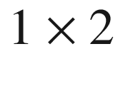

and B-type

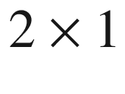

terraces [1069]; clearly also the step edges between A–B and B–A are quite different, one being much rougher than the other (Fig. [11.6](#u116076_4_En_11_Chapter-Fig6)). The surface is thus a two domain surface, the symmetry of both A- and B-type terraces being 2 mm, rotated by 90

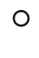

against each other.

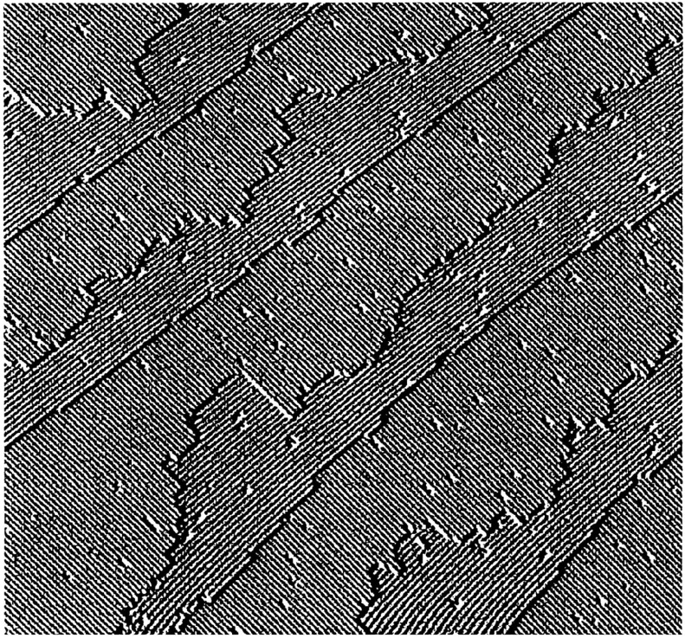

Fig. 11.6

STM image of Si(001) surface with an off-cut

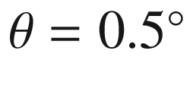

.

Adapted from [1069]

A similar example is the Zn(00.1) surface. The found step height of the monoatomic steps is 0.27 nm and corresponds *c*/2 [1070]. The terrace width is about 12 nm (Fig. [11.7](#u116076_4_En_11_Chapter-Fig7)a), yielding an off-cut ([11.2](#u116076_4_En_11_Chapter-Equ2)) of about

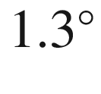

. The surface pattern shows triangular features in two orientations, rotated by 60

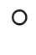

. The 3*m* symmetry of the surface, although the first monolayer has 6 m point symmetry (Table [11.1](#u116076_4_En_11_Chapter-Tab1)), occurs in two domains rotated against each other by 60



. The LEED pattern from each individual terrace is expected to have three-fold symmetry; the mixed character of the surface yields a six-fold pattern (Fig. [11.7](#u116076_4_En_11_Chapter-Fig7)b).

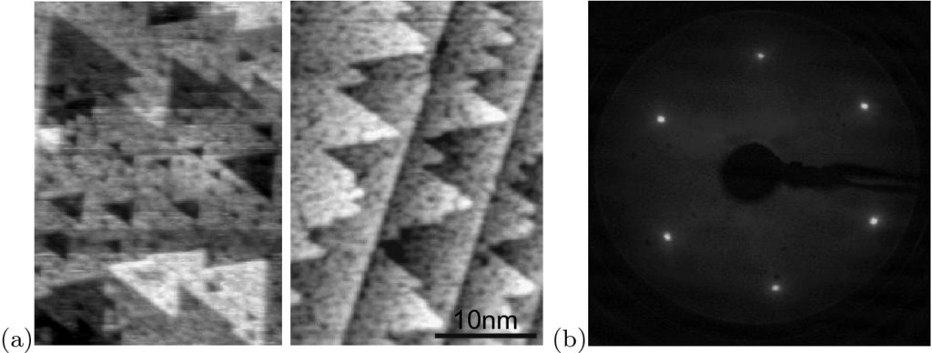

Fig. 11.7

**a** STM images a ZnO(00.1) O-terminated surface, left (right) panel with zero (about

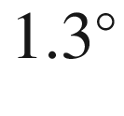

) off-cut, exhibiting monolayer step heights of 0.27 nm. **a** LEED pattern of such surface (recorded at 70 eV).

Adapted from [1070]

Steps can gather and form step bunches with a height much larger than a monolayer (Fig. [11.8](#u116076_4_En_11_Chapter-Fig8)). Faceting of higher index planes occurs when it is energetically favorable to form alternating facets of low energy low index planes, for example Si(223) exhibits periodic ridges with (111) and (113) facets [1071]. The faceting of a surface close to (113), exhibiting smooth (113) and rough (114) planes, is depicted in Fig. [11.9](#u116076_4_En_11_Chapter-Fig9).

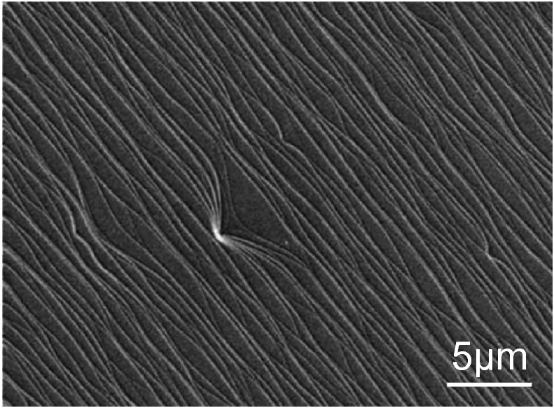

Fig. 11.8

SEM image of the surface of a 4H–SiC layer on [00.1]-oriented substrate with 8



misorientation towards [11.0].

Adapted from [1072]

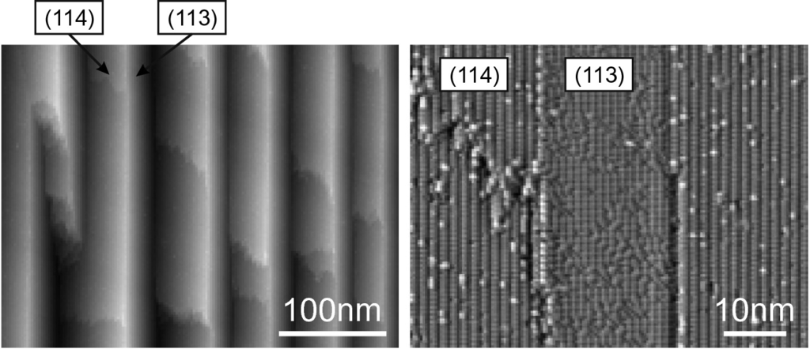

Fig. 11.9

STM images of a silicon surface close to (113), 21.5

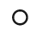

from (001) towards (111), i.e. (113)-3.7



.

Adapted from [1073]

### 11.6 Surface Physical Properties

#### 11.6.1 Surface Phonons

As a model for surface vibrational states, the diatomic one-dimensional chain model discussed in Sect. [5.​2.​2](The_Physics_of_Semiconductors00002.docx#u116076_4_En_5_Chapter) can be modified to allow for a different surface spring constant

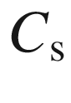

instead of

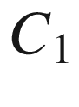

or

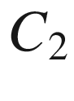

. Such model can be solved numerically for finite chain length. The bulk dispersion is found with an extra mode in the gap or above the maximum frequency for a range of values of



as depicted in Fig. [11.10](#u116076_4_En_11_Chapter-Fig10). When the spring constant of the surface atom is smaller than the larger of the two spring constants

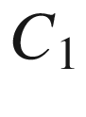

and

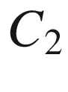

(in our model calculation

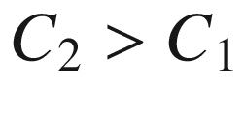

), a state in the gap forms; for a surface spring constant larger than



, first the surface vibration lies within the optical bulk band and then forms a state above the maximum optical frequency

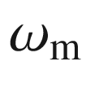

, given by ([5.​18](The_Physics_of_Semiconductors00002.docx#u116076_4_En_5_Chapter)).[2](#u116076_4_En_11_Chapter-Fn2)

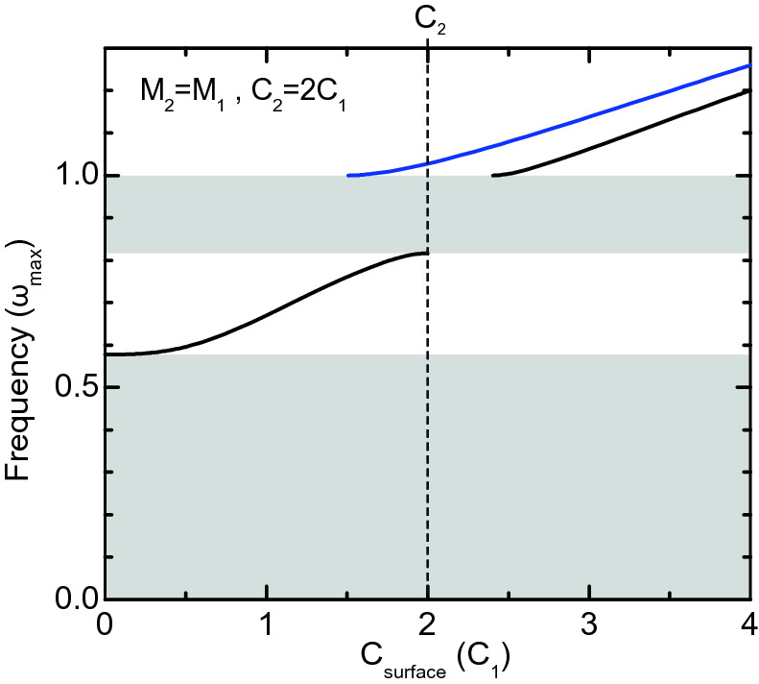

Fig. 11.10

One-dimensional model calculation of surface vibrational state frequency (in units of the maximum bulk optical phonon frequency

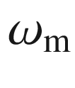

) as a function of the spring constant

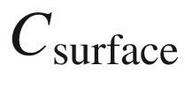

of the surface atom replacing

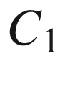

(*blue curve*) or



(*black curves*). As model parameters we use equal masses and

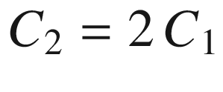

(

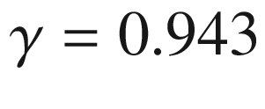

from ([5.​17](The_Physics_of_Semiconductors00002.docx#u116076_4_En_5_Chapter))). The *grey areas* represent the energy range of the acoustic and optical phonon bulk bands

In order to display the dispersion of surface states together with the bulk band structure, the latter is projected to the surface

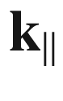

-vector:

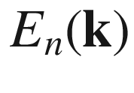

is considered as

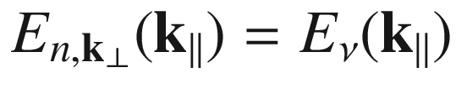

, where

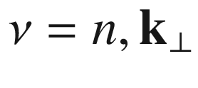

is a new, continuous index. In the plot of

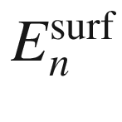

vs.



, for each value of



a *range* of energies reflects the bulk band structure (Fig. [11.11](#u116076_4_En_11_Chapter-Fig11)). This concept pertains to phonon dispersion as well as to electronic states.

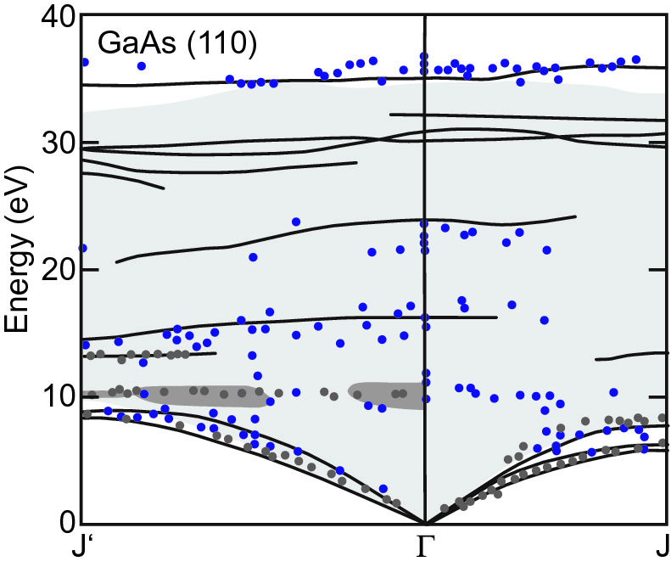

Fig. 11.11

Surface phonon dispersion for GaAs(110) (*solid lines*) with the surface projected bulk band structure (*light grey area*). The *symboles* are experimental data from two different methods. The *dark grey areas* at about 10 meV indicate regions where the A



-peak is present in the calculated scattering cross-section.

Adapted from [1063]

#### 11.6.2 Surface Plasmons

Free-carrier oscillations in the bulk had been discussed in Sect. [9.​9.​1](The_Physics_of_Semiconductors00004.docx#u116076_4_En_9_Chapter). A surface plasmon  is the quantum of a surface-bound plasma oscillation. Such effect has been discussed in [1074] and reviewed in [1075, 1076]. A metal (or conductive semiconductor) with dielectric constant according to ([9.​77](The_Physics_of_Semiconductors00004.docx#u116076_4_En_9_Chapter))

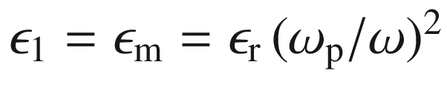

and a dielectric (or vacuum) with

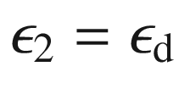

are assumed (Fig. [11.12](#u116076_4_En_11_Chapter-Fig12)).

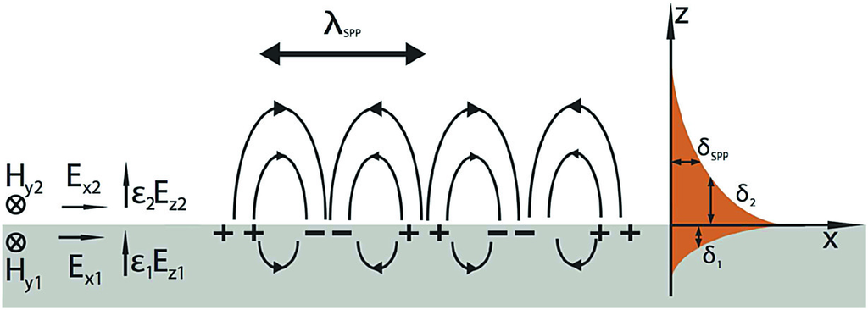

Fig. 11.12

Sketc.h of surface plasmon field distribution.

Adapted from [1077]

The surface plasmon (polariton) (SPP) is a wave localized at the surface with evanescent parts into the metal and the dielectric. The dispersion of the surface plasmon (polariton) is given by

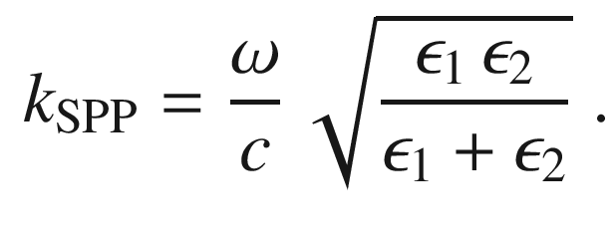

(11.3)

For large *k*, the limiting frequency is the SPP frequency (from

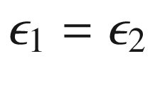

)

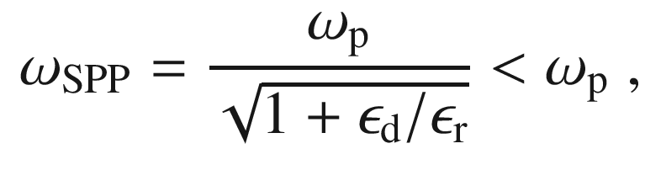

(11.4)

which is smaller than the plasma frequency. For a metal against vacuum,

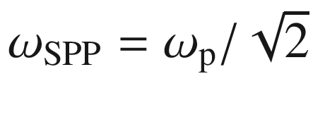

. The SPP dispersion for a ZnO:Ga/air interface is depicted in Fig. [11.13](#u116076_4_En_11_Chapter-Fig13) for three different doping concentrations.

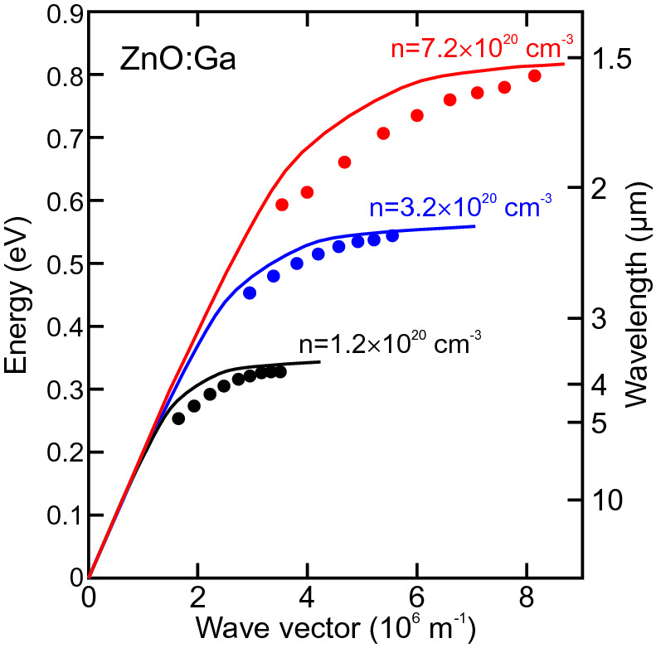

Fig. 11.13

Surface plasmon polariton dispersion for ZnO:Ga/air for three different carrier concentrations as labelled, experimental data (*symbols*) and theory (*lines*).

Adapted from [1078]

#### 11.6.3 Electronic Surface States

The bulk band structure is given by the energy eigenvalues

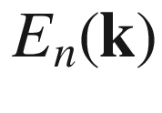

. The surface adds its own states

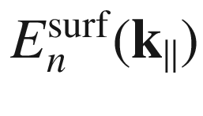

, many of them in the gap. The calculation of gap states has been already briefly discussed in Sect. [6.​2.​3](The_Physics_of_Semiconductors00003.docx#u116076_4_En_6_Chapter). The nature of bulk states is oscillatory in the bulk and exponentially decaying in the outside (Fig. [11.14](#u116076_4_En_11_Chapter-Fig14)a), the nature of surface states is localized at the surface and decaying both towards the bulk and the outside (Fig. [11.14](#u116076_4_En_11_Chapter-Fig14)b). A third type of states is a *surface resonance* which is oscillatory in the bulk and has enhanced probability at the surface, of course also decaying towards the outside (Fig. [11.14](#u116076_4_En_11_Chapter-Fig14)c); such states are surface related but energetically degenerate with states of the bulk band structure.

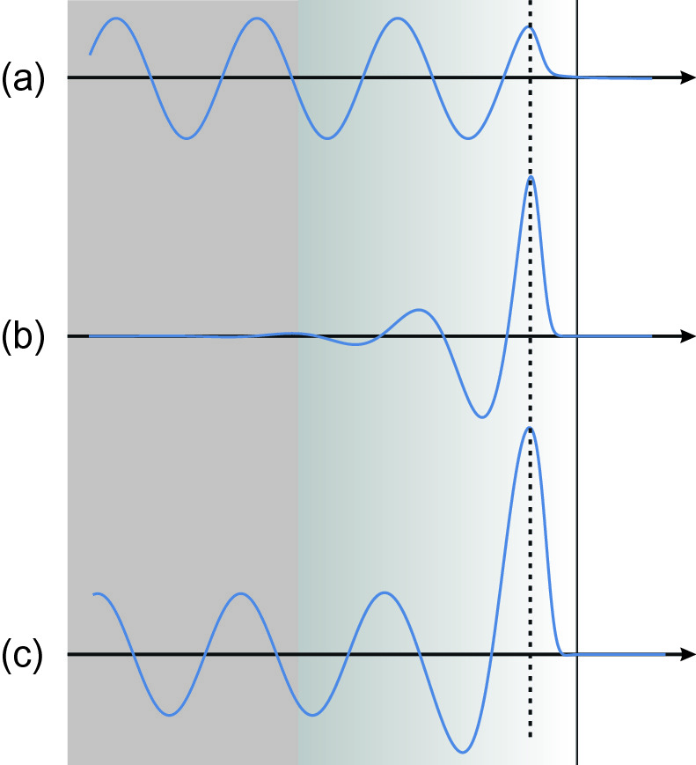

Fig. 11.14

Schematic wavefunction versus coordinate for **a** bulk state in the vicinity of the surface (its position indicated by the *vertical dashed line*), **b** surface state and **c** surface resonance state

Surface states for Si(100) in



reconstruction are shown in Fig. [11.15](#u116076_4_En_11_Chapter-Fig15). The surface bands arise from (filled and unfilled)

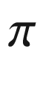

- and

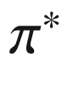

-orbitals from the dangling bonds on the threefold-coordinated surface atoms [1079]. A calculation for the ideal (unreconstructed) (100), (110) and (111) surfaces of Si, Ge and GaAs can be found in [1080]. Further work on silicon surface states (clean and with adsorbates) is compiled in [1081].

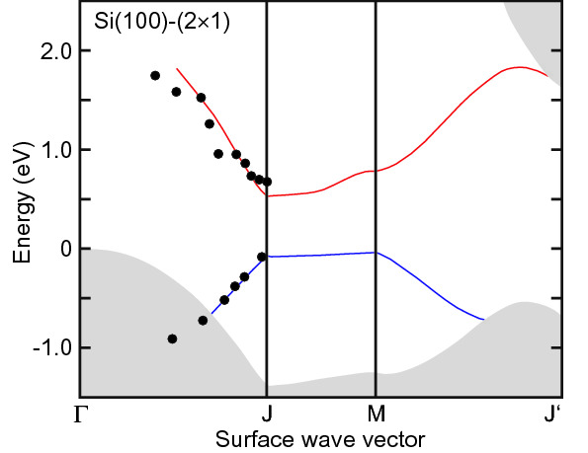

Fig. 11.15

Surface band structure of Si(100)-(

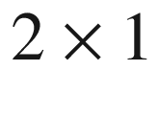

), *lines* denote a theoretical quasi-particle calculation, *symbols* represent experimental data. The *grey areas* indicate the projected bulk band structure.

Adapted from [1079]

For a conventional insulating material (with gap) the states of conduction and valence band have defined s- and p-type symmetry (cmp. Fig. [2.​5](The_Physics_of_Semiconductors00001.docx#u116076_4_En_2_Chapter-Fig5)) and the surface states can be populated with spin up and down electrons as is schematically drawn in Fig. [11.16](#u116076_4_En_11_Chapter-Fig16)a. Such ‘normal’ surface states are thus not spin-polarized. This has been shown, e.g., for the well-known surface states of Si(111)-(



) [1082] in [1083].

In a so-called *topological insulator* [464], a band inversion is present (cf. Sect. [6.​2.​6](The_Physics_of_Semiconductors00003.docx#u116076_4_En_6_Chapter)). In HgTe-like materials, s- and p-type bands are inverted at the

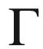

point (cmp. Sect. [6.​11](The_Physics_of_Semiconductors00003.docx#u116076_4_En_6_Chapter)). In layered (orthorhombic) Bi



Se



-like tri-chalcogenide materials two

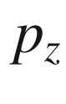

-orbitals with opposite parity are inverted at the

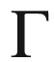

point. Reasons for the band inversion are spin-orbit interaction but also scalar relativistic effects and lattice distortions [1084]. The spin-orbit interaction is responsible for opening a gap; the associated surface states cross the band gap (Fig. [11.16](#u116076_4_En_11_Chapter-Fig16)b) and are spin-polarized (Fig. [11.16](#u116076_4_En_11_Chapter-Fig16)c) [1085, 1086]. A review of various systems is given in [463]. Charge transport in such spin-polarized surface states suffers no scattering (thus these states are called ‘topologically protected’) unless by a center that breaks time reversal symmetry (magnetic impurity). The more or less linear dispersion of these states forms a ‘Dirac cone’ (cmp. Sect. [13.​1.​2](The_Physics_of_Semiconductors00006.docx#u116076_4_En_13_Chapter) for the band structure of graphene with six Dirac cones) (Fig. [11.17](#u116076_4_En_11_Chapter-Fig17)).

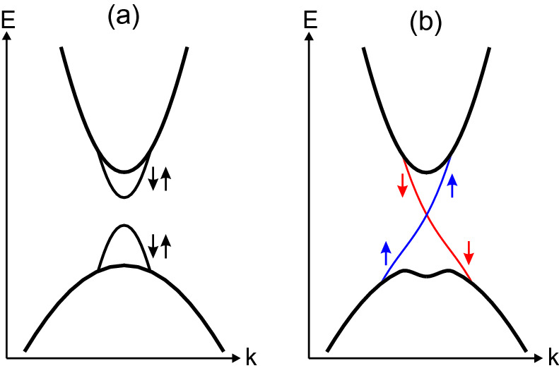

Fig. 11.16

**a** ‘Normal’ band structure with surface states, the valence band states are antisymmetric (‘–’) from p-states, the conduction band states are symmetric (‘+’) from s-states. The *arrows* denote the electron spin orientation of the states. **b** ‘Topological’ band structure with surface states crossing the gap and electrons in the two surface states having unique spin orientations

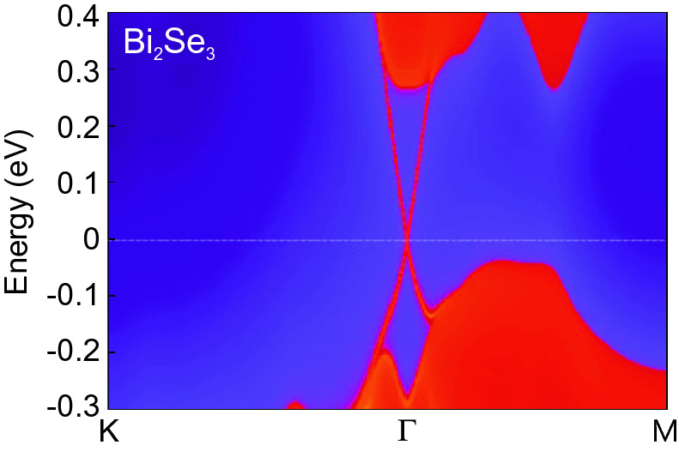

Fig. 11.17

Density of states for Bi



Se



(111) surface.

Adapted from [1086]

Topological surface states have been observed in various systems [463]. As an example we show data on bulk Bi



Se



[1087] for which the surface states are found to cross the band gap (Fig. [11.18](#u116076_4_En_11_Chapter-Fig18)a) and spin-polarized measurements (Fig. [11.18](#u116076_4_En_11_Chapter-Fig18)b) show a strong spin polarization (about 50%) of the two branches. Another situation where topological edge states appear is the interface between two semiconductors with bands of different topology, such as HgTe and CdTe (cf. Sect. [6.​11](The_Physics_of_Semiconductors00003.docx#u116076_4_En_6_Chapter)).

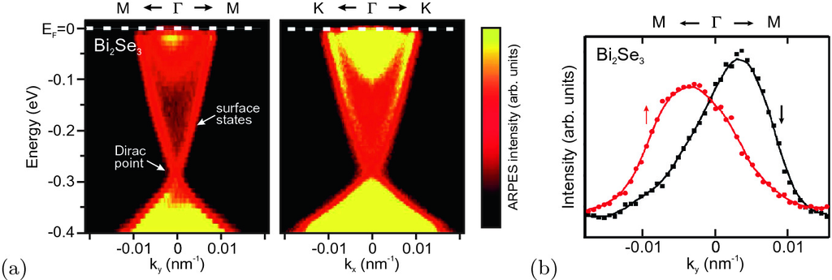

Fig. 11.18

**a** Angle-resolved photoemission spectra from Bi



Se



(111) surface along two different



-space directions. The Fermi level is at energy zero. The *blue dashed line* indicates the angular scan displayed in panel (**b**). **b** Spin-polarized momentum distribution curve at a binding energy of

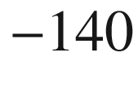

 meV, measured along the

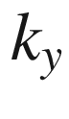

-direction.

Adapted from [1088]

Footnotes

[1](#u116076_4_En_11_Chapter-Fn1_source)

Typically the distance between the first and second layer is reduced, and the distance between the second and third layer a little bit increased.

[2](#u116076_4_En_11_Chapter-Fn2_source)

The appearance of states within the gap and above



resembles that of localized vibrational modes of substitutional masses (Sect. [5.​2.​7](The_Physics_of_Semiconductors00002.docx#u116076_4_En_5_Chapter)).

© Springer Nature Switzerland AG 2021

M. Grundmann

The Physics of Semiconductors

Graduate Texts in Physics

<https://doi.org/10.1007/978-3-030-51569-0_12>

## 12. Heterostructures

Marius Grundmann[1](#u116076_4_En_12_Chapter-Aff11)

(1)

Felix Bloch Institute for Solid State Physics, Universität Leipzig, Leipzig, Germany

Marius Grundmann

Email:

[grundmann@physik.uni-leipzig.de](mailto:grundmann@physik.uni-leipzig.de)

*The interface is the device.*

*H. Kroemer* [133]

## Abstract

Heterostructures are the most important basis for modern devices and are covered regarding various aspects including heteroepitaxy on planar and patterned substrates, surfactants, heterostructure band lineup as well as energy levels and recombination in planar confined systems (quantum wells and two-dimensional electron gases).

### 12.1 Introduction

Heterostructures consist of (at least two) different materials. The geometry of the interfaces between the two materials can be complicated. The simplest case is a planar interface, i.e., a layered system. A metal–semiconductor junction is generally a heterostructure. However, we will use the term mostly for structures of various semiconductors. Most of the heterostructures discussed here are epitaxial, i.e., fabricated by the successive epitaxy of the various layers on a substrate. Another method to fabricate heterostructures of different (and dissimilar) materials is wafer bonding that is briefly discussed in Sect. [12.6](The_Physics_of_Semiconductors00006.docx#u116076_4_En_12_Chapter-Sec22).

Many modern semiconductor devices rely on heterostructures, such as the heterobipolar transistor (HBT), the high electron mobility transistor (HEMT), lasers and nowadays also light-emitting diodes. Shockley had already considered heterostructures in his 1951 patent for pn-junctions. For the development and the realization of heterostructures H. Kroemer and Zh.I. Alferov were awarded the 2000 Physics Nobel Prize. The properties of charge carriers in layers that are part of heterostructures can be quite different from those in bulk material, e.g., extremely high mobility, high radiative recombination efficiency or novel states of matter, as revealed in the quantum Hall effects.

### 12.2 Heteroepitaxy

#### 12.2.1 Growth Methods

Since the thickness of layers in the active part of heterostructures has to be controlled to monolayer precision and the thickness of layers can go down to the single monolayer range, special growth methods have been developed [1089–1091]. Among these molecular beam epitaxy (MBE [1092]), chemical vapor deposition (CVD [1093, 1094]) and metalorganic vapor phase epitaxy (MOVPE [1095]) are the most common for Si, Ge, III–V and II–VI semiconductors. Thin films for many materials can also be fabricated by atomic layer deposition (ALD [1096, 1097]). In particular oxide semiconductors (and superconductors) are also fabricated with pulsed laser deposition (PLD [1098]). Liquid phase epitaxy (LPE [1099]) used to be very important for the fabrication of LEDs but has lost its role largely to MOVPE.

MBE is performed in an ultrahigh vacuum (UHV) chamber, pumped by getter pumps and cryo-shrouds. The source materials are evaporated from effusion cells and directed towards the heated substrate. If the source materials are supplied as a gas stream, the method is called gas-source MBE (GSMBE). If metalorganic compounds are used as precursors, the method is denoted as MOMBE. The atoms impinge on the substrate with thermal energy and are first physisorbed. After diffusion on the surface they either desorb or they are chemisorbed, i.e., incorporated into the crystal. In order to obtain high spatial homogeneity of material properties such as composition, thickness and doping, the substrate is rotated during deposition.

During CVD and MOVPE the heated substrate is in a gaseous environment. The transport gas is typically H



, N



or O



. Precursor materials are hydrides such as silane, germane, arsine or phosphine (SiH



, GeH



, AsH



, PH



) and (for MOVPE) metalorganic compounds, such as, e.g., trimethylgallium (TMG). Due to the toxicity of the hydrides, alternative, i.e., less-toxic and less-volatile compounds are used, such as TBAs ((CH



)



CAsH



). The crystal growth occurs after pyrolysis and catalysis of the compounds close to or on the substrate surface. All remaining C and H atoms (and whatever else that is not incorporated into the crystal) leave the reactor and are neutralized and stopped in a scrubber. In ALD alternating injections of molecular precursors and purge cycles build up the thin film atomic layer by atomic layer; this method is particularly advantageous for achieving conformal coatings.

In-situ monitoring is of importance to obtain information about the growth process while it is underway. Using the information in a feedback loop it is possible to achieve in-situ control of the process, e.g., for precise determination of growth rates or layer thickness. Techniques are RHEED (reflection high-energy electron diffraction) [1100] (only for UHV systems) and RAS (reflection anisotropy spectroscopy) [1101, 1102].

#### 12.2.2 Substrates

Thin-film epitaxy is mostly performed on wafers, i.e., thin circular slices of substrate material. The most common substrate materials are Si (currently up to 400 mm diameter [1103, 1104]), Ge (also up to 300 mm [1105]), GaAs (up to 6 inch), InP (up to 4 inch) and sapphire (up to 6 inch). Typical wafer thickness is 300–500

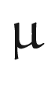

m. Also, very thin, flexible Si wafers (8–10

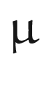

m) have been developed [1106]. A wafer is cut from a large single cylindrical crystal that is fabricated with suitable growth techniques such as Czochralski (CZ) growth [1107, 1108] modified by Teal and Little [1109–1111]. In CZ growth the crystal, starting with a small seed crystal, is pulled out of a melt of previously polycrystalline, pure or doped material. All dislocations stop in the narrow neck between the seed and the main body of the cylinder. The diameter of the crystal is controlled by the pulling rate (matching the crystallization speed of the material) and the heating power. For the growth of III–V compound semiconductors, liquid encapsulated CZ (LEC) growth has been developed to counteract the high volatility of the group-V component. During LEC growth the melt is completely covered with molten boric oxide (B



O



). The keys to optimization of the crystal growth process are numerical modeling and computer control. In Fig. [12.1](#u116076_4_En_12_Chapter-Fig1)a,c a large CZ silicon crystal and a smaller LEC GaAs crystal (boule) are shown. Over time wafer size and ingot mass have increased remarkably (Fig. [12.1](#u116076_4_En_12_Chapter-Fig1)b). For details on other important fabrication methods for bulk crystals, including float-zone (FZ [291, 1112]) or vertical gradient freeze (VGF), we refer to the literature [1113]. Significant expertise is necessary for cutting, grinding and polishing (lapping) wafers for epitaxy.

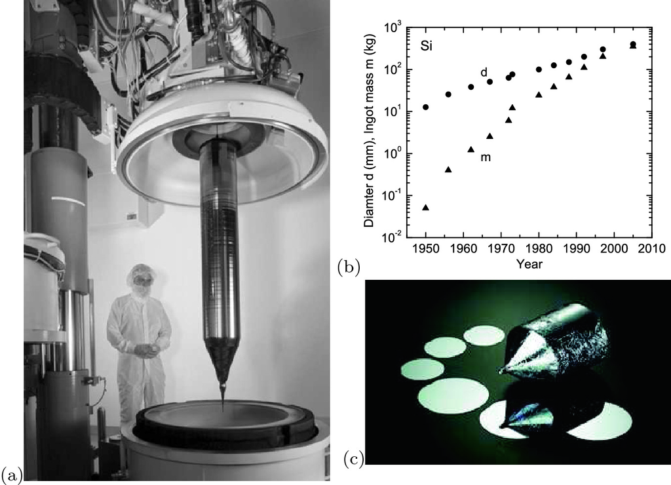

Fig. 12.1

**a** Silicon single crystal for 300-mm diameter wafers after opening of the crucible. From [1114] with permission. **b** Historic development (first year of larger production) of silicon wafer diameter and ingot mass. Data from [1104]. **c** GaAs single crystal (boule) for 4-inch wafers and some cut and polished wafers

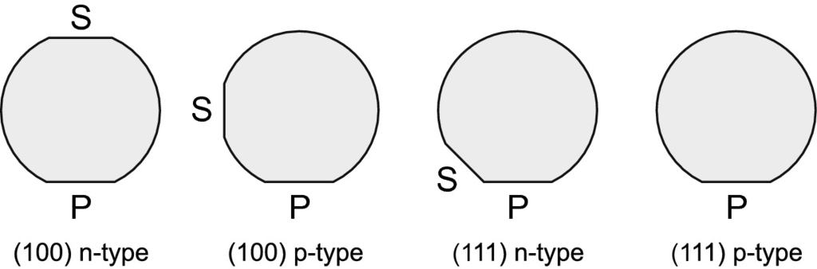

Fig. 12.2

Schematic semiconductor wafer geometry for various orientations and doping with the primary (P) and secondary (S) flats indicated

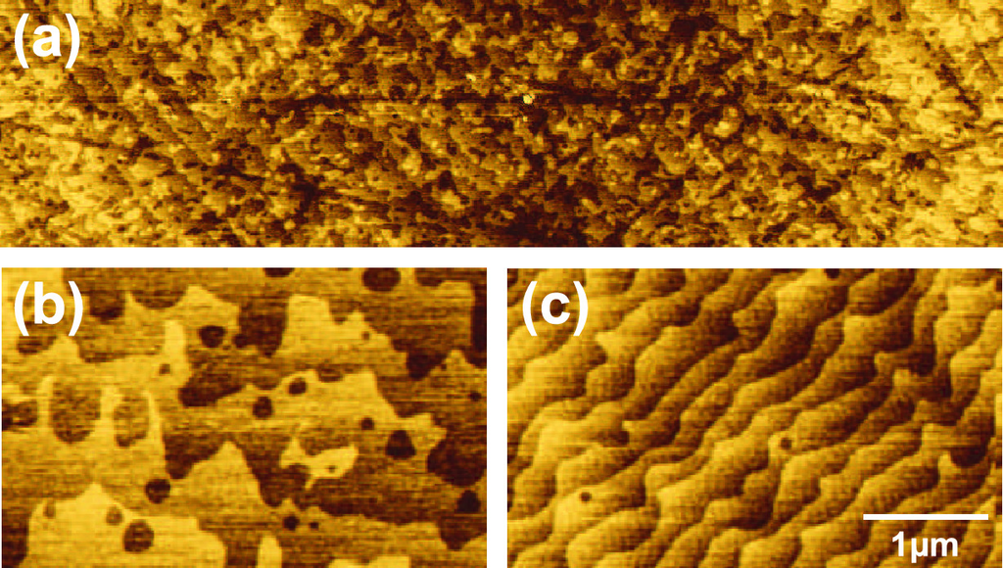

Fig. 12.3

**a** AFM images of an as-received ZnO wafer, exhibiting small terraces and nm deep scratches from polishing. (**b**, **c**) Two ZnO (

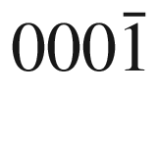

) wafers with vicinal surfaces after thermal treatment (1000

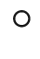

C for 2 h in O



), exhibiting atomically flat terraces with *c*/2 monoatomic step heights. Two different substrates with different off-cut (misorientation direction and angle) are shown.

Adapted from [1122]

For semiconductors, the wafer is marked with *flats* to indicate orientation and doping. In Fig. [12.2](#u116076_4_En_12_Chapter-Fig2) the standard flats are shown for (100)- and (111)-oriented material. The primary (major) flat (OF, orientation flat) defines the crystallographic orientation[1](The_Physics_of_Semiconductors00006.docx#u116076_4_En_12_Chapter-Fn1) is longer than the secondary (minor) flat which defines the conductivity type (IF, identification flat). For a 4-inch (100 mm) diameter wafer the OF is 32 and the IF 12 mm long. The front surface, on which the epitaxy is performed, typically undergoes an elaborate cleaning and polishing process. Silicon processes [1115, 1116] are based on the RCA cleaning procedure [1117] and the related Shiraki etch [1118] and can achieve clean, atomically flat surfaces [1119]. III-V semiconductors are typically prepared using a polishing etch [1120, 1121], often solutions containing bromine. It is possible to create compound semiconductor surfaces that exhibit large, essentially monoatomically flat terraces between individual surface steps. Polishing or other surface damage can also be removed prior to epitaxy with thermal (Fig. [12.3](#u116076_4_En_12_Chapter-Fig3)) or ion beam treatments.

One prerequisite for making high-quality heterostructures with thin layers is a flat surface. Even if the polished substrate is not perfect, flat interfaces can be achieved with the growth of appropriate superlattice buffer layers (Fig. [12.4](#u116076_4_En_12_Chapter-Fig4)). Roughness can exist on all length scales and is typically investigated using atomic force microscopy scans.

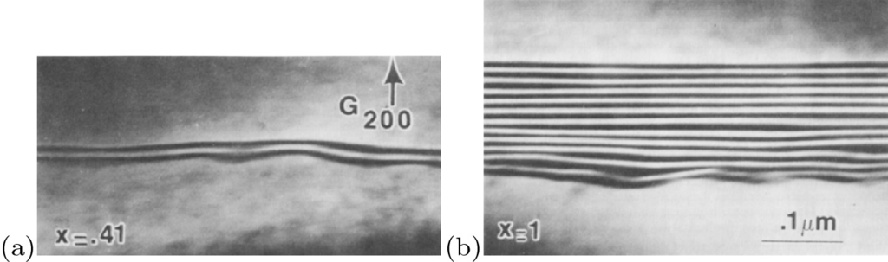

Fig. 12.4

Cross-sectional TEM of MBE-grown Al



Ga

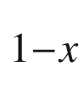

As/GaAs heterostructures for (**a**)

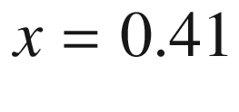

and (**b**)

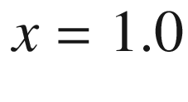

. Using an AlAs/GaAs superlattice an excellent flattening of substrate roughness is achieved.

From [1123]

High throughput demands and the advent of multi-wafer reactors make prior cleaning and etching procedures tedious. For this purpose, substrates for well-developed material systems are offered ‘epiready’. Epiready wafers are often covered with a very thin protective film that can be released using a thermal treatment at or below typical growth temperature in the growth reactor immediately prior to epitaxy. The protective film separates the polished semiconductor wafer from the ambient. Examples are a few monolayers of arsenic on GaAs or two monolayers GaN on SiC. However, the suitability of a purchased substrate may depend on the duration and conditions of its storage.

A special case is the use of *curved* substrates which allow the study of growth on different crystal orientations in a continuous fashion. Such experiments have been performed using cylindrical substrates [1124] and hemispherical crystals. For the latter homoepitaxy has been reported for Si [1125, 1126], SiC [1127] or GaAs [1128]. Also heteroepitaxy has been investigated, for example for GaP and GaAs on Ge [1129] (cmp. Fig. [12.12](#u116076_4_En_12_Chapter-Fig12)). Using such curved substrates, the growth rate can be determined as a function of crystal orientation as shown for GaAs (on GaAs) in Fig. [12.5](#u116076_4_En_12_Chapter-Fig5); large differences are found for (111)A and (111)B surfaces. For growth of silicon the variations with angle are much smaller in the range of 10% [1124].

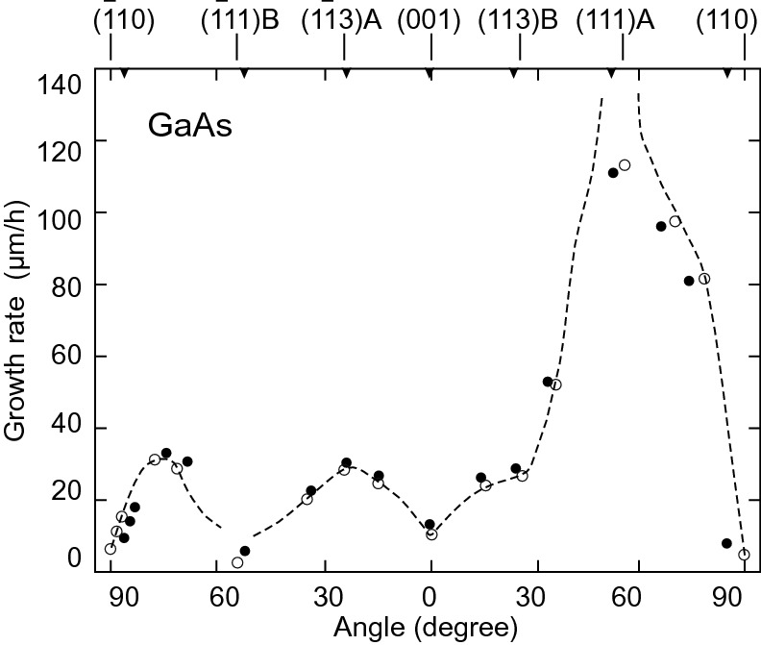

Fig. 12.5

Growth rate of GaAs in vapor phase transport at 725



as a function of crystal orientation. The *dashed line* is guide to the eye.

Adapted from [1128]

#### 12.2.3 Growth Modes

The growth of a material A on a material B can occur via three fundamental growth modes (Fig. [12.6](#u116076_4_En_12_Chapter-Fig6)), the layer-by-layer or Frank-van der Merwe (FvdM) growth mode [435], the island or Volmer-Weber (VW) growth mode [1130] and the Stranski-Krastanow (SK) growth mode [1131, 1132].  In [1132] the possibility of island formation on an initially flat heteroepitaxial surface was proposed for the growth of lattice-*matched* ionic crystals that have different charges. The term SK growth is now typically used in lattice-*mismatched* heteroepitaxy for the island formation (and related relaxation of strain energy, cmp. Fig. [14.​37](The_Physics_of_Semiconductors00006.docx#u116076_4_En_14_Chapter-Fig37)) on an initially two-dimensional layer (wetting layer).[2](The_Physics_of_Semiconductors00006.docx#u116076_4_En_12_Chapter-Fn2)  Also growth of islands *relaxed* by misfit dislocations in strained heteroepitaxy has been termed SK growth [1133].

The growth mode is determined by the relation of the free energies (per area) of the surface

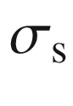

, interface

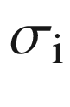

and film

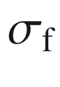

. Wetting of the substrate and growth of a coherent film (FvdM-growth) occurs for

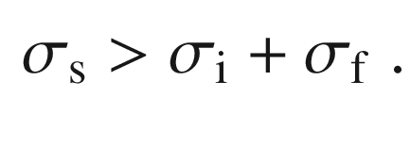

(12.1)

If the inequality has the opposite sign, Volmer-Weber or Stranski-Krastanow growth occurs. Additionally the strain energy of the film must be considered. The SK growth generally occurs when there is wetting of the substrate but layer strain is unfavorable and leads to islanding.

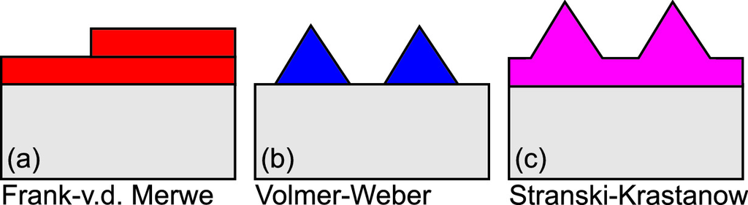

Fig. 12.6

Schematic of the three different fundamental epitaxial growth modes

Layer-by-layer growth typically involves nucleation of two-dimensional islands and ‘filling’ of the remaining monolayer before the next one is started. Another growth mode resulting in smooth epitaxial layers is step-flow growth where adatoms are incorporated mainly at step edges. A more detailed discusion can be found in [1134]. Further details on crystal growth can be found in [1135].

The nucleation and the initial film growth are important and determine the film quality. Several techniques have been developed to overcome common problems. A typical strategy is the growth of a low-temperature nucleation layer.

#### 12.2.4 Heterosubstrates

If homosubstrates are not available or very expensive, semiconductors are grown on dissimilar substrates, e.g., (Al,Ga)N and ZnO on sapphire (Al



O



) or SiC.[3](The_Physics_of_Semiconductors00006.docx#u116076_4_En_12_Chapter-Fn3) In Fig. [12.7](#u116076_4_En_12_Chapter-Fig7) the interface region of hexagonal AlN on 6H-SiC (cmp. Fig. [3.​31](The_Physics_of_Semiconductors00002.docx#u116076_4_En_3_Chapter-Fig31)b) is shown. The change of crystallographic phase is obvious; the perfect atomic arrangement justifies the term ‘epitaxy’, literally meaning ‘order on top’.

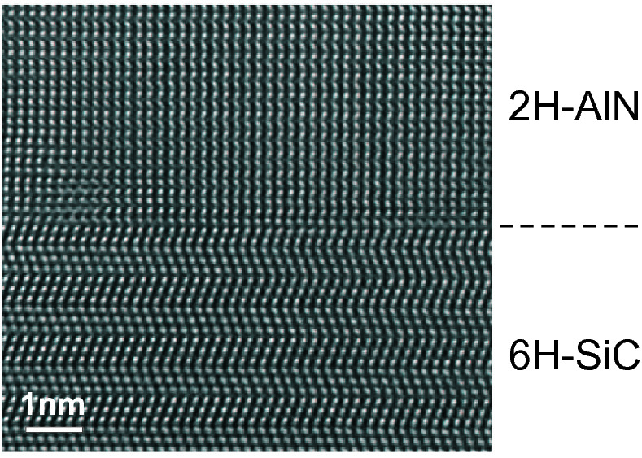

Fig. 12.7

HRTEM cross section of the interface region of MOVPE grown hexagonal AlN on 6H-SiC substrate.

Adapted from [1137]

In many cases, the integration of III–V- or II–VI-based semiconductors for optoelectronic applications on silicon for electronic devices is desirable, such as GaAs/Si, InP/Si, GaN/Si or the growth on economic substrates is attractive such as GaN/Al



O



and ZnO/Al



O



. For all such combinations the epitaxial relationship, i.e., the alignment of the crystallographic directions of both materials, which can have different space groups, has to be considered. Some examples for epitaxial relationships are given in Table [12.1](#u116076_4_En_12_Chapter-Tab1). The epitaxial relation is determined by the energetically favorite formation of the interface and the early stages of growth.Table 12.1

Epitaxial relationship for various film/substrate combinations, ZnO (or GaN) on *c*-, *a*- and *r*-sapphire and Si(111)

| ZnO | Al  $$_2$$  O  $$_3$$ | ZnO | Al  $$_2$$  O  $$_3$$ | ZnO | Al  $$_2$$  O  $$_3$$ | ZnO / GaN | Si |
| --- | --- | --- | --- | --- | --- | --- | --- |
| [00.1] | [11.0] | $$[\bar{1}0.2]$$ | [111] |
| [00.1] | [00.1] | [00.1] | [11.0] | [11.0] | $$[\bar{1}0.2]$$ | [00.1] | [111] |
| [11.0] | [01.0] | [11.0] | [00.1] | [00.1] | $$[0\bar{1}.1]$$ | — /  $$[2 \bar{1}.0]$$ | $$[\bar{1}10]$$ |

In Fig. [12.8](#u116076_4_En_12_Chapter-Fig8), X-ray diffraction data are shown from a ZnO layer on *c*-oriented sapphire. The hexagonal ZnO lattice is rotated by 30

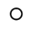

with respect to the trigonal sapphire lattice. In the case of growth of ZnO on Si(111) an amorphous SiO



layer can form at the interface such that the crystallographic information of the substrate is lost. The ZnO grains exhibit random in-plane orientation (Fig. [12.9](#u116076_4_En_12_Chapter-Fig9)).

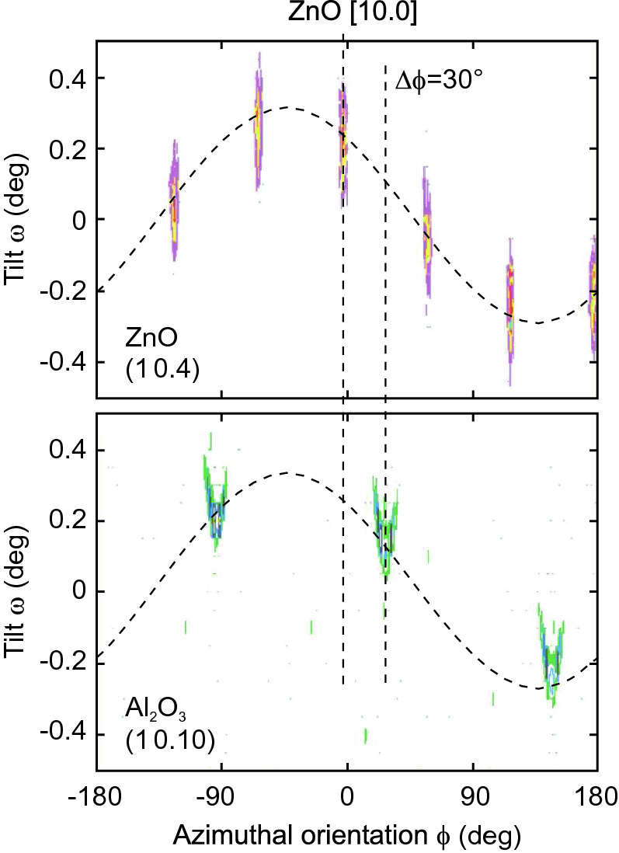

Fig. 12.8

X-ray diffraction intensity from the asymmetric ZnO (10.4) (*upper panel*) and the sapphire (10.10) (*lower panel*) reflections as a function of the azimuthal sample orientation (rotation angle

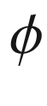

around the [00.1] axis). The peaks appear at different tilt angles

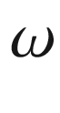

due to an overall tilt of the mounted sample (*dashed sinusoidal lines*). The ZnO [00.1] axis is not tilted with respect to the sapphire [00.1] direction

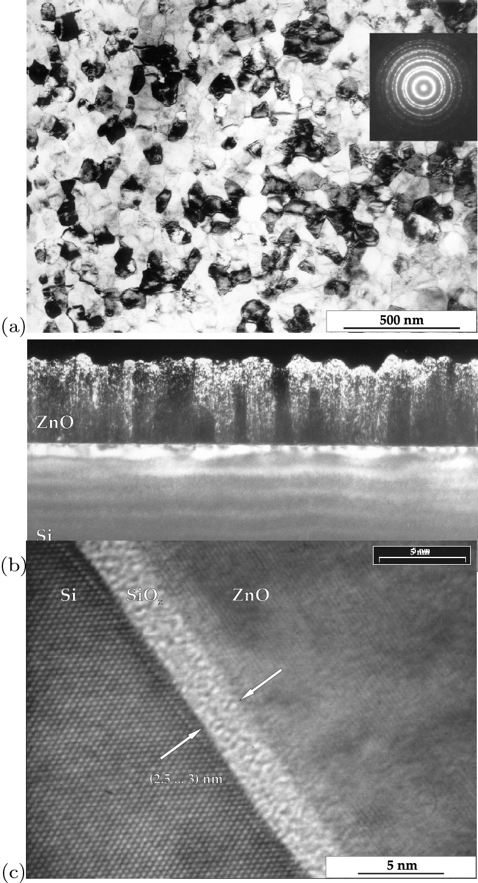

Fig. 12.9

**a** Plan-view TEM image (*inset*: electron diffraction diagram averaged over several grains) of ZnO on Si(111). **b** Cross-sectional TEM of the same sample. **c** High-resolution cross-sectional image of the ZnO/SiO



/Si interface region.

Adapted from [1138]

If substrate and epilayer have different space groups, the formation of domains can occur [1139]. The two-dimensional symmetries of various substrates are listed in Table [11.​1](#u116076_4_En_11_Chapter-Tab1). The group theoretical minimum number of domains

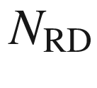

in dependence of the two-dimensional symmetries of substrate and epilayer with rotational symmetries

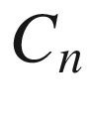

and

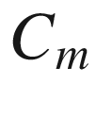

, respectively, is given by [1140]

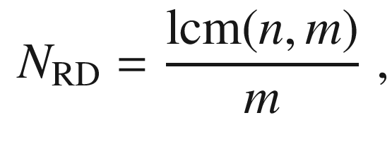

(12.2)

where

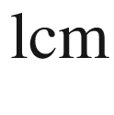

denotes the least common multiple. The values are listed in Table [12.2](#u116076_4_En_12_Chapter-Tab2) and visualized in Fig. [12.10](#u116076_4_En_12_Chapter-Fig10).

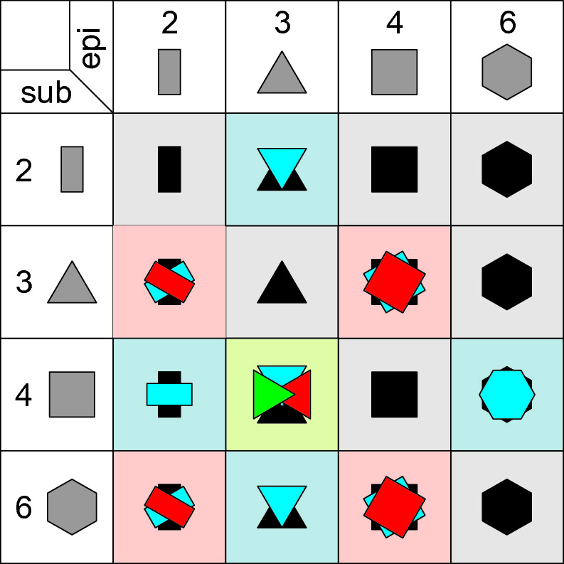

Fig. 12.10

Visualization of the minimum number of rotational domains for different substrate and epilayer symmetries according to Table [12.2](#u116076_4_En_12_Chapter-Tab2)

Table 12.2

Number of rotational (or mirror) domains

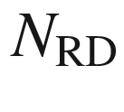

for all 2D point groups of substrate (

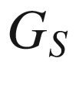

) (rows) and epilayer (

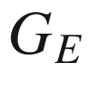

) (columns). When two numbers are given (*x*|*y*), the first (second) number represents the number of domains if mirror symmetry planes of substrate and epilayer align (misalign)

| $$G_S \backslash G_E$$ | 1 | *m* | 2 | 2*mm* | 3 | 3*m* | 4 | 4 mm | 6 | 6 mm |
| --- | --- | --- | --- | --- | --- | --- | --- | --- | --- | --- |
| 1 | 1 | 1 | 1 | 1 | 1 | 1 | 1 | 1 | 1 | 1 |
| m | 2 | 1|2 | 2 | 1|2 | 2 | 1|2 | 2 | 1|2 | 2 | 1|2 |
| 2 | 2 | 2 | 1 | 1 | 2 | 2 | 1 | 1 | 1 | 1 |
| 2 mm | 4 | 2|4 | 2 | 1|2 | 4 | 2|4 | 2 | 1|2 | 2 | 1|2 |
| 3 | 3 | 3 | 3 | 3 | 1 | 1 | 3 | 3 | 1 | 1 |
| 3 m | 6 | 3|6 | 6 | 3|6 | 2 | 1|2 | 6 | 3|6 | 2 | 1|2 |
| 4 | 4 | 4 | 2 | 2 | 4 | 4 | 1 | 1 | 2 | 2 |
| 4 mm | 8 | 4|8 | 4 | 2|4 | 8 | 4|8 | 2 | 1|2 | 4 | 2|4 |
| 6 | 6 | 6 | 3 | 3 | 2 | 2 | 3 | 3 | 1 | 1 |
| 6 mm | 12 | 6|12 | 6 | 3|6 | 4 | 2|4 | 6 | 3|6 | 2 | 1|2 |

If the main symmetry axes of substrate and epilayer are not aligned, mirror domains appear. An example is the growth of GaN(00.1) on Ge(111), for which it has been reported that the major symmetry directions do not align exactly. There is a

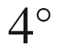

in-plane rotation of the lattices with respect to the usual

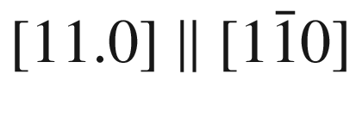

in-plane relationship [1141] (cmp. the exact alignment for GaN/Si(111) in Table [12.1](#u116076_4_En_12_Chapter-Tab1)). Due to 3 m mirror symmetry of the substrate, the misaligment is equivalent for clockwise and counter-clockwise rotation. Therefore two domains with an angle of

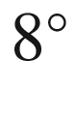

occur (Fig. [12.11](#u116076_4_En_12_Chapter-Fig11)).

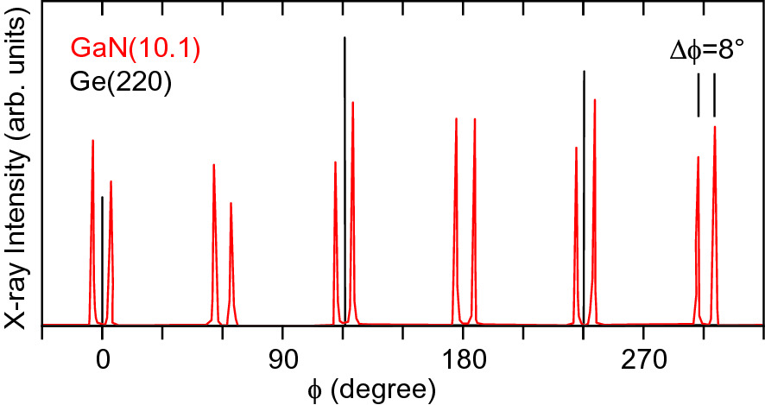

Fig. 12.11

X-ray diffraction

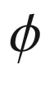

-scans of GaN(00.1)/Ge(111).

Adapted from [1141]

Another well-known domain effect in heteroepitaxy is the occurence of antiphase domains of zincblende semiconductors (e.g., GaAs, GaP, InP,



) grown on Si(001) with monoatomic steps; such surface actually exhibits two kind of terraces (

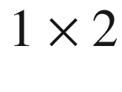

and

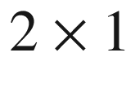

reconstructions) and is thus itself not homogeneous. The formation of antiphase domains can be avoided by using an off-cut of the surface against the (001)-planes promoting double-atomic steps [1142]. In Fig. [12.12](#u116076_4_En_12_Chapter-Fig12)a the growth of GaP on a Ge hemisphere with [111]-pole is depicted; spherical triangles meeting at the

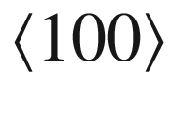

poles can be seen. In a similar experiment GaAs was grown in a spherical depression in Ge(001) (Fig. [12.12](#u116076_4_En_12_Chapter-Fig12)b), allowing a more detailed look at the [001]-pole. Close to the it, within an approximately square area, antiphase domains (cmp. Sect. [4.​4.​4](The_Physics_of_Semiconductors00002.docx#u116076_4_En_4_Chapter)) form. Along the connection lines between different

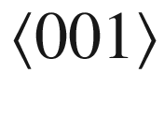

-poles, an antiphase domain boundary forms, microscopially broken up into domains [1129].

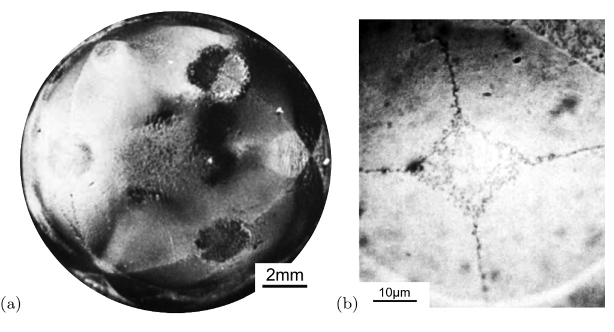

Fig. 12.12

The morphology of **a** GaP grown on a Ge hemisphere with [111]-pole and **b** GaAs grown in a Ge(001) spherical depression.

Adapted from [1129]

Details of the initial deposition steps can determine the orientation in polar materials. GaN directly grown on *c*-Al



O



grows with N-face orientation (see Fig. [3.​19](The_Physics_of_Semiconductors00002.docx#u116076_4_En_3_Chapter-Fig19)). The high surface mobility of Ga allows nitrogen to take its preferred position in the first atomic layer. Even under Ga-rich conditions the N atoms can kick-off the Ga from its favorite site on the surface. If an AlN buffer is used the strong bond between Al and oxygen leads to an Al atomic layer at the interface and subsequent GaN grows with a Ga-face [1143]. Also for the epitaxy of ZnO on on *c*-Al



O



the polarity of the epilayer can be controlled, e.g., via the details of an MgO buffer layer [1144].

#### 12.2.5 Patterned Substrates

Using patterning of the substrate certain growth modes and crystallographic directions of the growth front can be evoked.

Returning to the discussion of [00.1] or [00.

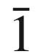

] growth of wurtzites, on a sapphire substrate with lateral AlN patterns, laterally orientation-modulated GaN can be grown (Fig. [12.13](#u116076_4_En_12_Chapter-Fig13)). At the juncture of the phases an inversion domain boundary forms [1145].

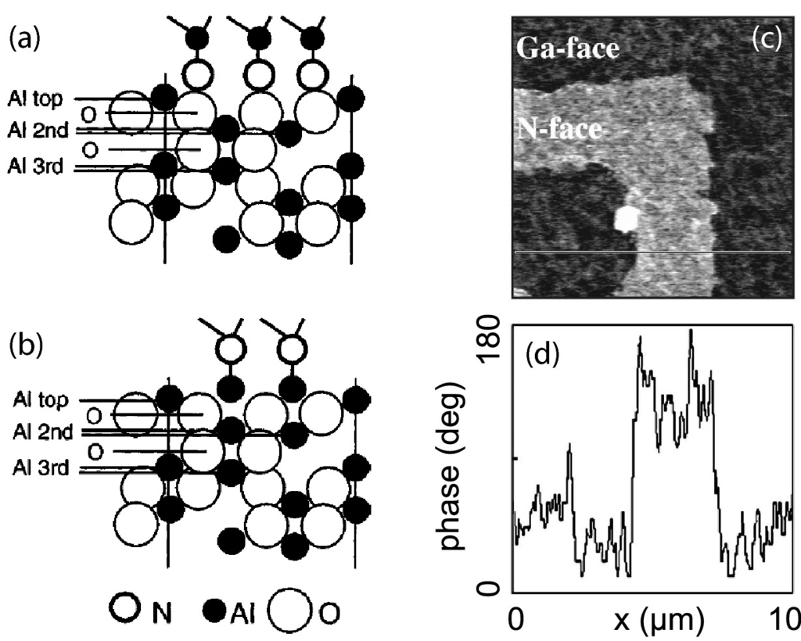

Fig. 12.13

Side view of the heterointerfaces between AlN and *c*-oriented sapphire with nitrogen (**a**) and Al (**b**) being the first layer. Adapted from [1143]. **c** Phase image of piezoresponse force microscopy (PFM) of lateral polarity GaN heterostructure and **d** linescan of phase signal along *white line* in part (**c**).

Adapted from [1146], part (**c**) reprinted with permission, ©2002 AIP

The defect density can be reduced in parts of the structure using pendeo-epitaxy [1147] or epitaxial lateral overgrowth (ELO) [1148]. The defects thread only from the limited contact area of the layer with the substrate and the part of the layer away from the mask (‘wing’) is free of defects (Fig. [12.14](#u116076_4_En_12_Chapter-Fig14)).

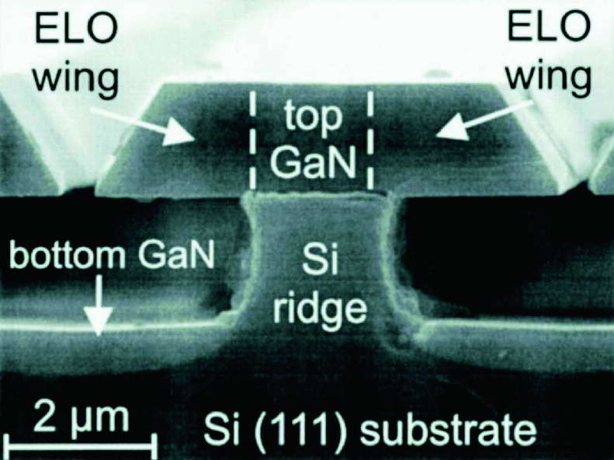

Fig. 12.14

SEM cross-sectional image of GaN grown on a structured Si(111) substrate. The laterally grown wings extend about 2.5

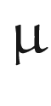

m over the grooves. The thickness of the GaN layer is 0.5

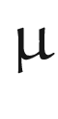

m on the bottom of the grooves, while it is 1.4



m on top of the ridges.

Reprinted with permission from [1148], ©2001 AIP

While the patterning of a mask may be cumbersome and require interruption of growth, the in-situ deposition of a random SiN mask with small holes has been found beneficial in the epitaxy of GaN [1149]. GaN islands nucleate selectively in the mask openings (Fig. [12.15](#u116076_4_En_12_Chapter-Fig15)a). The nucleation and subsequent coalescence of islands (Fig. [12.15](#u116076_4_En_12_Chapter-Fig15)b) leads to defect annihilation and eventually again to a flat film (Fig. [12.15](#u116076_4_En_12_Chapter-Fig15)c). The reduction of defect density is evident (Fig. [12.15](#u116076_4_En_12_Chapter-Fig15)d) and leads to improved optical properties [1150].

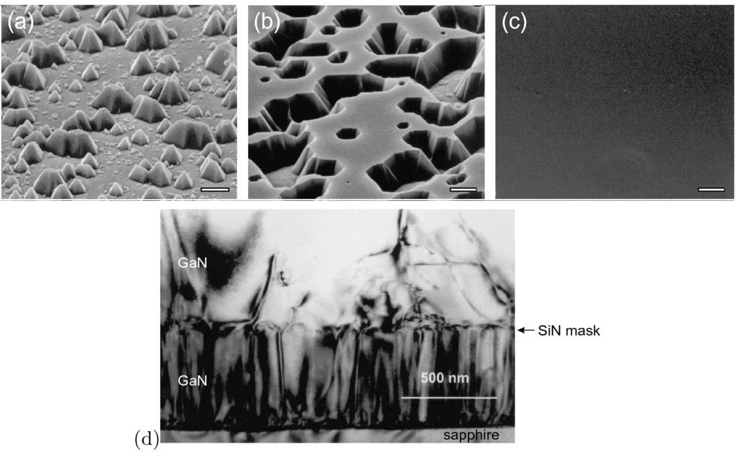

Fig. 12.15

SEM images of GaN **a** growing through the openings of a random SiN mask, **b** laterally overgrowing the mask and coalescing and **c** eventually forming a flat film. Bar widths are 2



m, 1

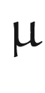

m and 10



m. **d** Cross-section TEM image.

Adapted from [1149]

Using patterned substrates with stripe-like mesas and promoting the growth on a sidewall of the mesa, the direction of GaN growth front can be steered into a semipolar direction (cmp. Sect. [16.​4.​3](The_Physics_of_Semiconductors00006.docx#u116076_4_En_16_Chapter)). The r-plane sapphire substrate with etched mesa stripes oriented along the [11.0] direction exposes [00.1]-oriented sidewall facets on which the GaN grows along its *c*-axis; The angle of 57.6

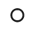

between the r- and the c-planes of sapphire is very close to the angle ([3.​22c](The_Physics_of_Semiconductors00001.docx#u116076_4_En_3_Chapter)) of 58.4

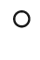

between the GaN semipolar (11.2) and the (00.1) plane. The flat growth front represents a (11.2) facet [1151] (Fig. [12.16](#u116076_4_En_12_Chapter-Fig16)). After coalescence of grains from various mesas, a flat (11.2) surface arises, allowing the reduction of various defects including basal stacking faults [1152, 1153].

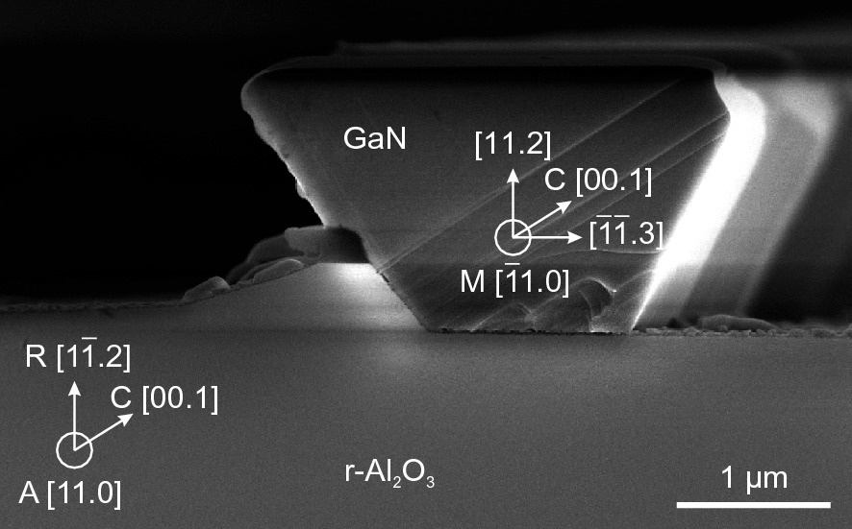

Fig. 12.16

SEM cross-sectional image of MOVPE GaN grown on patterned r-sapphire exposing a (11.2) growth front.

Based on SEM image courtesy of F. Tendille

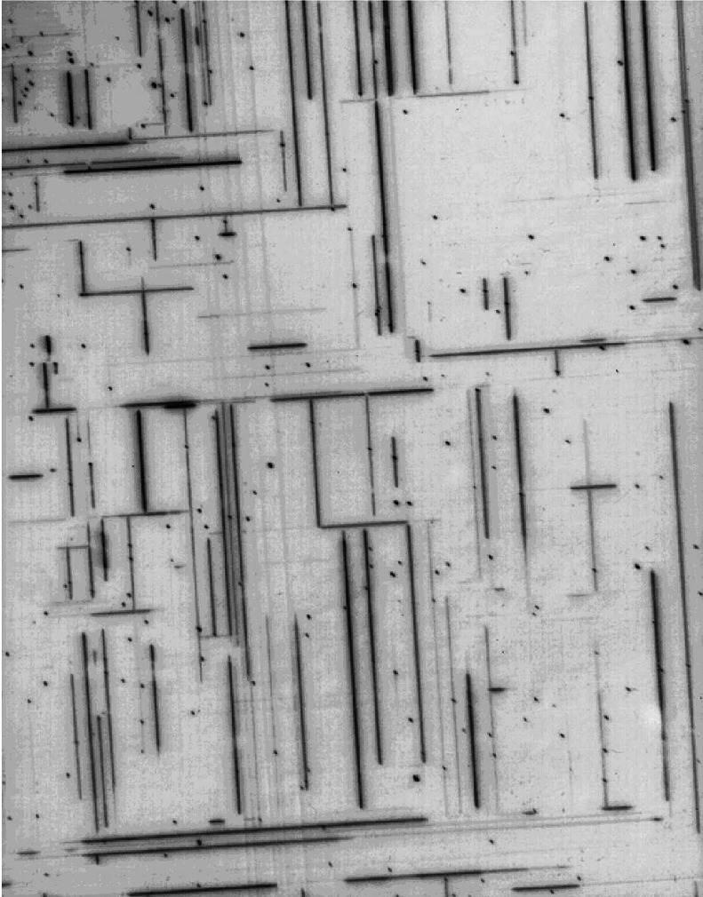

Fig. 12.17

Optical image of the surface of a supercritical, plastically relaxed In



Ga

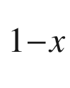

As film on GaAs. Image width is about 1 mm. The cross-hatch pattern is due to misfit dislocations along [110] and [1

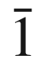

0]. A pseudomorphic layer would exhibit no contrast under the given conditions

#### 12.2.6 Pseudomorphic Structures

Heterostructures can generally be made from any sequence of materials. However a mismatch in lattice constant (or a different crystal structure) leads to strains and stresses that are of the order of

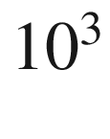

 atmos for strains of 1% (

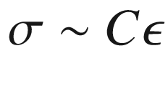

,

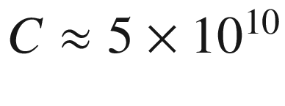

 Pa) as discussed in Sect. [5.​3.​3](The_Physics_of_Semiconductors00002.docx#u116076_4_En_5_Chapter). The total strain energy is

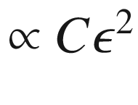

. Above a critical thickness

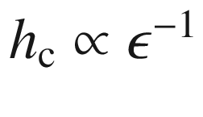

(cf. Sect. [5.​4.​1](The_Physics_of_Semiconductors00002.docx#u116076_4_En_5_Chapter)) defects, e.g., misfit dislocations (relaxing strain with their edge components), are generated (Sect. [12.2.7](#u116076_4_En_12_Chapter-Sec9)). There are a number of semiconductor combinations that are lattice matched and thus can be grown with arbitrary thickness. Al



Ga

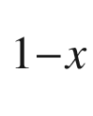

As is closely lattice matched to GaAs for all Al concentrations. See Fig. [6.​25](The_Physics_of_Semiconductors00003.docx#u116076_4_En_6_Chapter-Fig25) for lattice-matched pairs, e.g., In

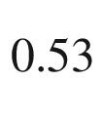

Ga

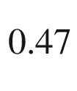

As/InP. Often, thin layers of lattice-mismatched materials with thickness smaller than the critical thickness are used.

For many device applications the ability to grow pseudomorphic layers thicker than the critical layer thickness would be beneficial. The use of compliant substrates was proposed in [1154] to meet this demand. A recent review on compliant substrate technologies can be found in [445]. Schemes to accommodate part of the mismatch strain in the substrate include the use of cantilevered membranes, silicon-on-insulator, twist bonding, glass bonding or trenched substrates. In this sense also nanowhiskers (Sect. [14.​2.​3](The_Physics_of_Semiconductors00006.docx#u116076_4_En_14_Chapter)) represent a compliant substrate, enabling the growth of coherent (laterally confined) layers thicker than the critical thickness of a 2D layer (cmp. Fig. [14.​8](The_Physics_of_Semiconductors00006.docx#u116076_4_En_14_Chapter-Fig8)).

#### 12.2.7 Plastic Relaxation

Above the critical thickness, a film will relax plastically by forming defects, often misfit dislocations. A cross-hatch pattern at the surface due to misfit dislocations is shown in Fig. [12.17](#u116076_4_En_12_Chapter-Fig17) (cf. also Sect. [4.​3.​1.​4](The_Physics_of_Semiconductors00002.docx#u116076_4_En_4_Chapter)).

The strain relaxation in mismatched heteroepitaxy can be determined experimentally via the wafer curvature of the heterostructure (Sect. [5.​3.​5](The_Physics_of_Semiconductors00002.docx#u116076_4_En_5_Chapter)). Data for the thickness dependent relaxation

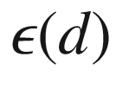

of In

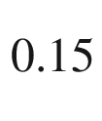

Ga

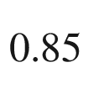

As on GaAs (mismatch



%) are shown in Fig. [12.18](#u116076_4_En_12_Chapter-Fig18). Growth interruptions lead to larger relaxation at smaller thickness. Therefore relaxation at early times or small thickness (above

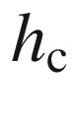

) is kinetically hindered, i.e., the available dislocation density and glide velocity are not sufficient to relieve the strain. At large thickness the strain does not go to zero (saturation regime) and the film remains in a metastable, incompletely relaxed state as discussed in more detail in [1155].

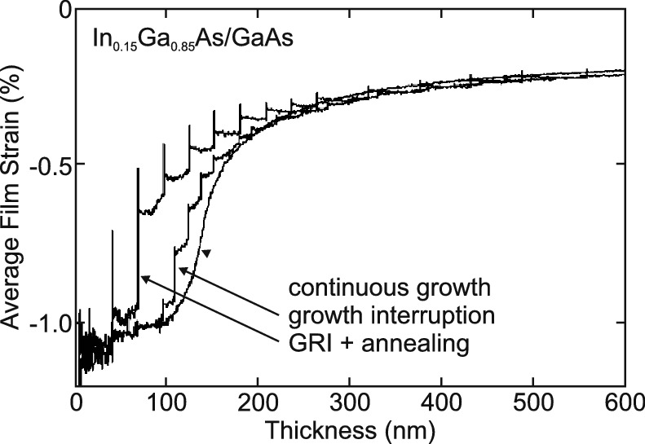

Fig. 12.18

Average film strain (measured in-situ via substrate curvature) of In

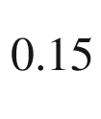

Ga

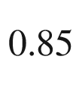

As/GaAs grown at 450

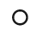

C as a function of film thickness (determined from growth time



deposition rate). Relaxation for three different growth modes are shown (as labeled): continuous growth, employment of several growth interruptions (GRI) and GRI with annealing step (to 550



).

Adapted from [1155]

An extreme case of plastic relaxation is cracking (Sect. [4.​4.​1](The_Physics_of_Semiconductors00002.docx#u116076_4_En_4_Chapter)) which can occur for example in thick films during cooling due to the mismatch of the thermal expansion coefficients of substrate and epilayer (Fig. [12.19](#u116076_4_En_12_Chapter-Fig19)). Such cracking can be avoided by the introduction of suitable stress-relaxing layers and growth on predefined mesas [1156, 1157].

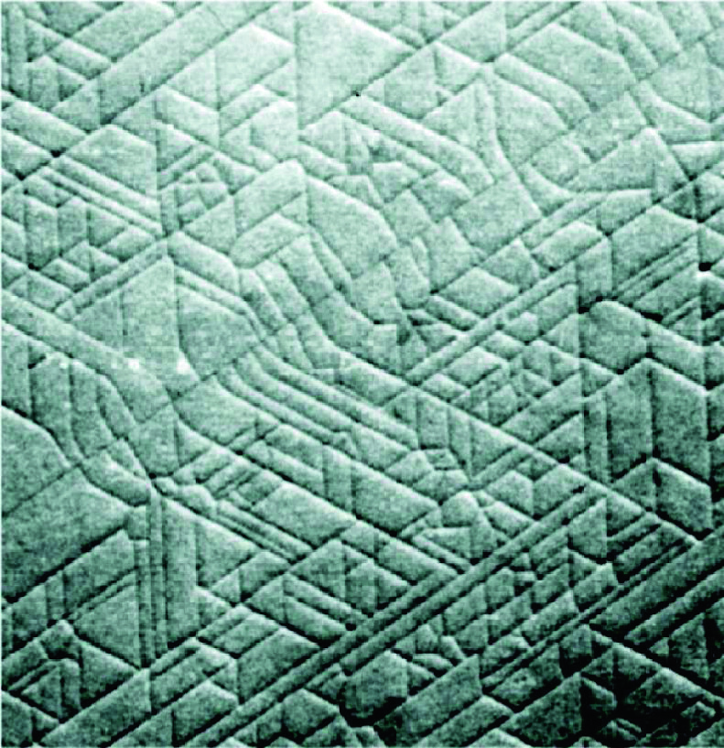

Fig. 12.19

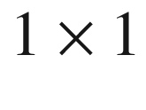

 mm

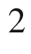

top view with a differential interference contrast microscope of a 1.3



m thick GaN layer grown on Si(111).

Reproduced with permission from [1156], ©2000 IPAP

#### 12.2.8 Surfactants

The condition ([12.1](#u116076_4_En_12_Chapter-Equ1)) allows layer-by-layer growth (cf. Sect. [12.2.3](#u116076_4_En_12_Chapter-Sec5)), i.e., the substrate surface free energy is higher than the than the total of interface and film surface free energy. This makes wetting energetically favorable. For two elements A and B, one of them must have the lower surface free energy. If A can be grown on B in Frank-van der Merwe (or Stranski-Krastanow) growth mode, then ([12.1](#u116076_4_En_12_Chapter-Equ1)) does not hold for B on A and the growth will occur in Volmer-Weber mode, i.e., with islands. This is a serious problem for the growth of embedded layers of the type A–B–A. If the embedded film grows well, the capping does not and vice versa.

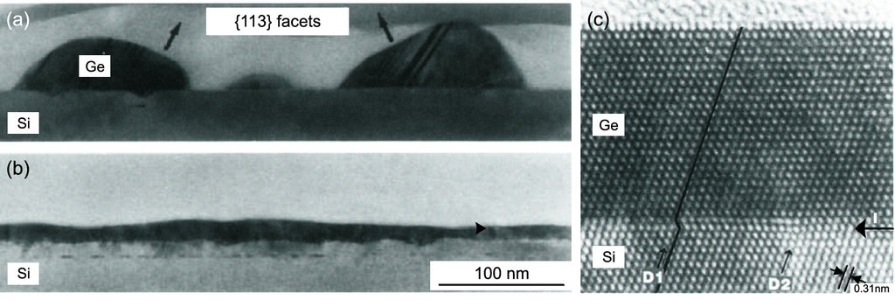

Fig. 12.20

**a**, **b** 10 nm thick Ge layer on Si (100) deposited at room temperature with MBE and annealed up to 770

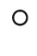

C without (**a**) and with (**b**) Sb surfactant. Adapted from [1165]. **c** Cross-section TEM image of a heterostructure of 70 monolayers germanium on Si (111), grown by MBE with Sb surfactant. The *horizontal arrow* labeled ‘I’ denotes the position of the interface. The *arrows* labeled ‘D1’ and ‘D2’ denote the positions of partial dislocations (cmp. Fig. [4.​20](The_Physics_of_Semiconductors00002.docx#u116076_4_En_4_Chapter-Fig20)).

Adapted from [327]

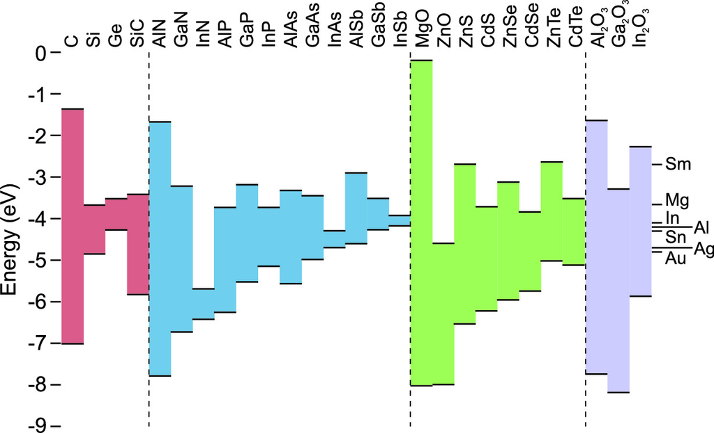

Fig. 12.21

Position of conduction and valence-band edges for a variety of semiconductors (relative to a common vacuum level at

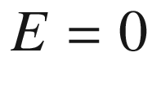

 eV). Based on values from [1167], and from Al



O



(on InP) [1168], InN on diamond [1169], InN on MgO [1170], Ga



O



on GaN from [1171], and In



O



on Si from [1172, 1173]. On the right hand side, the work functions of several metals are shown for comparison

In the case of Ge on Si, Ge has the lower surface free energy than Si. Ge grows on Si in Stranski-Krastanow mode [1158] (Fig. [12.20](#u116076_4_En_12_Chapter-Fig20)a). Si grows both on Ge(001) and Ge/Si(001) in a Volmer-Weber mode [1159] causing severe problems for the fabrication of Si/Ge/Si quantum wells or superlattices. A substantial modification of growth mode can be achieved by using a third element C as a capping layer, saturating surface bonds. It lowers the surface free energy of both materials A and B, thus favoring wetting of the substrate. Such element C is called *surfactant* (surface-active species) [1160, 1161]. Typical examples are As [1160] or Sb [327] on Si and Ge (Fig. [12.20](#u116076_4_En_12_Chapter-Fig20)b). Also the surfactant modifies defect nucleation and can lead to defect-free epitaxial Ge/Si layers (Fig. [12.20](#u116076_4_En_12_Chapter-Fig20)c). Surfactants have also been described for the growth of compound semiconductors, e.g., In [1162] or Sb [1163, 1164] for GaAs.

### 12.3 Energy Levels in Heterostructures

#### 12.3.1 Band Lineup in Heterostructures

In heterostructures, semiconductors with different band gaps are combined. The relative position of conduction and valence band (band alignment) is determined by the electron affinities

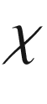

as shown in Fig. [12.21](#u116076_4_En_12_Chapter-Fig21). For a semiconductor, the electron affinity is the (positive) energy difference between vacuum level and conduction band edge. It can lead to different types of heterostructures. Early perspectives of semiconductor heterostructures are discussed in [1166]. The band alignment can be estimated from the position of the branch point energies (Sect. [7.​8](The_Physics_of_Semiconductors00003.docx#u116076_4_En_7_Chapter)) of the two constituents [699] but additional interface dipoles may have to be considered.

In Fig. [12.22](#u116076_4_En_12_Chapter-Fig22), the band alignment for type-I, type-II and type-III heterostructures are shown.  In the type-I structure (straddled band lineup) the lower conduction-band edge and the higher valence-band edge are both in the material with smaller band gap. Thus, electrons and holes will localize there. In the type-II structure a staggered lineup is present and electrons and holes will localize in different materials. In the type-III structure, also termed ‘broken gap’ structure, the conduction band of one material is below the valence band of the other material. The technologically most relevant are type-I structures. The design of heterostructures to fulfill a certain device functionality or to have certain physical properties is called ‘band gap engineering’.

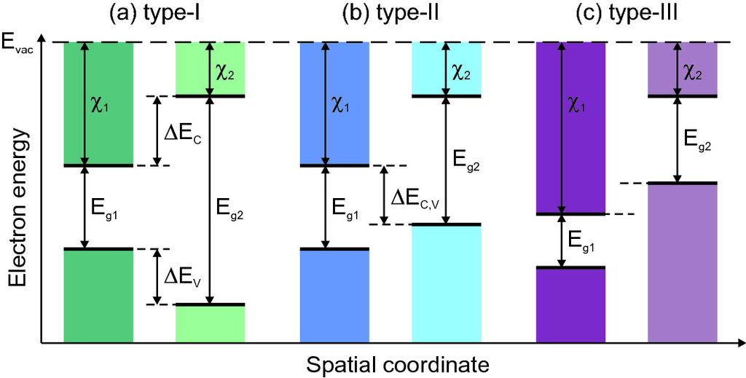

Fig. 12.22

Position of band edges (band alignment) in **a** type-I, **b** type-II and **c** type-III heterostructure

In a type-I heterostructure, the conduction- and valence-band discontinuities are given, respectively, by

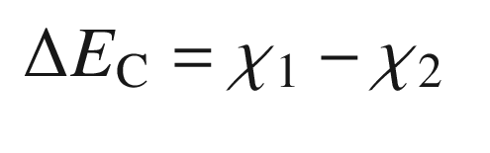

(12.3a)

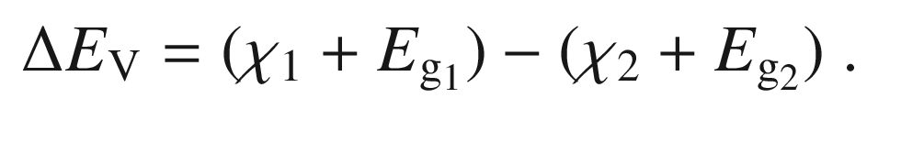

(12.3b)

Experimentally, the valence band offset can be determined using X-ray photoelectron spectroscopy (XPS) probing the filled states; together with the band gap then also the conduction band offsets are obtained. As example, in Fig. [12.23](#u116076_4_En_12_Chapter-Fig23)a the binding energies of an indium and a gallium core level are shown with the valence band edges of InN and GaN, respectively, set to zero energy. Both core levels are then also investigated in a 5 nm InN on GaN heterostructure (the InN layer is sufficiently thin to allow photoelectrons to escape from the GaN underneath). The sum of the shifts represents the valence band offset (

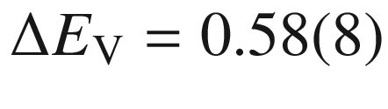

 eV from the analysis of several core levels [1174]). Together with the band gaps, the conduction band offset results in

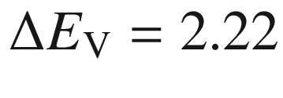

 eV as schematically depicted in Fig. [12.23](#u116076_4_En_12_Chapter-Fig23)b.

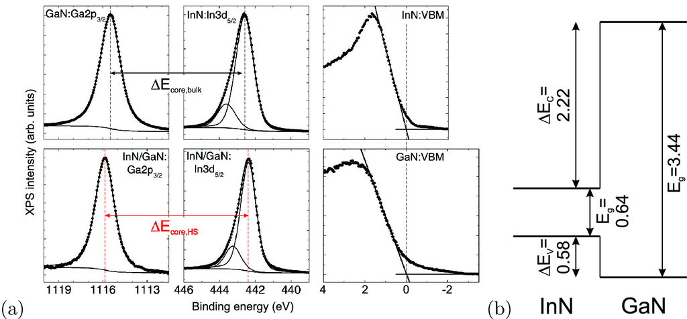

Fig. 12.23

**a** XPS measurements of InN and GaN and a InN/GaN heterostructure. The vertical dashed lines indicate the core level positions in the bulk (black) and the heterostructure (red). The valence band offset is given by

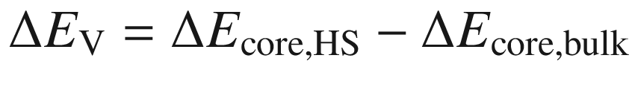

(when

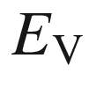

is set to zero for both the bulk materials). **b** Schematic band lineup of the type-I InN/GaN heterojunction (all energies in eV).

Adapted from [1174]

Depending on the layer sequence of high- and low-bandgap materials various configurations, as shown in Fig. [12.24](#u116076_4_En_12_Chapter-Fig24) have obtained special names, such as single heterointerface, quantum well (QW), multiple quantum well (MQW), superlattice (SL). In the extreme case the layer is only one monolayer thick (Fig. [12.25](#u116076_4_En_12_Chapter-Fig25)) and the concept of layer and interface blurs. Such atomically precise layer sequences are mastered nowadays for a variety of material systems such as (Al,Ga)As/GaAs/InAs, InP/(In,Ga)As, Si/SiGe, ZnO/(Mg,Zn)O and also BaTiO



/SrTiO



.

The abruptness of interfaces is determined by the epitaxial machine through the switching precision of the incoming material flux and fundamentally limited by segregation phenomena which can be modeled with a segregation coefficient [1175] (cmp. Sect. [4.​2.​4](The_Physics_of_Semiconductors00002.docx#u116076_4_En_4_Chapter)). As shown in Fig. [12.25](#u116076_4_En_12_Chapter-Fig25)c, In has the tendency to be carried into the following GaAs layer. A quantitative evaluation is possible using aberration-corrected scanning transmission electron microscopy [1176].

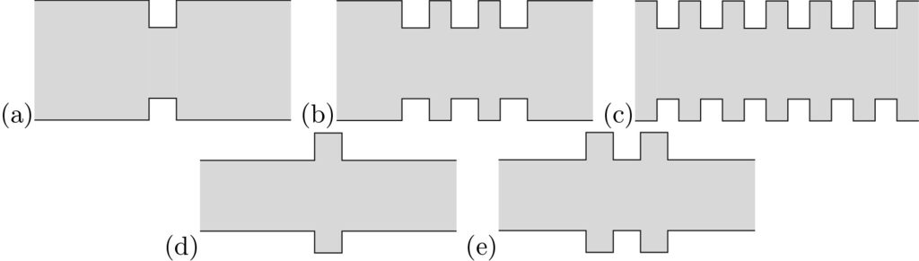

Fig. 12.24

Heterostructures with different layer sequences (band gap engineering). **a** quantum well (QW), **b** multiple quantum well (MQW), **c** superlattice (SL), **d** single-barrier tunneling structure, **e** double-barrier tunneling structure

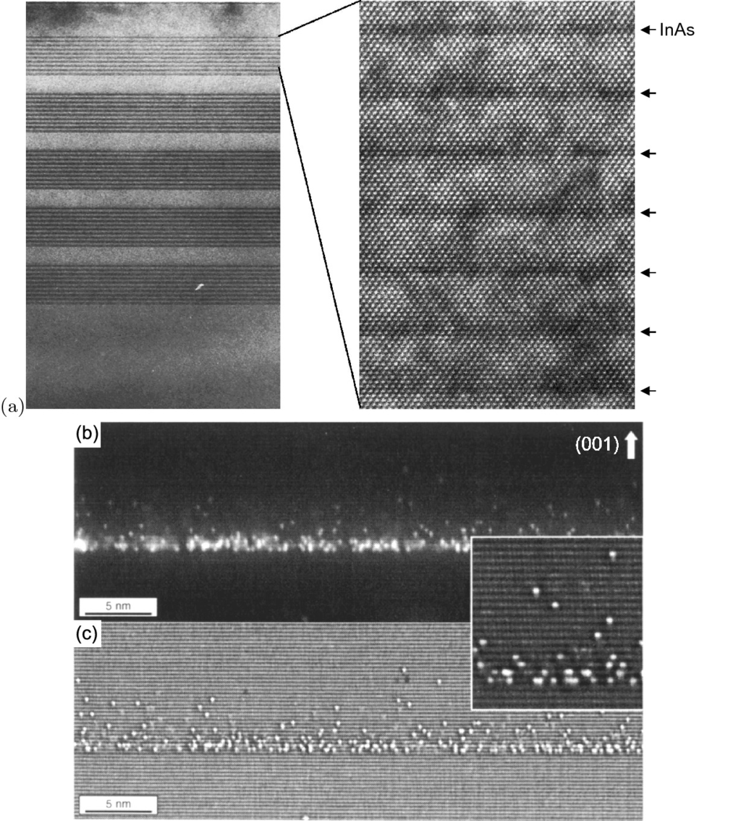

Fig. 12.25

Ultrathin heterostructures: **a** Cross-sectional TEM of a MOVPE-grown short-period superlattice (SPS) of InAs layers in GaAs



N



). In high resolution (*right image*), the individual rows of atoms can be seen. From [1177]. **b**, **c** Cross-section STM image of 2 ML InAs on GaAs; the segregation of In into the top layer is visible atom by atom.

Adapted from [1178]

#### 12.3.2 Quantum Wells

The energy in a single quantum well of thickness

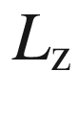

(along the growth direction *z*) can be calculated with the quantum-mechanical particle-in-a-box model. In the envelope function approximation  (Appendix I) the wavefunction is written as a product of the Bloch function and the envelope function

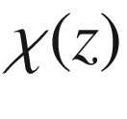

.

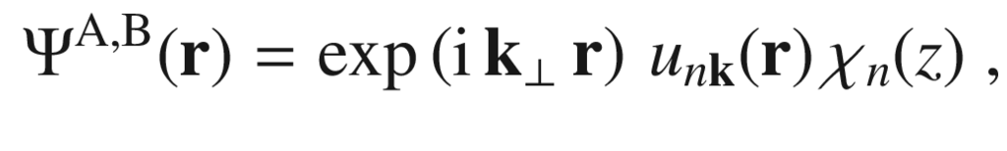

(12.4)

where ‘A’ and ‘B’ denote the two different materials. The envelope function

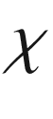

fulfills, approximately, the one-dimensional Schrödinger-type equation,

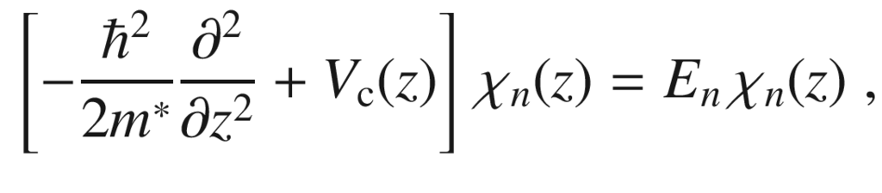

(12.5)

where

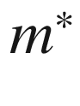

denotes the effective mass.

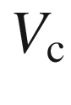

is the confinement potential determined by the band discontinuities. Typically,

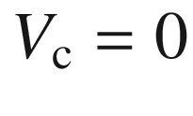

in the well and

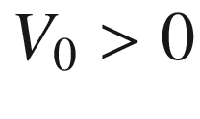

outside in the barrier.

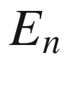

are the resulting energy values of the quantized levels. In the case of infinite barriers (

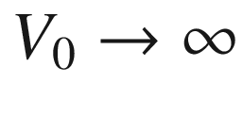

, Fig. [12.26](#u116076_4_En_12_Chapter-Fig26)a) the boundary conditions

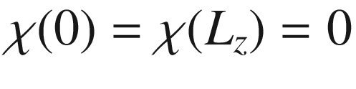

yield

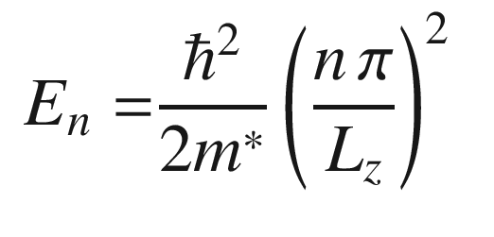

(12.6)

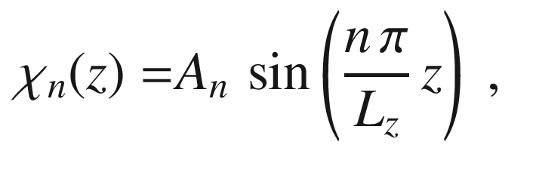

(12.7)

where

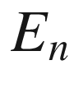

is called the confinement energy.

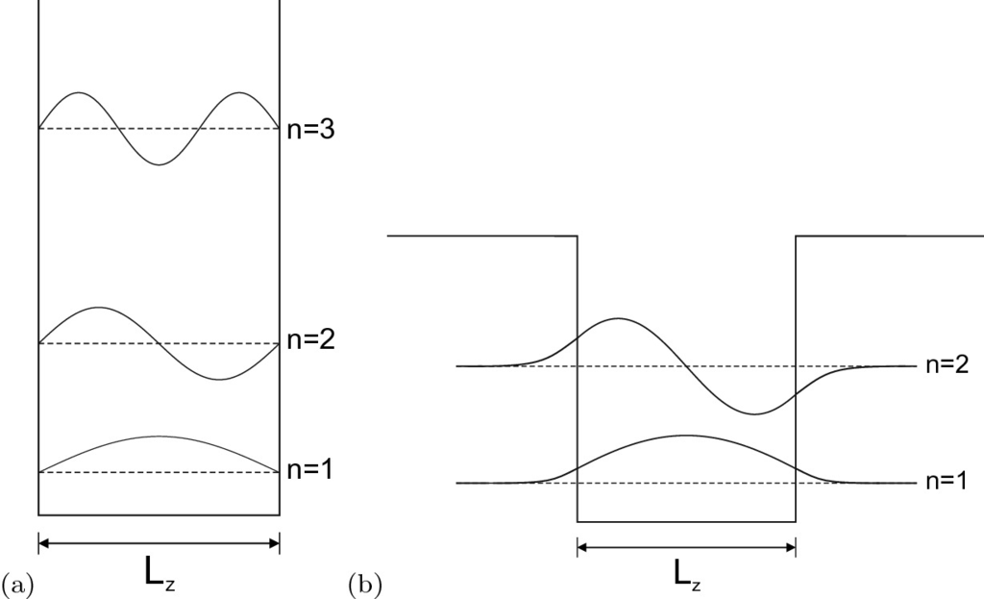

Fig. 12.26

Schematic energy levels and wavefunctions in a potential well with **a** infinite barriers, and **b** finite barrier height

For finite barrier height

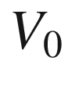

(Fig. [12.26](#u116076_4_En_12_Chapter-Fig26)b) the calculation leads to a transcendental equation. The wavefunction tunnels into the barrier. While for infinite barrier height the lowest level diverges for

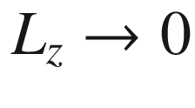

, for finite barrier height

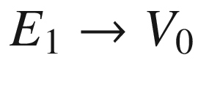

. A complication arises from the different effective mass in the well and barrier material. This is taken into account by forcing the continuity of

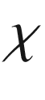

and

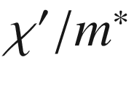

across the interfaces[4](The_Physics_of_Semiconductors00006.docx#u116076_4_En_12_Chapter-Fn4) (‘BenDaniel-Duke’ boundary conditions [1180]). The Schrödinger equation and (semi-)analytical solutions for special and numerical methods for arbitrary potential distributions are discussed in [1181]. The application of

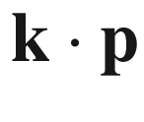

theory (Appendix H) to heterostructures is discussed in [1182].

The motion of carriers in the plane is still free and has a two-dimensional dispersion. Thus, each quantized level contributes

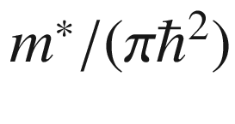

to the density of states at each subband edge

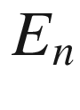

.

For holes, the situation is a little more complicated than for electrons (Fig. [12.27](#u116076_4_En_12_Chapter-Fig27)). First, the degeneracy of heavy and light holes  is lifted since their mass enters the confinement energy. The effective hole masses along the *z* direction, i.e., those that enter ([12.5](#u116076_4_En_12_Chapter-Equ6)), are

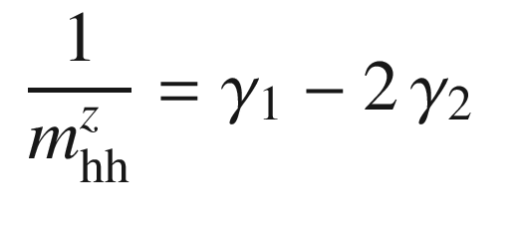

(12.8a)

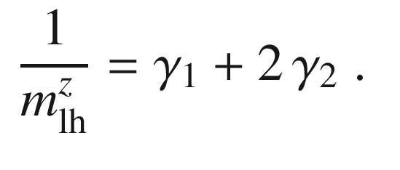

(12.8b)

The light holes have the higher quantization energy. The angular momentum is quantized along the *z* direction. The transverse masses for the dispersion in the interface plane are

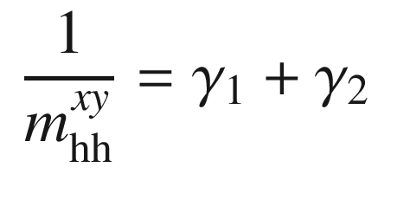

(12.9a)

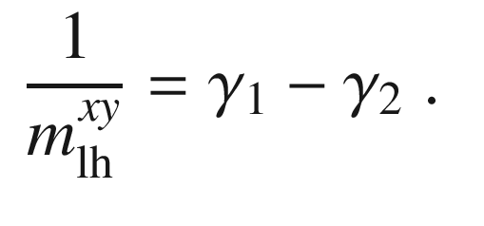

(12.9b)

Now the heavy hole, i.e., the

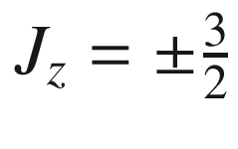

state, has the smaller mass and the light hole (

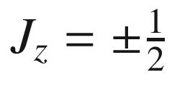

) the larger (Fig. [12.27](#u116076_4_En_12_Chapter-Fig27)c). However, this consideration is only an approximation since the lifting of degeneracy and the dispersion have to be treated on the same level. Higher terms of the perturbation calculation lead to band mixing and remove the band crossing that seems to originate from the situation at the

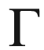

point. In reality, the bands show anticrossing behavior and are strongly deformed. The hole dispersion in a superlattice and the anticrossing behavior is shown in Fig. [12.28](#u116076_4_En_12_Chapter-Fig28).

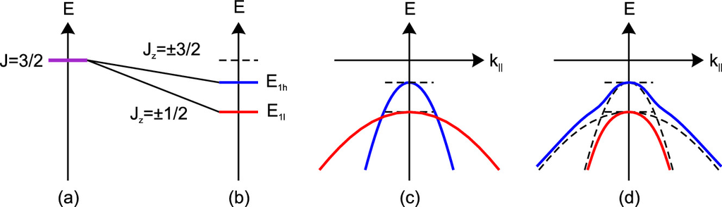

Fig. 12.27

Schematic representation of the development of hole levels in a quantum well: **a** degenerate bulk levels at

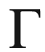

, **b** splitting at the subband edge (due to different quantized values of

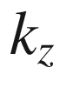

), **c** in-plane dispersion (mass reversal), **d** anticrossing behavior.

Based on [1123]

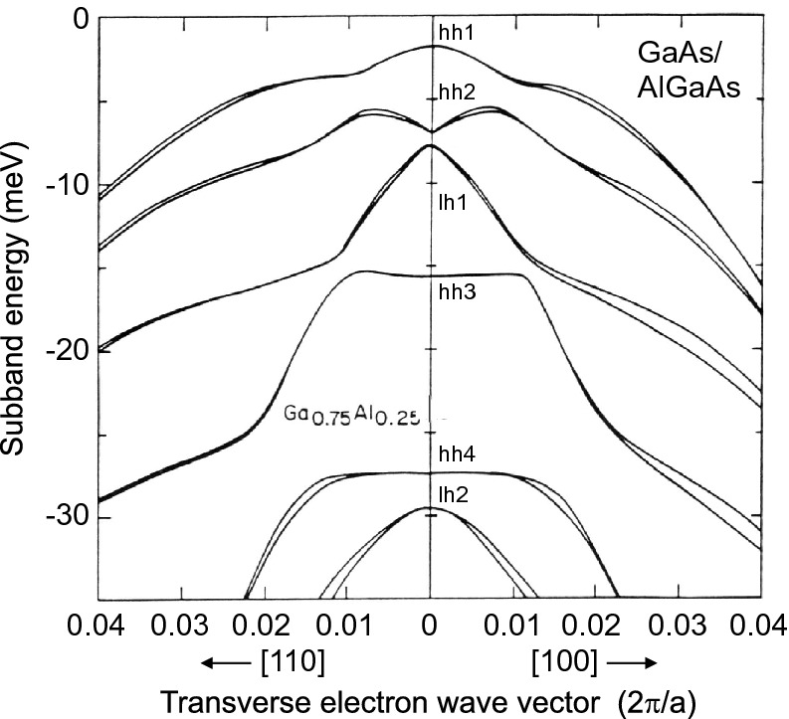

Fig. 12.28

Hole dispersion in a 68-ML GaAs/71 ML Al

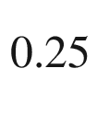

Ga

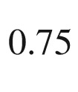

As superlattice (numerical calculation). The double curves originate from a lifting of time-reversal symmetry at

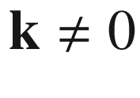

.

Reprinted with permission from [1183], ©1985 APS

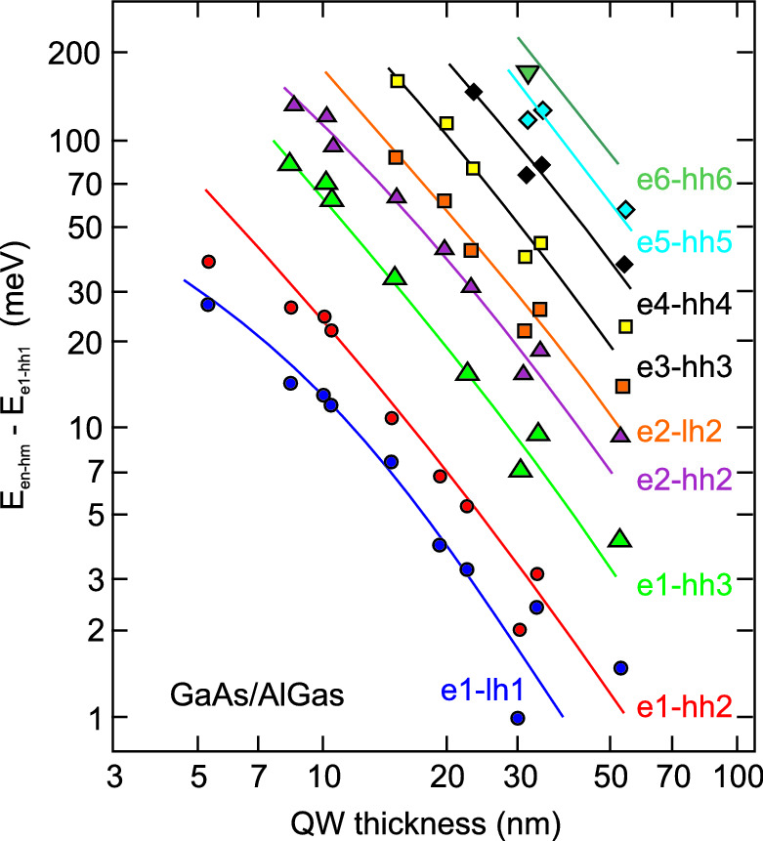

Fig. 12.29

Observed electron–hole transitions (energy difference to the first e–h transition from excitation spectroscopy) in GaAs/(Al,Ga)As quantum wells of varying thickness. *Symbols* are experimental data, *solid lines* are theoretical model.

Data from [1184]

Experimentally observed transition energies in quantum wells of varying thickness are shown in Fig. [12.29](#u116076_4_En_12_Chapter-Fig29) and are in good agreement with the theoretical calculation. We note that for infinite barriers optical transitions are only allowed between confined electron and hole states with the same quantum number *n*. For finite barriers this selection rule becomes relaxed, and other transitions become partially allowed, e.g., e



–hh



. The optical matrix element from the Bloch part of the wavefunction, which was isotropic for (cubic) bulk material ([9.​37](The_Physics_of_Semiconductors00004.docx#u116076_4_En_9_Chapter)), is anisotropic for quantum wells. TE (TM) polarization is defined with the electromagnetic field in (perpendicular to) the plane of the quantum well (Fig. [12.30](#u116076_4_En_12_Chapter-Fig30)a). At the subband edge, i.e., for in-plane wavevector

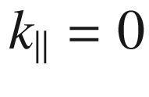

 the matrix elements for the various polarizations and propagation directions are given in Table [12.3](#u116076_4_En_12_Chapter-Tab3). The matrix elements averaged over all in-plane directions for TE-polarization are

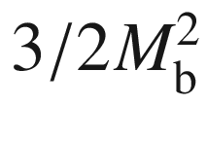

(

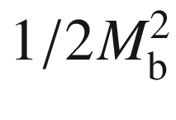

) for the electron to heavy (light) hole transition. For TM polarization the values are 0 and

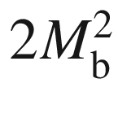

, respectively [1185]. The optical selection rules are shown in Fig. [12.30](#u116076_4_En_12_Chapter-Fig30) (see Fig. [9.​12](The_Physics_of_Semiconductors00004.docx#u116076_4_En_9_Chapter-Fig12) for bulk material). For propagation along the quantum-well plane, the ratio between the strength of the TE polarized e–hh and e–lh transitions is 3:1.

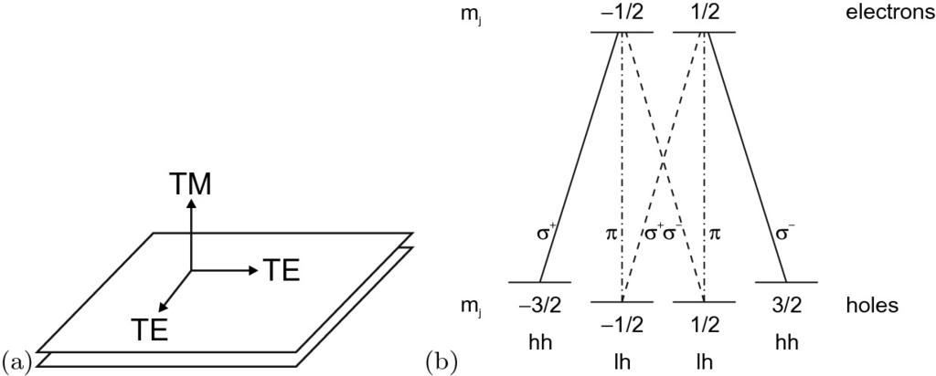

Fig. 12.30

**a** Directions of electric-field vector relative to the quantum-well plane for TE and TM polarization. **b** Optical selection rules for band–band transitions in a quantum well. If the (in-plane averaged) relative strength of the e–hh transitions (*solid lines*) is 1, the relative strength of the TE-polarized e–lh transitions (*dashed lines*) is 1/3 and that of the TM-polarized e–lh transitions (*dash-dotted lines*) is 4/3

Table 12.3

Squared momentum matrix elements

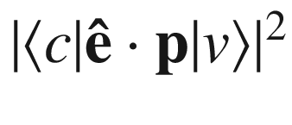

in a quantum well for various propagation directions in units of

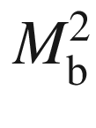

. The quantum-well normal is along

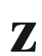

|  | Propagation | $${\varvec{\hat{\mathrm{e}}}}_{\mathrm {x}}$$   (TE) | $${\varvec{\hat{\mathrm{e}}}}_{\mathrm {y}}$$   (TE) | $${\varvec{\hat{\mathrm{e}}}}_{\mathrm {z}}$$   (TM) |
| --- | --- | --- | --- | --- |
| e–hh | $$\mathbf{x}$$ | – | 1/2 | 0 |
| $$\mathbf{y}$$ | 1/2 | – | 0 |
| $$\mathbf{z}$$ | 1/2 | 1/2 | – |
| e–lh | $$\mathbf{x}$$ | – | 1/6 | 2/3 |
| $$\mathbf{y}$$ | 1/6 | – | 2/3 |
| $$\mathbf{z}$$ | 1/6 | 1/6 | – |
| e–so | $$\mathbf{x}$$ | – | 1/3 | 1/3 |
| $$\mathbf{y}$$ | 1/3 | – | 1/3 |
| $$\mathbf{z}$$ | 1/3 | 1/3 | – |

The confinement potential squeezes charge carriers bound to impurities closer to the ion. Therefore, the binding energy increases as shown in Fig. [12.31](#u116076_4_En_12_Chapter-Fig31). This behavior can be modeled theoretically with good precision. It makes a difference whether the impurity is located at the center or the interface of the quantum well.

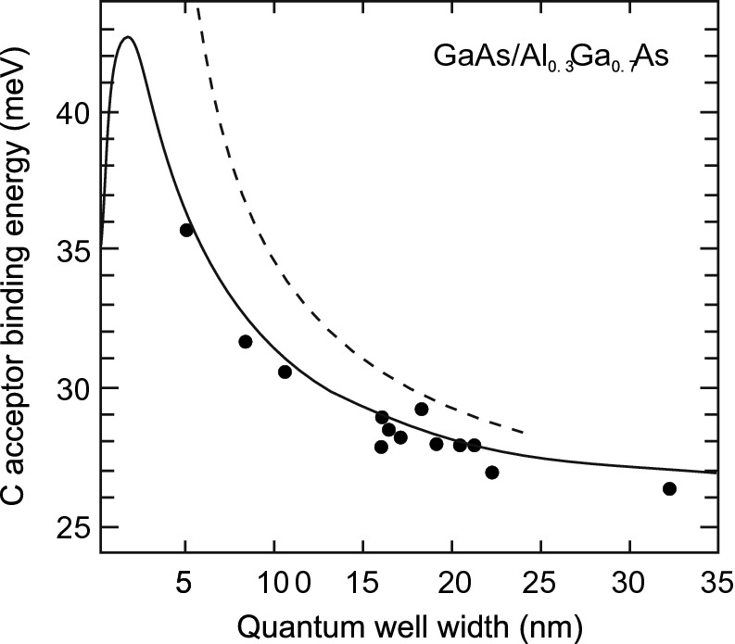

Fig. 12.31

Experimental values for the acceptor binding energy in GaAs/Al

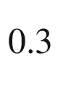

Ga

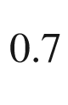

As quantum wells (*solid circles*) from [1186] as a function of well width. *Solid line* is theory (variational calculation) for the well-center acceptor including top four valence bands and finite barriers, *dashed line* is hydrogen-like model with infinite barrier height.

Adapted from [1187]

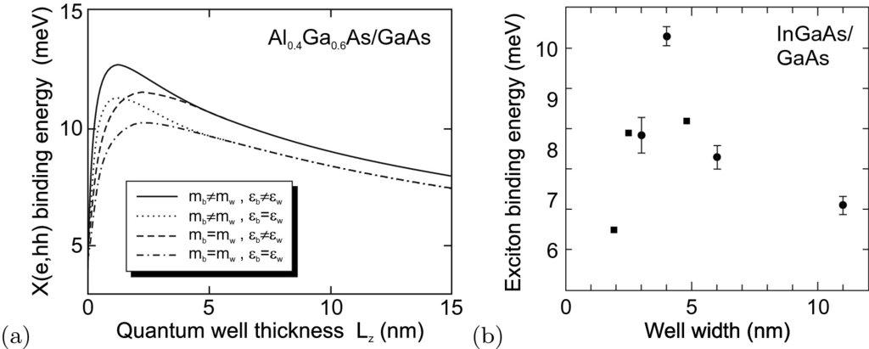

Fig. 12.32

**a** Theoretical (variational) calculation (*solid line*) of the heavy-hole exciton binding energy versus QW thickness in a GaAs/Al

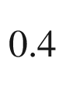

Ga

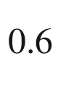

As quantum well (using also different approximations, *other lines*). Adapted from [1188]. **b** Experimental exciton binding energy in In



Ga

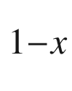

As/GaAs quantum wells of different thickness. *Circles*: data and error bars from [1189], *x* unspecified, *squares*: data from [1190],

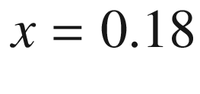

The confinement potential also squeezes electrons and holes in the exciton closer together and thus increases their Coulomb interaction. The binding energy of the quantum-well exciton is thus larger than in bulk material and depends on the well width (Fig. [12.32](#u116076_4_En_12_Chapter-Fig32)). In the simple hydrogen-like model with infinite barriers the exciton binding energy is 4 times the bulk binding energy in the limit

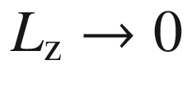

. In a realistic calculation the effect of different dielectric constants in the well and barrier (image charge effect) need to be considered.

#### 12.3.3 Superlattices

In a superlattice, the barrier thickness  is so small that carriers can tunnel in neighboring wells or, in other terms, that there exists a significant wavefunction overlap between adjacent wells. This leads to a band structure (Fig. [12.33](#u116076_4_En_12_Chapter-Fig33)), similar to the Kronig-Penney model (Appendix F). For the superlattice the bands are called minibands, the gaps are called minigaps. The density of states does not make a step at the subband edge but follows an arccos function. The modification of the density of states, as seen in the absorption spectrum, are shown in Fig. [12.34](#u116076_4_En_12_Chapter-Fig34) for 1, 2, 3 and 10 coupled wells.

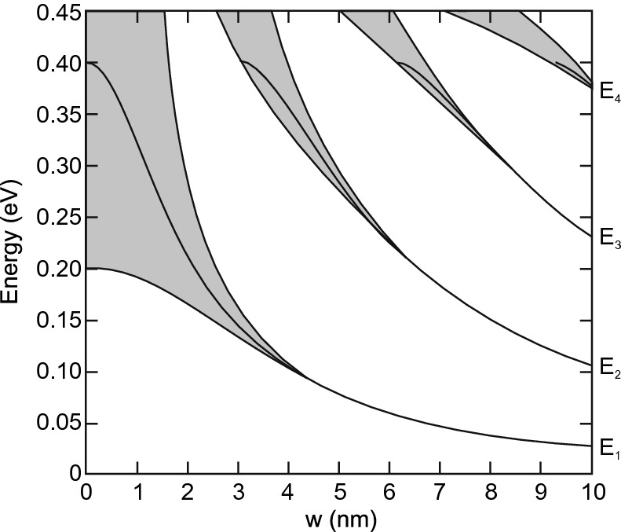

Fig. 12.33

Band structure of a superlattice with a potential depth of 0.4 eV and well and barrier width *w* (

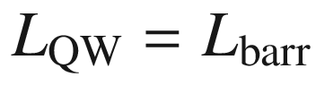

).

Adapted from [1191]

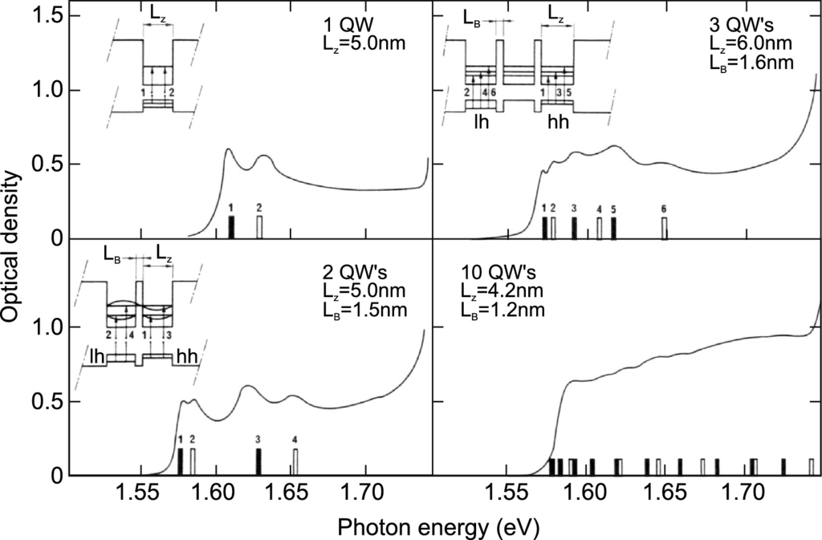

Fig. 12.34

Absorption spectra of a single, double, triple and ten coupled quantum wells. Theoretically predicted transitions with heavy (light) holes are labeled with *filled* (*empty*) *bars* at their respective transition energies.

Adapted from [1192]

#### 12.3.4 Heterointerface Between Doped Materials

We consider a single heterointerface between n-doped materials. As an example we take n-(Al,Ga)As/n-GaAs (Fig. [12.35](#u116076_4_En_12_Chapter-Fig35)). First, we consider the materials without contact, forming a type-I structure. In thermodynamic equilibrium the system must have a constant Fermi level. Thus, charge is transferred from the region close to the interface from (Al,Ga)As to GaAs. This results in the formation of a triangular potential well in the GaAs close to the interface. A two-dimensional electron gas (2DEG) forms in this potential well (Fig. [12.36](#u116076_4_En_12_Chapter-Fig36)). The charge transfer in thermodynamic equilibrium adjusts the band bending and the charge density (quantized levels in the well) in such a way that they are self-consistent. The Poisson equation and the Schrödinger equation are simultaneously fulfilled. Numerically, both equations are iteratively solved and the solution is altered until it is self-consistent, i.e., it fulfills both equations.

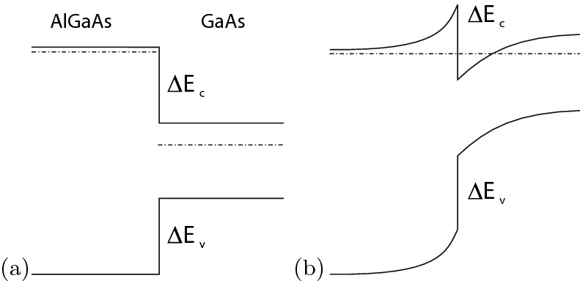

Fig. 12.35

Schematic formation of a triangular potential well in a n-(Al,Ga)As/n-GaAs heterostructure, **a** before and **b** after equilibration of Fermi levels

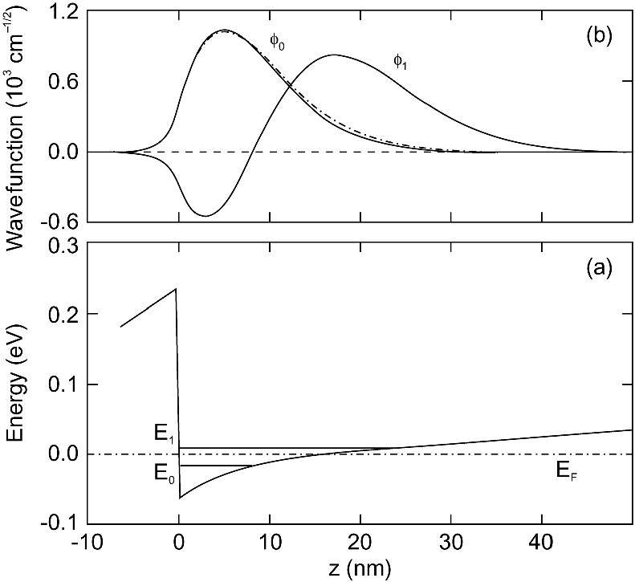

Fig. 12.36

**a** Conduction-band edge at a GaAs/Al

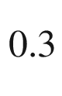

Ga



As heterointerface (

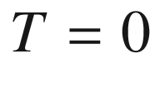

 K) with two confined states at

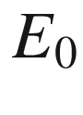

and

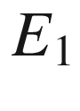

marked with *solid horizontal lines*. In the GaAs channel there are

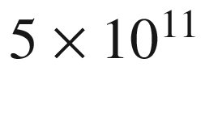

 cm

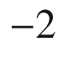

electrons. The barrier height is 300 meV,

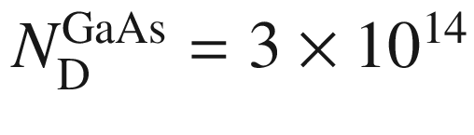

 cm

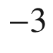

. The position of the Fermi level

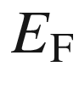

is at

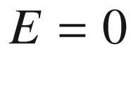

and indicated with a *dash-dotted line*. **b** Envelope wavefunctions

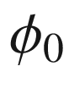

and

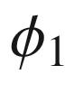

of the two confined states, *dash-dotted line*: calculation without exchange and correlation for state at

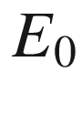

.

Adapted from [1193]

If the region of the 2DEG is not doped, the electron gas exists without any dopant atoms and ionized impurity scattering no longer exists. This concept is called *modulation doping*. Mobilities up to

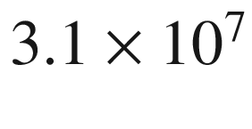

 cm



/Vs have been realized (Fig. [12.37](#u116076_4_En_12_Chapter-Fig37)). The theoretical limits of mobility in a 2DEG at modulation-doped (Al,Ga)As/GaAs heterointerfaces are discussed in detail in [1194].

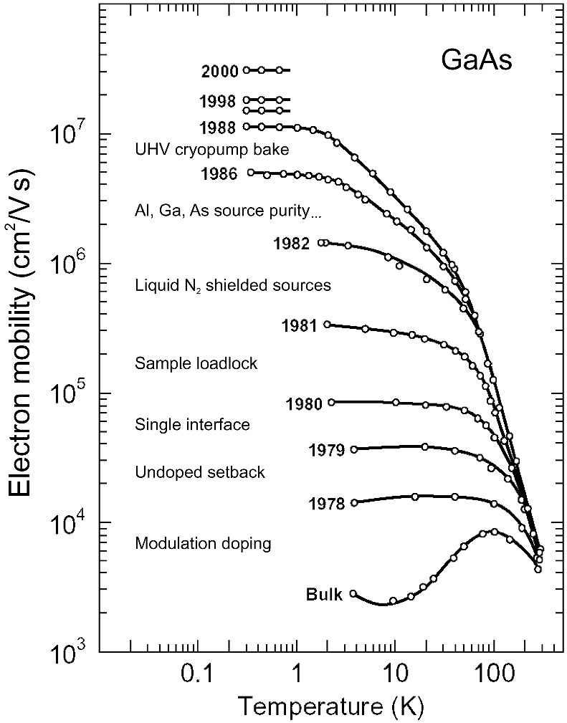

Fig. 12.37

Progress in the achievement of high electron mobility in GaAs, annotated with the technical innovation responsible for the improvement.

Adapted from [1195], reprinted with permission, ©2003 Elsevier B.V

#### 12.3.5 Heterointerface Between Semiconductors with Band Structures of Different Topology

Let us remember the situation of the topological linear chain developing end states when sandwiched between trivial material (cf. Sect. [5.​2.​10](The_Physics_of_Semiconductors00002.docx#u116076_4_En_5_Chapter)). Also surface states develop between a material with non-trivial topological band structure and vacuum (which is trivial) (cf. Sect. [11.​6.​3](#u116076_4_En_11_Chapter)). These effects are expression of the bulk-boundary correspondence, which says that at the interface of topologically different materials, edge states develop.

If now a semiconductor heterointerface is made up from two topologically differnt materials, a conductive interface channel is expected. This effect has been found for the HgTe/CdTe system where HgTe represents the non-trivial material with inverted band structure. (cf. Sect. [6.​11](The_Physics_of_Semiconductors00003.docx#u116076_4_En_6_Chapter)). A quantum well structure was proposed where HgTe is sandwiched between layers of Hg



Cd

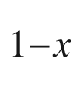

Te [1196]. Taking the electron and hole quantization effects into account, normal band order is present for thickness of the HgTe layer up to a critical thickness of

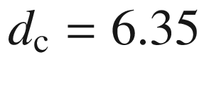

 nm (for

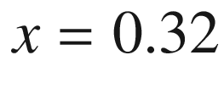

) and the sample should be insulating. For thicker QWs, the two-dimensional bands invert and edge states arise. The quantized electrical conductance due to the edge states was indeed found and measured [1197, 1198].

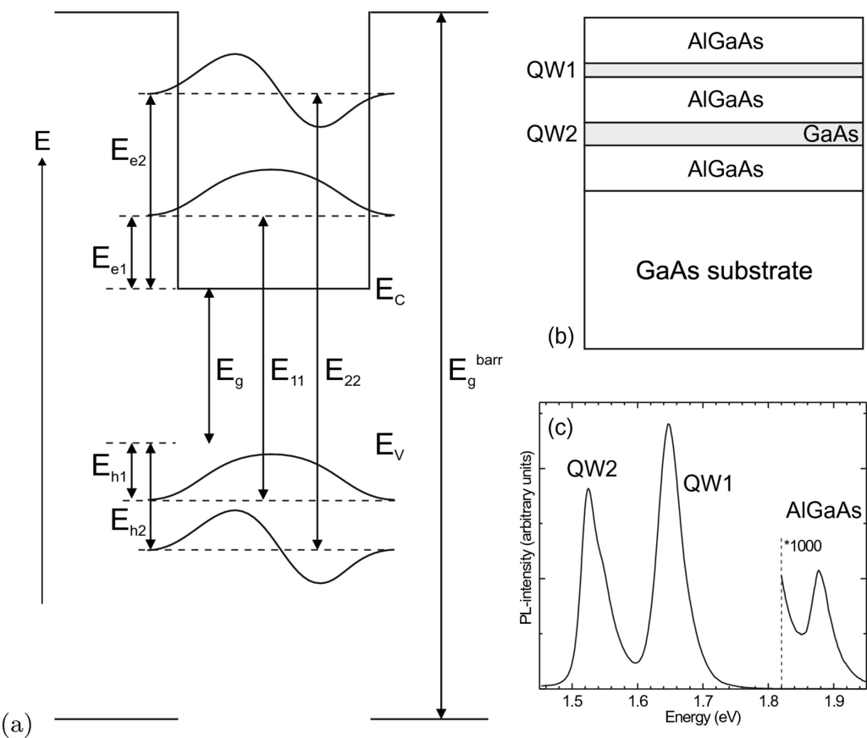

Fig. 12.38

**a** Schematic energy diagram of a quantum well with confined electron (e1, e2) and hole (h1, h2) states and recombination between them at energies

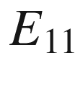

and

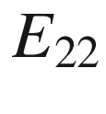

. **b** Schematic sample structure with two GaAs/Al



Ga



As quantum wells with thicknesses 3 nm and 6 nm. **c** Photoluminescence spectrum (

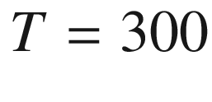

 K) of the structure from part (**b**). A small amount of barrier luminescence appears at 1.88 eV, according to

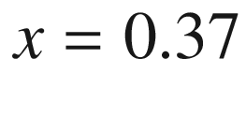

(cf. Fig. [6.​24](The_Physics_of_Semiconductors00003.docx#u116076_4_En_6_Chapter-Fig24)c)

### 12.4 Recombination in Quantum Wells

#### 12.4.1 Thickness Dependence

The energy of exciton recombination in quantum wells is blue-shifted with respect to that in bulk material due to the quantum-confinement energies of electrons and holes (Fig. [12.38](#u116076_4_En_12_Chapter-Fig38)). The electron–hole recombination lineshape in quantum wells is given by the product of the joint density of states and the Boltzmann function (when Boltzmann statistics apply). The JDOS is given by a step function (Heavyside function *H*(*E*)).

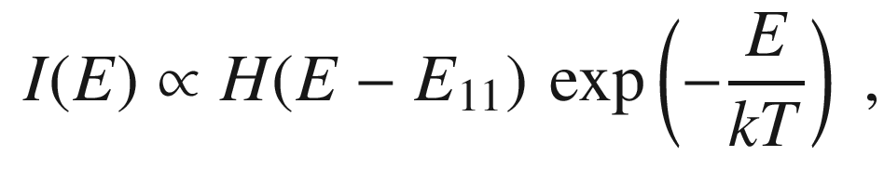

(12.10)

where

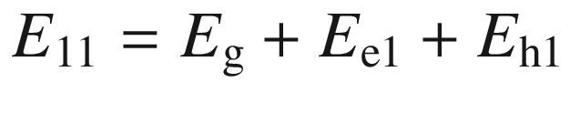

represents the energy of the E1–H1 subband edge as shown in Fig. [12.38](#u116076_4_En_12_Chapter-Fig38). An experimental spectrum (Fig. [12.40](#u116076_4_En_12_Chapter-Fig40)a) shows that excitonic effects influence the recombination lineshape in a GaAs quantum well even at room temperature [1199].

The recombination decay constant of excitons decreases with decreasing well width, partly due to the increase of exciton binding energy as discussed in [1200].

#### 12.4.2 Broadening Effects

**Many-Body Effects**

At high carrier densities when the electron (quasi-) Fermi level is above the electron subband edge, the spectrum broadens and reflects the Fermi–Dirac distribution (Fig. [12.40](#u116076_4_En_12_Chapter-Fig40)b). At low temperatures a many-body effect, multiple electron–hole scattering with electrons at the Fermi edge, leads to an additional peak, termed *Fermi-edge singularity* that is discussed in [1201].

**Homogeneous Broadening**

The temperature dependence of the homogeneous broadening of quantum well luminescence has been investigated in [1202]. It follows the dependence of the broadening known from bulk material (Sect. [9.​7.​7](The_Physics_of_Semiconductors00004.docx#u116076_4_En_9_Chapter)) with similar values for the LO broadening parameter. In Fig. [12.39](#u116076_4_En_12_Chapter-Fig39)a the reflectance spectra for different temperatures of a 17 nm GaAs/Al

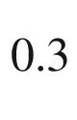

Ga

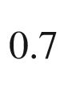

As QW are shown. The optical phonon broadening parameter for various well widths is shown in Fig. [12.39](#u116076_4_En_12_Chapter-Fig39)b and coincides with the bulk value.

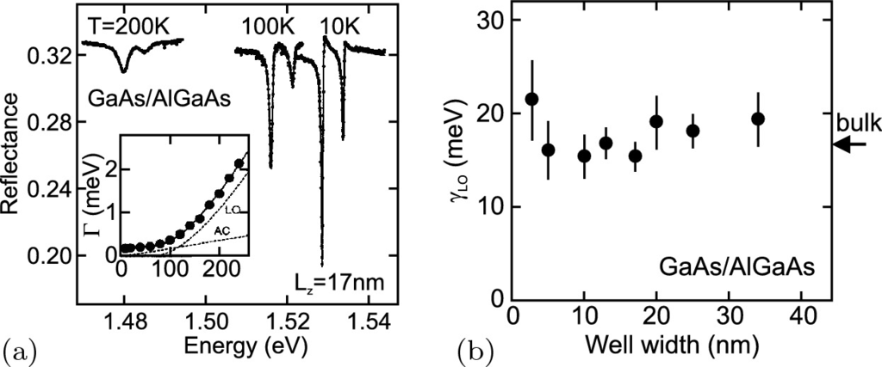

Fig. 12.39

**a** Reflectance spectra at various temperatures from a 17 nm thick GaAs/Al

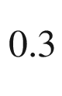

Ga



As quantum well. The *inset* shows the temperature dependence of the homogeneous linewidth. **b** LO phonon broadening parameter (FWHM) for various quantum well widths.

Adapted from [1202]

The homogeneous broadening leads to excitons with in-plane center-of-mass wave-vector

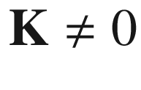

being allowed to recombine radiatively. This leads to a linear increase of exciton lifetime as demonstrated for GaAs quantum wells up to 50 K in [1200]. In [1203] all exciton wave-vectors within the light cone are considered, explaining the linear increase of exciton lifetime in (non-polar) ZnO quantum wells up to room temperature.

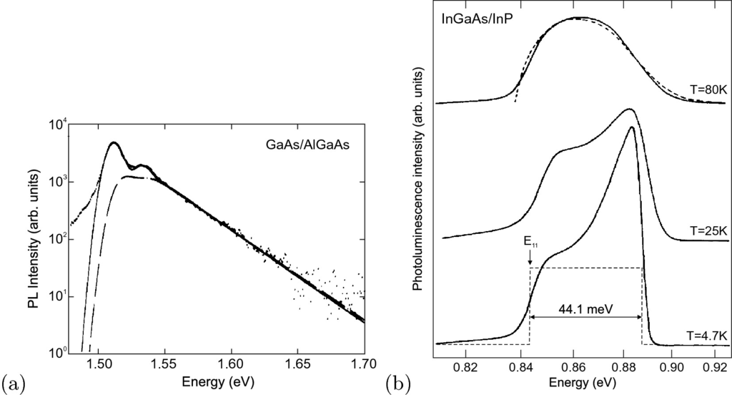

Fig. 12.40

**a** Photoluminescence spectrum of a 5-nm GaAs/(Al,Ga)As quantum well at

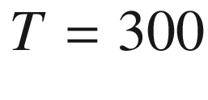

 K. The *solid* (*dashed*) line is fit with (without) excitonic effects. The two peaks are due to transitions involving heavy and light holes. Adapted from [1199]. **b** Photoluminescence spectra at three different temperatures as labeled of a 10-nm modulation-doped (In, Ga)As/InP quantum well with an electron sheet density

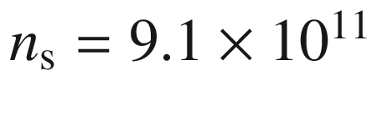

 cm

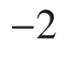

. The electron quasi-Fermi level is

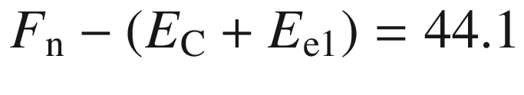

 meV from the subband edge. The *dashed line* in the

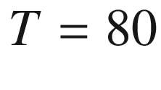

 K spectrum is the lineshape from JDOS and a Fermi–Dirac distribution without enhancement at the Fermi edge.

Adapted from [1201]

**Inhomogeneous Broadening**

Inhomogeneous broadening affects the recombination lineshape. Since the interfaces of the QW are not ideally flat, the exciton averages over different quantum-well thicknesses within its volume. Also, e.g., for the GaAs/(Al,Ga)As system, the wavefunction in the (binary) quantum well tunnels into the barrier, the amount depending on the QW width, and there ‘sees’ the alloy broadening (see Sect. [10.​3.​3](#u116076_4_En_10_Chapter)). The problem of exciton dynamics in a potential with random fluctuations has been treated in detail [1204, 1205].

A simplified picture is as follows: At low temperatures the excitons populate preferentially the potential minima. A simple lineshape[5](The_Physics_of_Semiconductors00006.docx#u116076_4_En_12_Chapter-Fn5) of the QW absorption or joint density of states is given by a step function (cf. Table [9.​3](The_Physics_of_Semiconductors00004.docx#u116076_4_En_9_Chapter-Tab3)) at the QW band edge

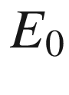

. The inhomogeneous broadening has a Gaussian probability distribution

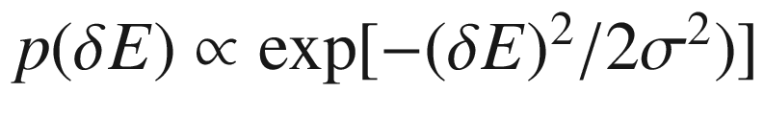

with

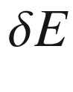

being the deviation from the QW band edge

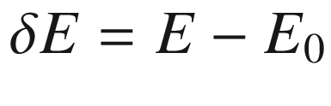

. The resulting lineshape is given by the convolution of the Gaussian with the unperturbed absorption spectrum yielding an error-function-like spectrum[6](The_Physics_of_Semiconductors00006.docx#u116076_4_En_12_Chapter-Fn6) as shown in Fig. [12.41](#u116076_4_En_12_Chapter-Fig41)a.

For complete thermalization the level population is given by the Boltzmann function. The recombination spectrum is given by the product of the absorption spectrum (or JDOS) and the Boltzmann function. It is (red-) shifted with respect to



by about[7](The_Physics_of_Semiconductors00006.docx#u116076_4_En_12_Chapter-Fn7)

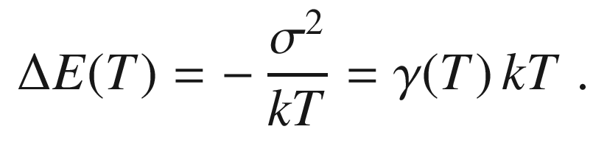

(12.11)

This shift between emission and absorption is also called the Stokes shift.

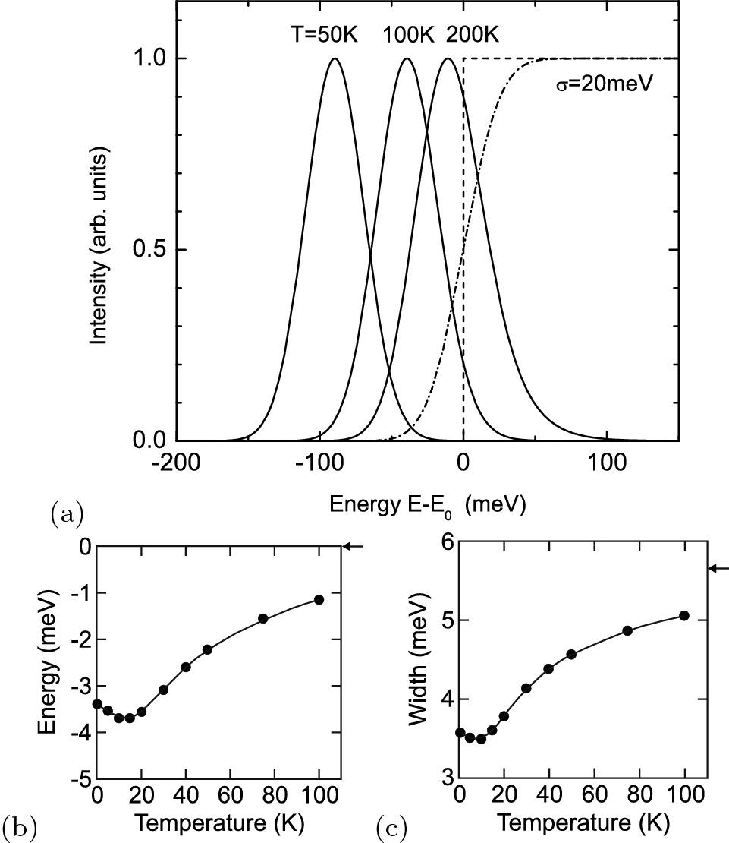

Fig. 12.41

**a** Recombination spectra (*solid lines*, scaled to same height) of a model quantum well for different temperatures as labeled and complete thermalization, *dashed* (*dash-dotted*) *line* is unperturbed (inhomogeneously broadened by

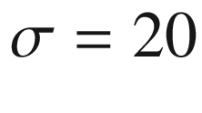

 meV) shape of the QW absorption edge. The energy scale is relative to the energy position of the unperturbed QW absorption edge at

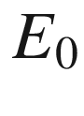

. **b** Theoretical energy position and **c** linewidth of exciton recombination from a model disordered quantum well. The high-temperature limits are marked by *arrows*.

Parts (**b**, **c**) adapted from [1204]

Within their lifetime, limited at least by radiative recombination, the excitons are typically unable to reach the energy position required by the Boltzmann function, but only a local minimum. Thus, their thermalization may be incomplete due to insufficient lateral diffusion. This effect is particularly important at low temperatures when thermal emission into adjacent deeper potential minima is suppressed. In this case, the red-shift is smaller than expected from ([12.11](#u116076_4_En_12_Chapter-Equ14)). A numerical simulation [1204] yields such behavior of the energy position of the recombination line as shown in Fig. [12.41](#u116076_4_En_12_Chapter-Fig41)b. Simultaneously, the width of the recombination spectrum also exhibits a minimum (Fig. [12.41](#u116076_4_En_12_Chapter-Fig41)c). These findings are in agreement with experiments [1206, 1207]. An analytical model for temperature dependent exciton localization in the presence of disorder has been given in [1208], yielding a value

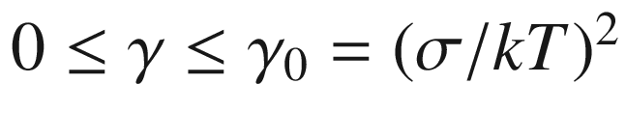

in ([12.11](#u116076_4_En_12_Chapter-Equ14)).

A potential fluctuation  can localize an exciton laterally at low temperatures [1199] and behave like a quantum dot (cf. Sect. [14.​4](The_Physics_of_Semiconductors00006.docx#u116076_4_En_14_Chapter)). Localized and delocalized excitons  are separated by a boundary called the mobility edge [1209]. The transition between the two regimes is a Mott transition [1210].

**Monolayer Growth Islands**

Under certain growth conditions, quantum wells with piecewise very flat interfaces can be fabricated. The thickness difference between such regions (with lateral extension in the



m range) is an integer monolayer. Accordingly, the recombination spectrum yields several, typically two or three, discrete lines (Fig. [12.42](#u116076_4_En_12_Chapter-Fig42)).

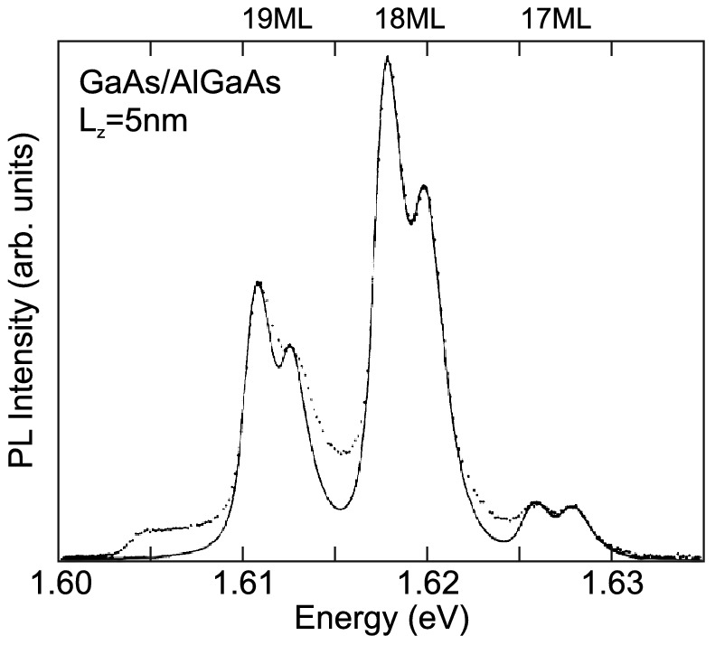

Fig. 12.42

Photoluminescence spectrum (

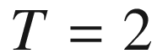

 K) (*dots*) of GaAs/ (Al,Ga)As quantum well grown by MBE with 120 s growth interruptions. Recombination is due to excitons in islands of 19, 18, and 17 monolayers (

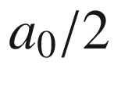

) height. The *solid line* is a lineshape fit including lifetime broadening (

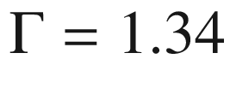

 meV) and residual inhomogeneous broadening (

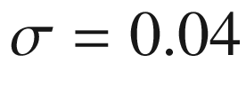

 meV) due to (Al,Ga)As barrier alloy fluctuations. Note that the energy separation of the peaks is much larger than *kT*. The peak doublet structure is discussed in [1199].

Adapted from [1199]